UNITED STATES

SECURITIES AND EXCHANGE COMMISSION

Washington, D.C. 20549

FORM 8-K

CURRENT REPORT

Pursuant to Section 13 or 15(d) of the

Securities Exchange Act of 1934

Date of Report (Date of earliest event reported): October 27, 2026

COSTAR GROUP, INC.

(Exact name of registrant as specified in its charter)

 | Delaware |  |  | 0-24531 |  |  | 52-2091509
(State or other jurisdiction of incorporation or organization) |  |  | (Commission File Number) |  |  | (I.R.S. Employer Identification No.)
1201 Wilson Blvd. |  | Arlington, VA |  |  |  | 22209
(Address of principal executive offices) |  |  |  |  |  | (Zip Code)

Registrant’s telephone number, including area code: (202) 346-6500

Not Applicable

(Former name or former address, if changed since last report.)

Check the appropriate box below if the Form 8-K filing is intended to simultaneously satisfy the filing obligation of the registrant under any of the following provisions:

- Written communications pursuant to Rule 425 under the Securities Act (17 CFR 230.425)

- Soliciting material pursuant to Rule 14a-12 under the Exchange Act (17 CFR 240.14a-12)

- Pre-commencement communications pursuant to Rule 14d-2(b) under the Exchange Act (17 CFR 240.14d-2(b))

- Pre-commencement communications pursuant to Rule 13e-4(c) under the Exchange Act (17 CFR 240.13e-4(c))

Securities registered pursuant to Section 12(b) of the Act:
 | Title of each class |  | Trading Symbol |  |  | Name of each exchange on which registered
Common Stock ($0.01 par value) |  |  |  | CSGP |  | Nasdaq Global Select Market

Indicate by check mark whether the registrant is an emerging growth company as defined in Rule 405 of the Securities Act of 1933 (§230.405 of this chapter) or Rule 12b-2 of the Securities Exchange Act of 1934 (§240.12b-2 of this chapter).

Emerging Growth Company ☐

If an emerging growth company, indicate by check mark if the registrant has elected not to use the extended transition period for complying with any new or revised financial accounting standards provided pursuant to Section 13(a) of the Exchange Act.
o

Item 1.01 Entry into Material Definitive Agreement.

On October 27, 2026, CoStar Group, Inc. (“CoStar Group” or the “Company”), through its wholly owned subsidiaries, CoStar Realty Information, Inc., a Delaware corporation and Velocity Merger Sub, Inc, a Delaware corporation, entered into an Agreement and Plan of Merger (the “Merger Agreement”) with Vexcel Group, Inc. a Delaware corporation (together with its subsidiaries, “Vexcel”), and Fortis Advisors LLC, a Delaware limited liability company, solely in its capacity as the stockholder representative, to acquire Vexcel, a leading provider of comprehensive aerial imagery and geospatial data programs, for $730 million in cash, subject to customary working capital and other post-closing adjustments (the “Transaction”).

Consummation of the Transaction is subject to certain customary conditions, including, among others: expiration or termination of the applicable waiting periods under the Hart-Scott-Rodino Antitrust Improvements Act of 1976, and certain other foreign regulatory laws, the absence of any government, order, decree, ruling, injunction, or law prohibiting or making illegal the consummation of the Transaction. Each party’s obligation to consummate the Transaction is subject to certain other conditions, including the accuracy of the representations and warranties of the other party and compliance in all material respects by the other party with its obligations under the Merger Agreement, and CoStar Group’s obligation to consummate the Transaction is subject to the absence of a material adverse effect related to Vexcel. Consummation of the Transaction is not subject to approval by the stockholders of CoStar Group or to any financing condition.

The Merger Agreement contains certain termination provisions for CoStar Group and Vexcel, including the right of either party to terminate the Merger Agreement if the Transaction is not consummated by July 27, 2027 (subject to extension in certain specified circumstances), or if any governmental authority shall have issued an order, decree or ruling or taken any other action permanently enjoining, restraining or otherwise prohibiting the Transaction, and such order, decree or ruling shall have become final and nonappealable.

The representations, warranties and covenants of each party set forth in the Merger Agreement have been made only for the purposes of, and were and are solely for the benefit of the parties to, the Merger Agreement, and may be subject to limitations agreed upon by the contracting parties. Accordingly, the representations and warranties may not describe the actual state of affairs at the date they were made or at any other time, and investors should not rely on them as statements of fact. In addition, such representations and warranties will not survive consummation of the Transaction and were made only as of the date of the Merger Agreement or such other date as is specified in the Merger Agreement.

The foregoing summary of the Merger Agreement does not purport to be complete and is qualified in its entirety by reference to the full text of the Merger Agreement, a copy of which is attached hereto as Exhibit 10.1 and is incorporated herein by reference.

Item 2.02 Results of Operations and Financial Condition.

On October 27, 2026, the Company announced its financial and operating results for the quarter ended September 30, 2026. The full text of the press release (the “Earnings Release”) issued in connection with the announcement is furnished as Exhibit 99.1 to this Current Report on Form 8-K.

The information contained in this Item 2.02 and the Earnings Press Release shall be considered "furnished" and shall not be deemed "filed" for purposes of Section 18 of the Securities Exchange Act of 1934, as amended (the "Exchange Act"), or otherwise subject to the liabilities of that Section or Sections 11 and 12(a)(2) of the Securities Act of 1933, as amended (the "Securities Act"), nor shall it be deemed incorporated by reference into any reports or filings with the Securities and Exchange Commission (the "SEC"), whether made before or after the date hereof, except as expressly set forth by specific reference in such a filing.

Item 7.01 Regulation FD Disclosure.

On October 27, 2026, the Company issued a press release announcing the entry into the Merger Agreement to acquire Vexcel (the "Press Release"). A copy of the Press Release is attached hereto as Exhibit 99.2 and is incorporated by reference herein.

The information contained in this Item 7.01 and the Press Release shall be considered “furnished” and shall not be deemed “filed” for purposes of Section 18 of the Exchange Act, or otherwise subject to the liabilities of that Section or Sections 11 and 12(a)(2) of the Securities Act, nor shall it be deemed incorporated by reference into any reports or filings with the SEC, whether made before or after the date hereof, except as expressly set forth by specific reference in such a filing.

Item 9.01 Financial Statements and Exhibits.

 | Exhibit No. |  |  | Description
 |  |  |  | Agreement and Plan of Merger dated as of October 27, 2026 among CoStar Realty Information, Inc., Velocity Merger Sub, Inc., Vexcel Group, Inc. and
10.1* |  |  |  | Fortis Advisors LLC.
99.1 |  |  |  | CoStar Group, Inc. Earnings Release dated October 27, 2026.
99.2 |  |  |  | CoStar Group, Inc. Press Release dated October 27, 2026.
104 |  |  |  | Cover Page Interactive Data File (formatted as inline XBRL and contained in Exhibit 101).
* |  |  |  | Schedules and exhibits (or similar attachments) have been omitted from this exhibit pursuant to Item 601(a)(5) of Regulation S-K. The Company will
 |  |  |  | furnish copies of any such schedules (or similar attachments) to the SEC upon request.

SIGNATURES

Pursuant to the requirements of the Securities Exchange Act of 1934, the registrant has duly caused this report to be signed on its behalf by the undersigned hereunto duly authorized.

 |  | COSTAR GROUP, INC.
 |  | By: /s/ Robin Rossmann
Date: | October 27, 2026 | Name: Robin Rossmann
 |  | Title: Chief Financial Officer

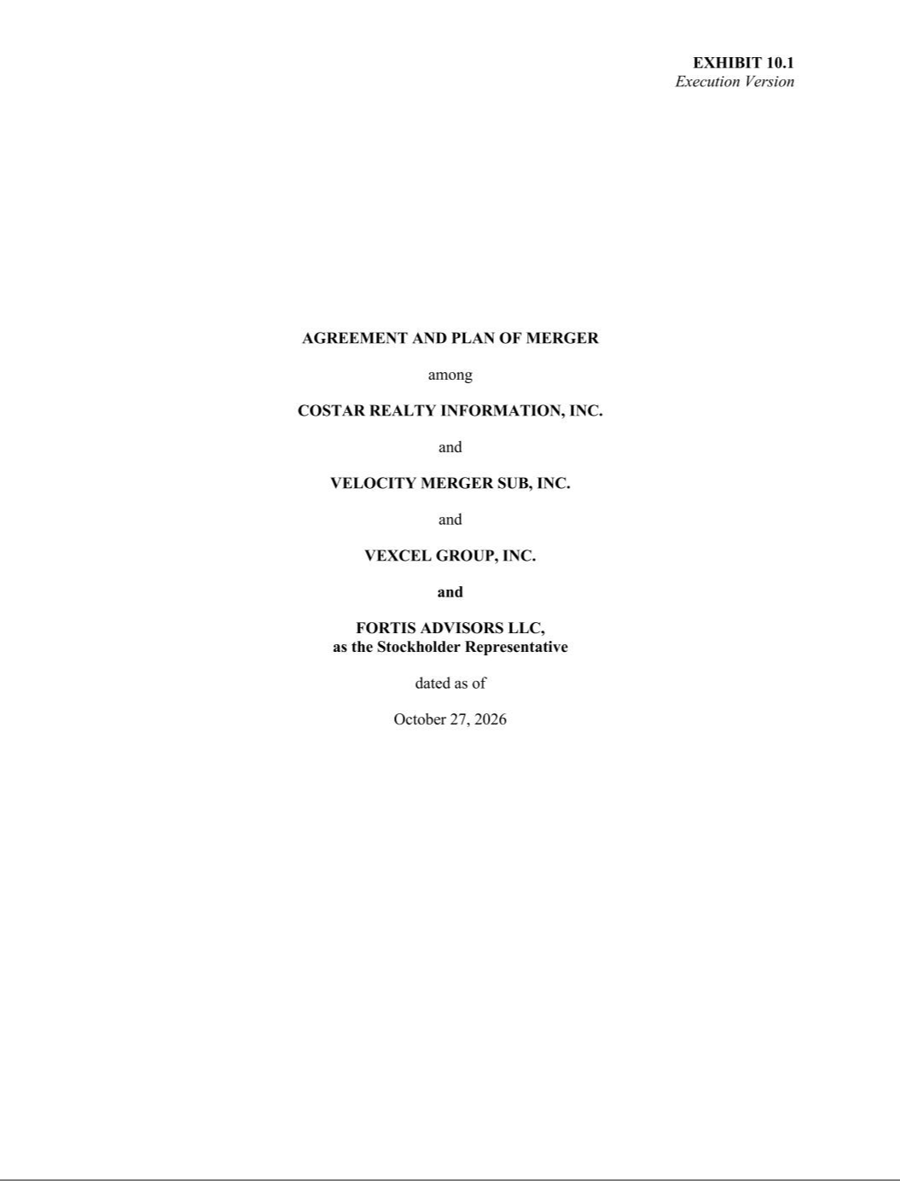

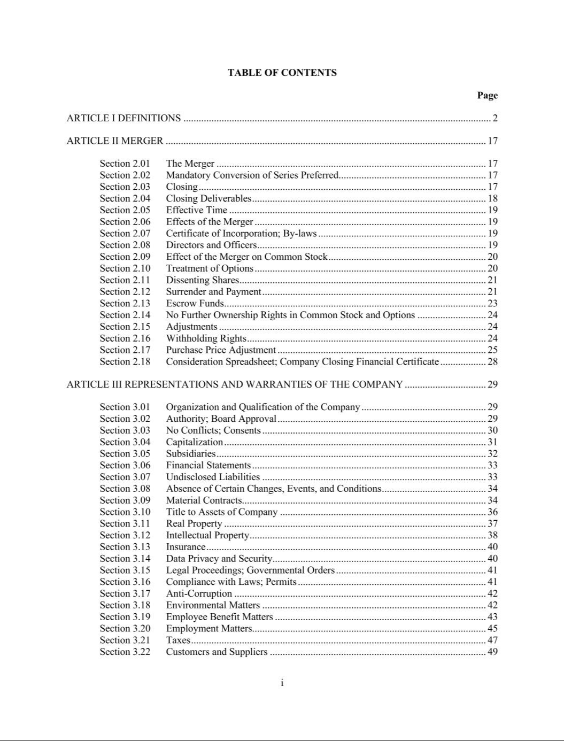

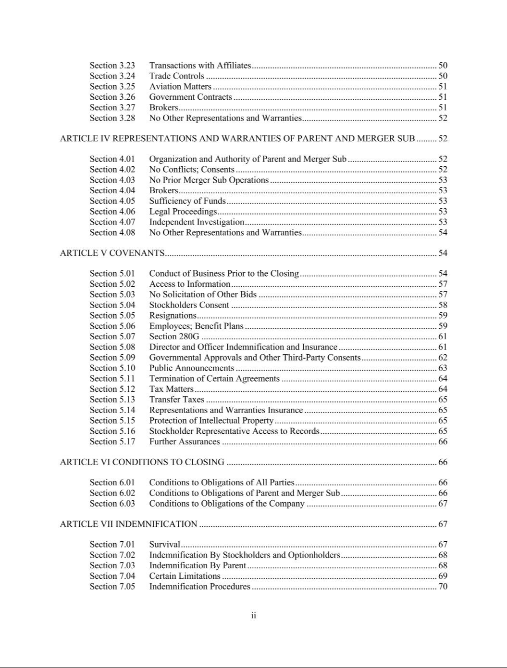

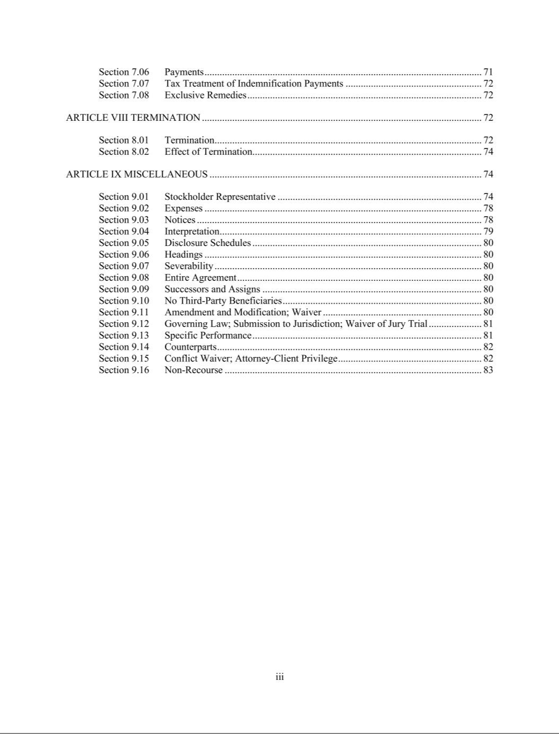

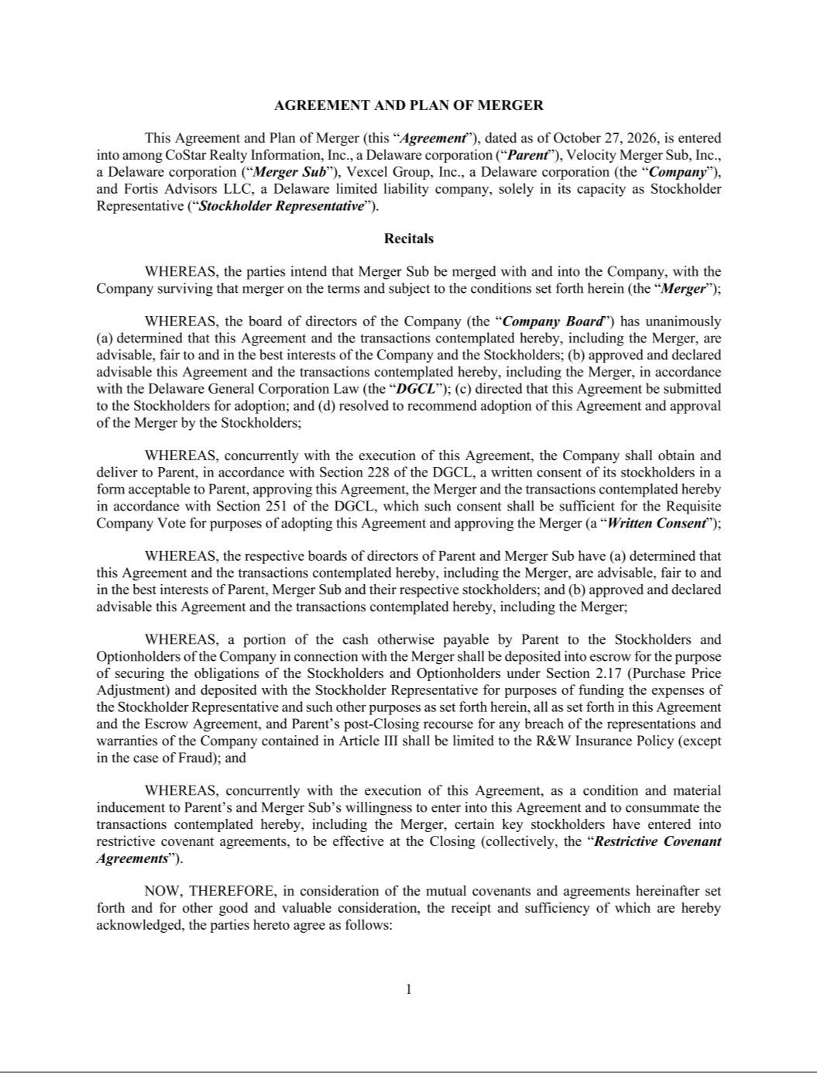

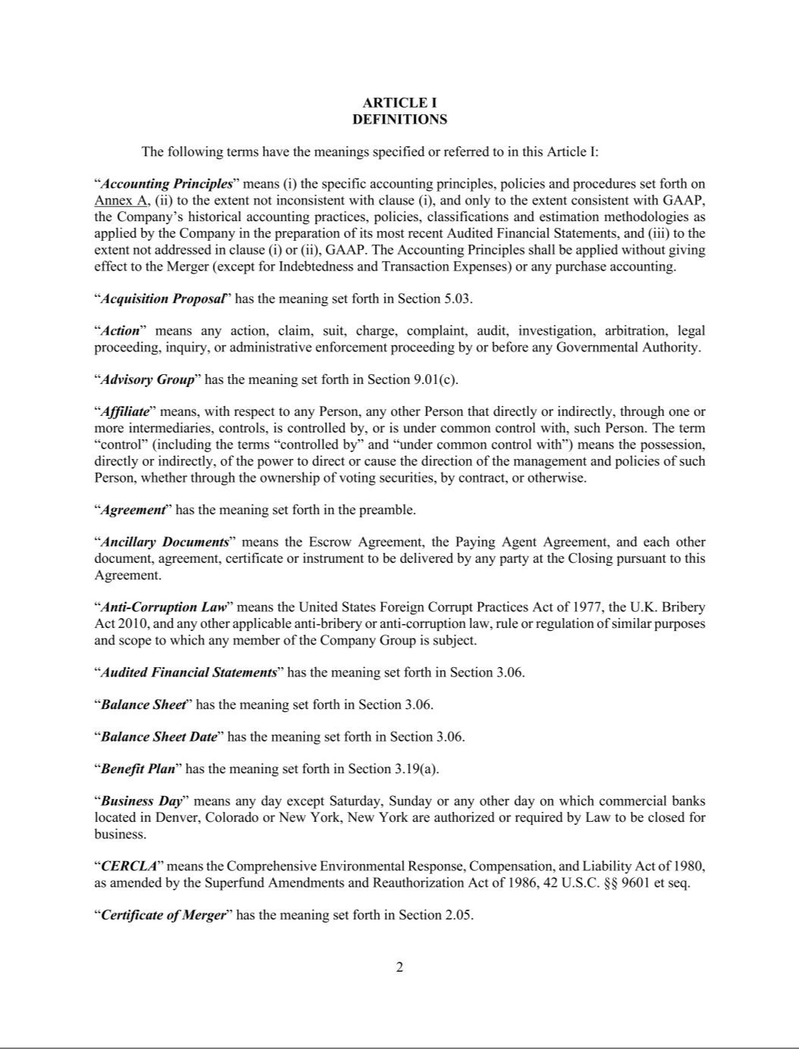

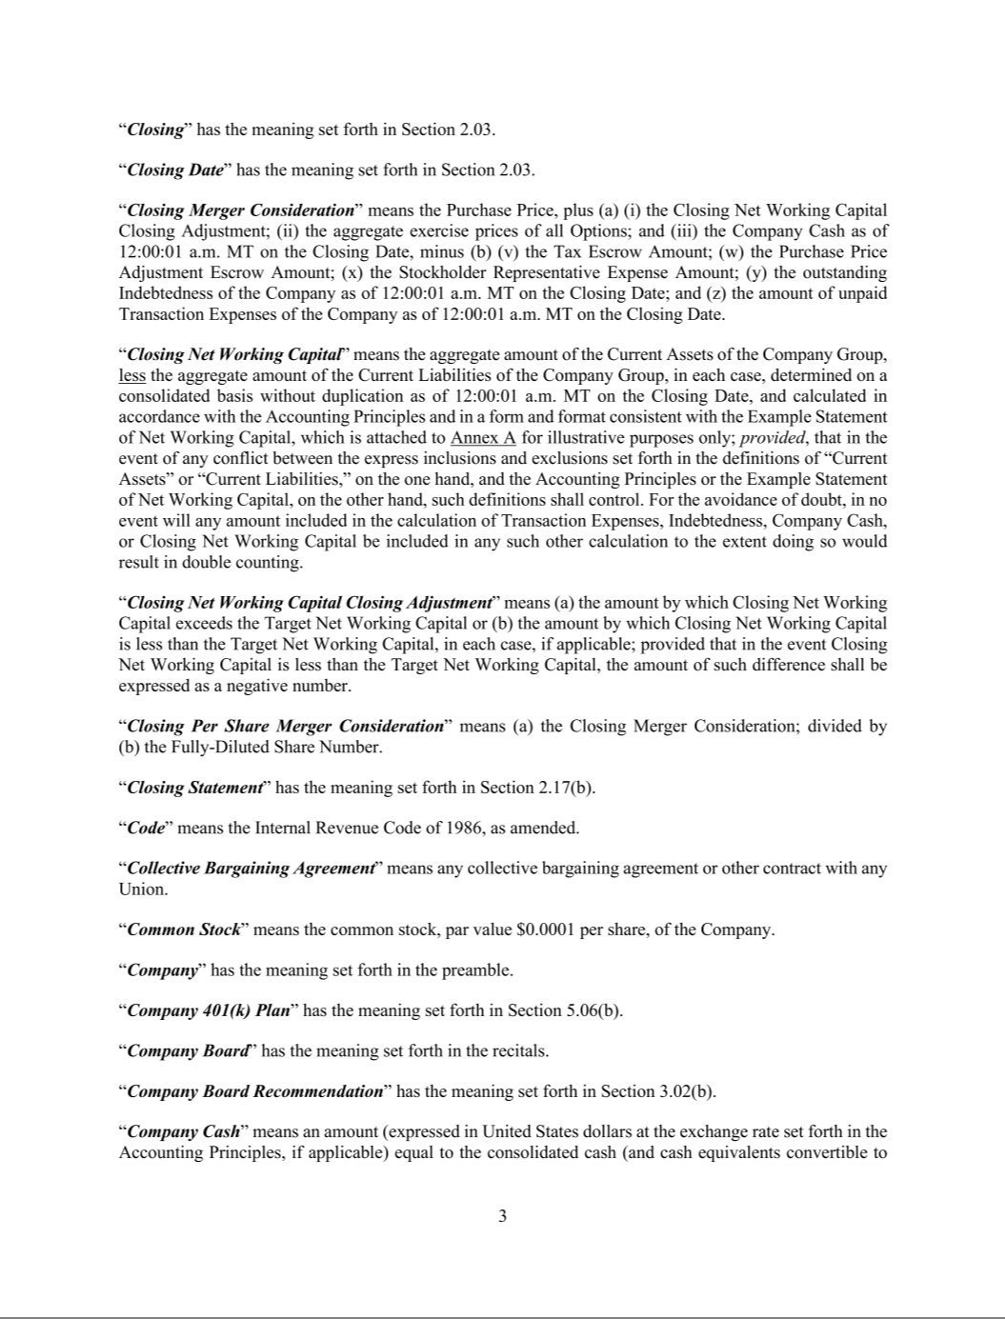

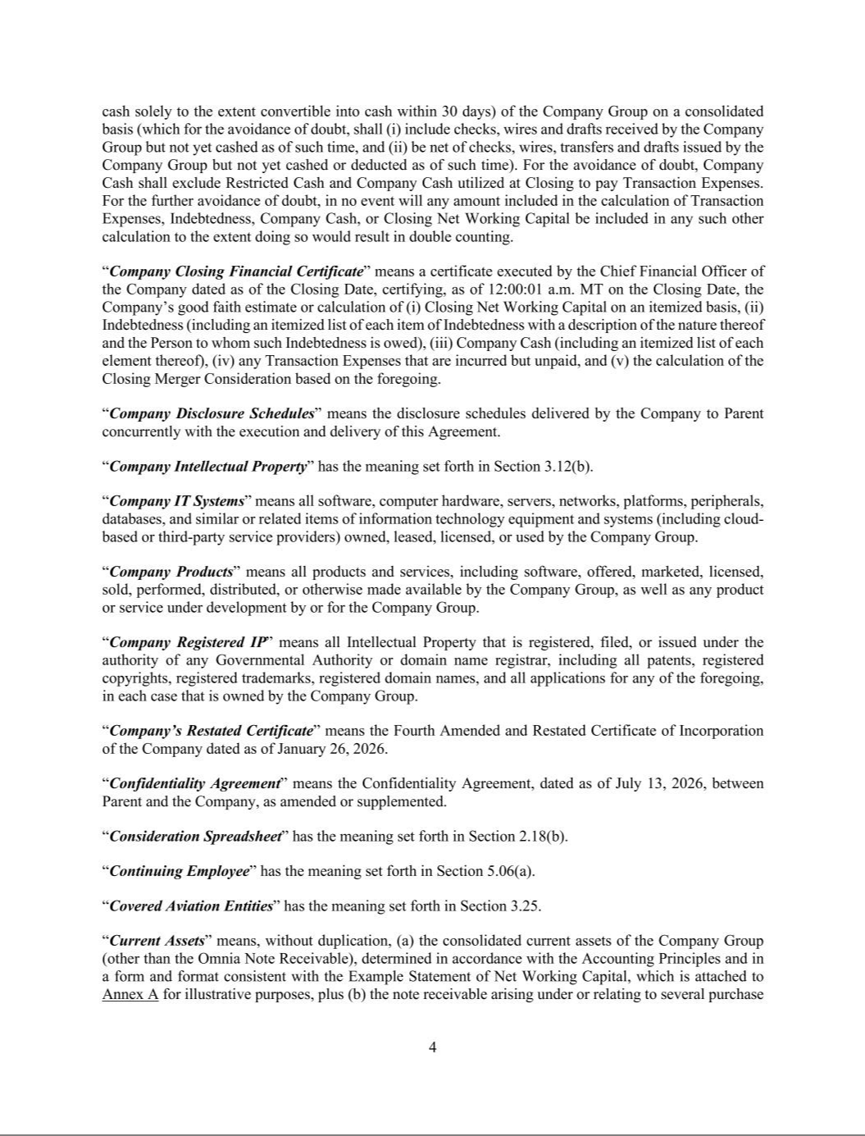

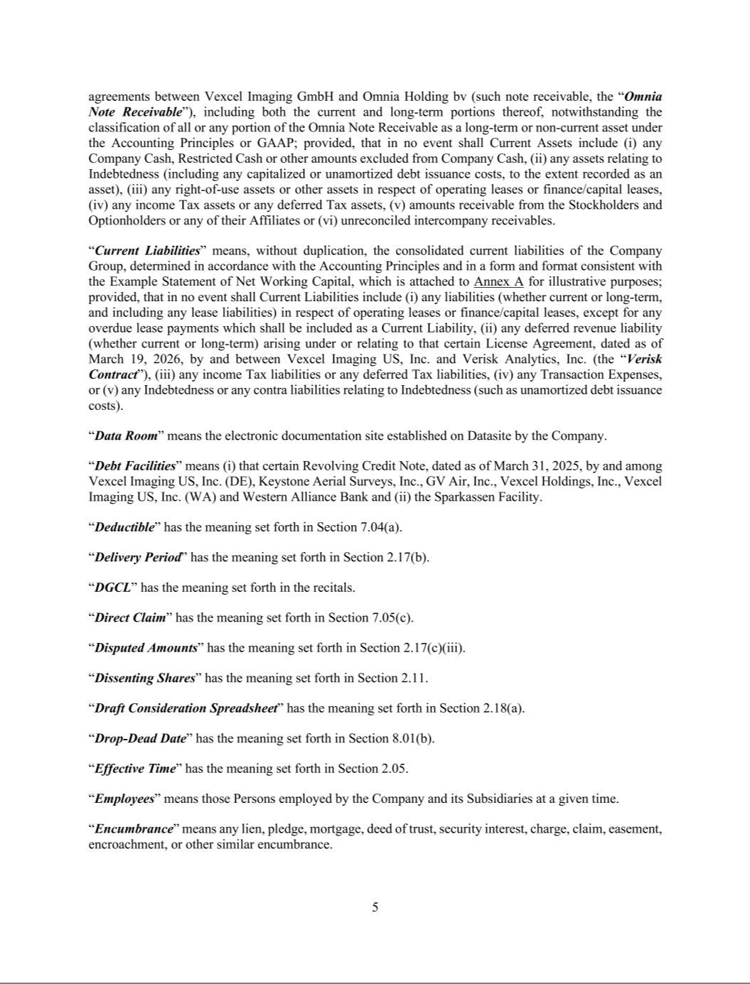

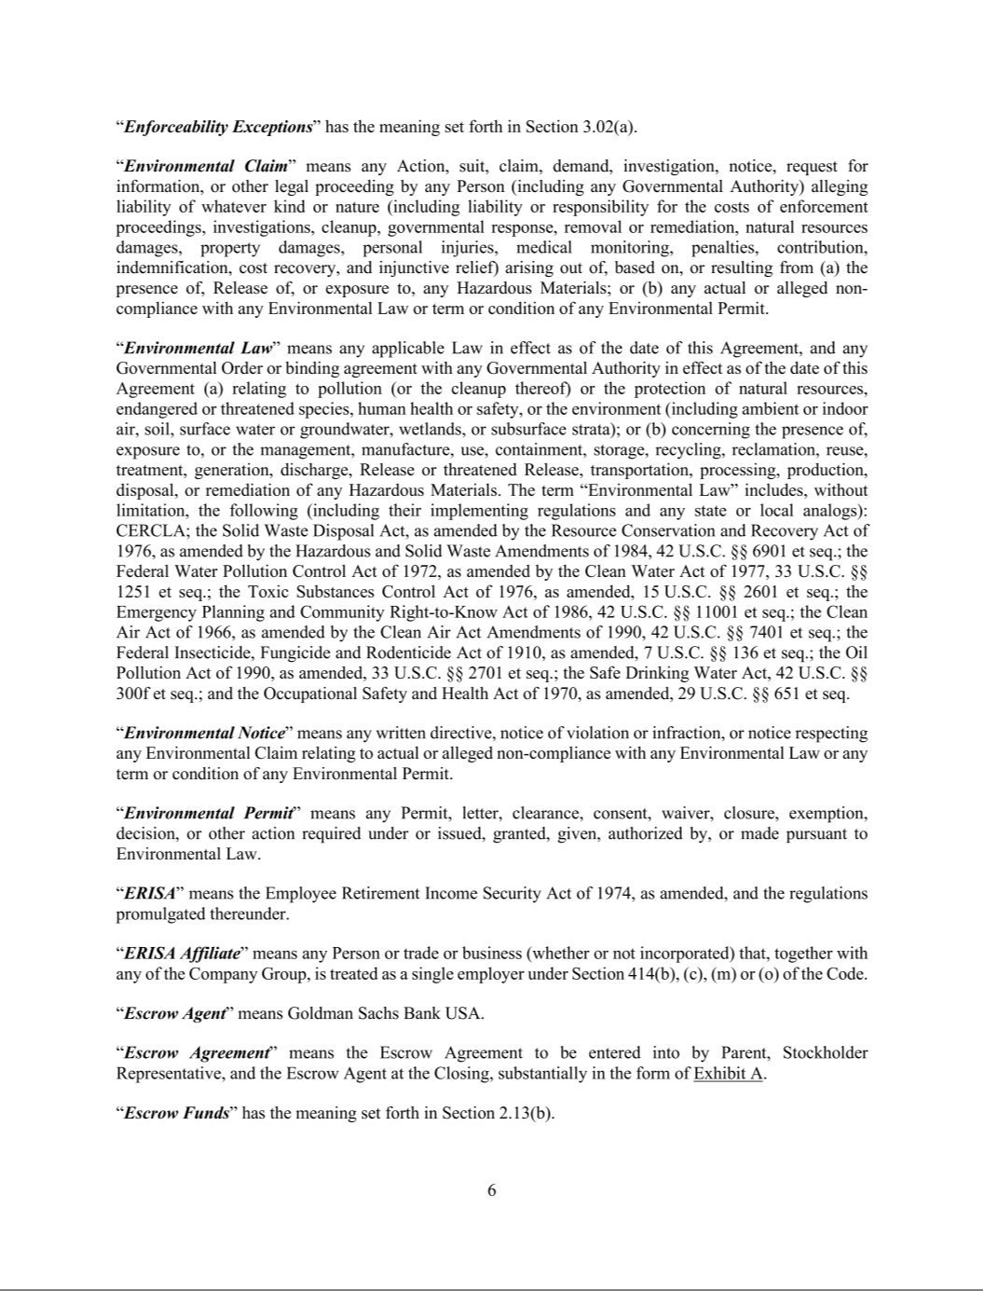

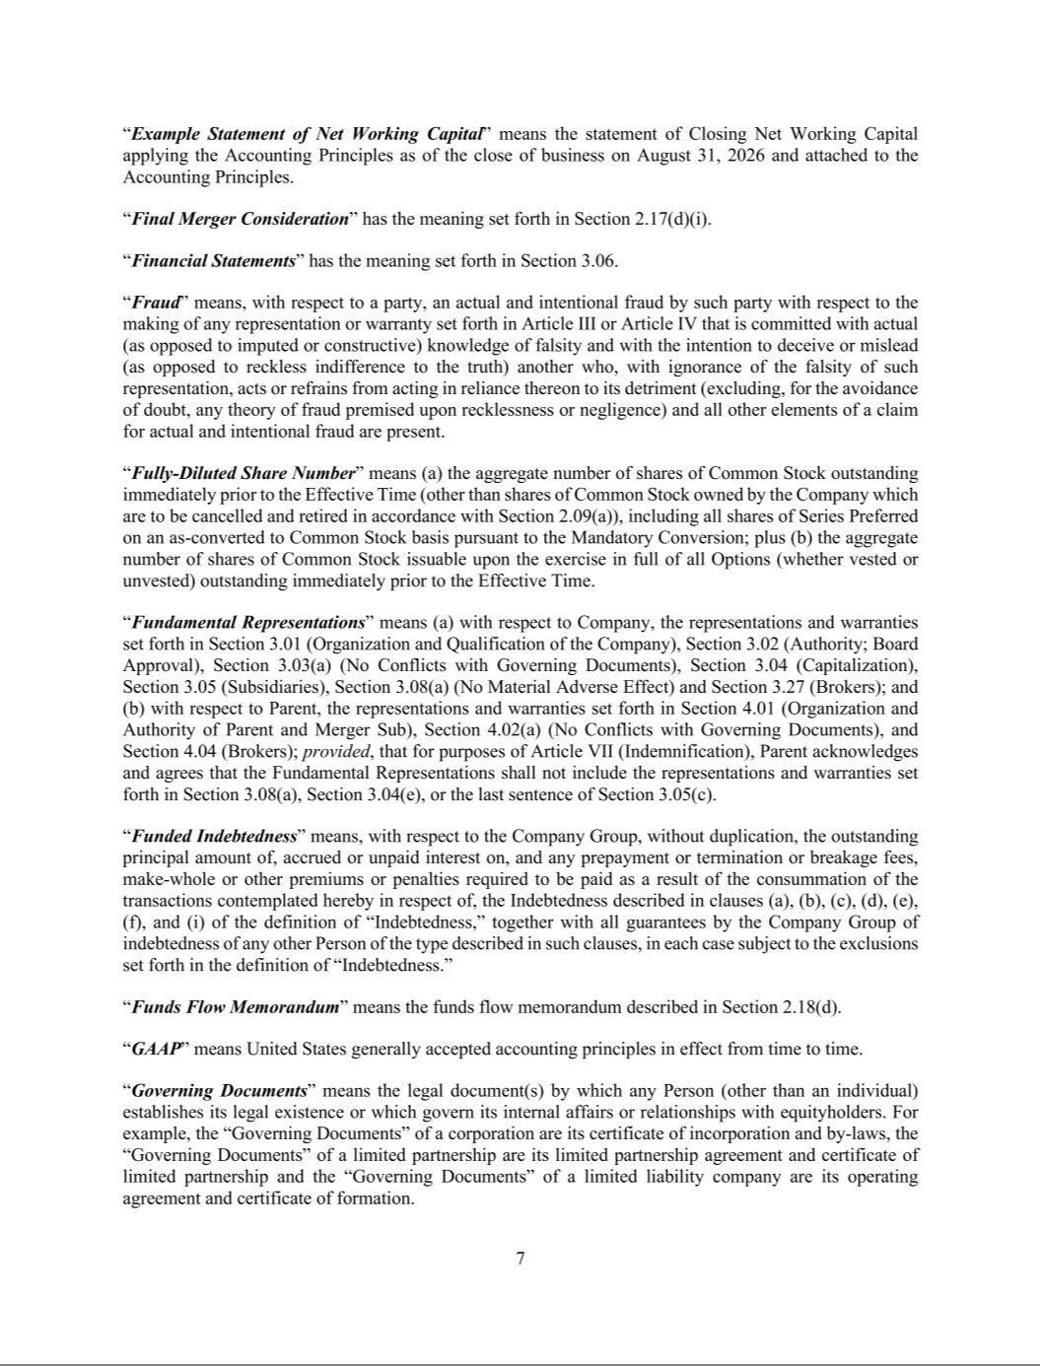

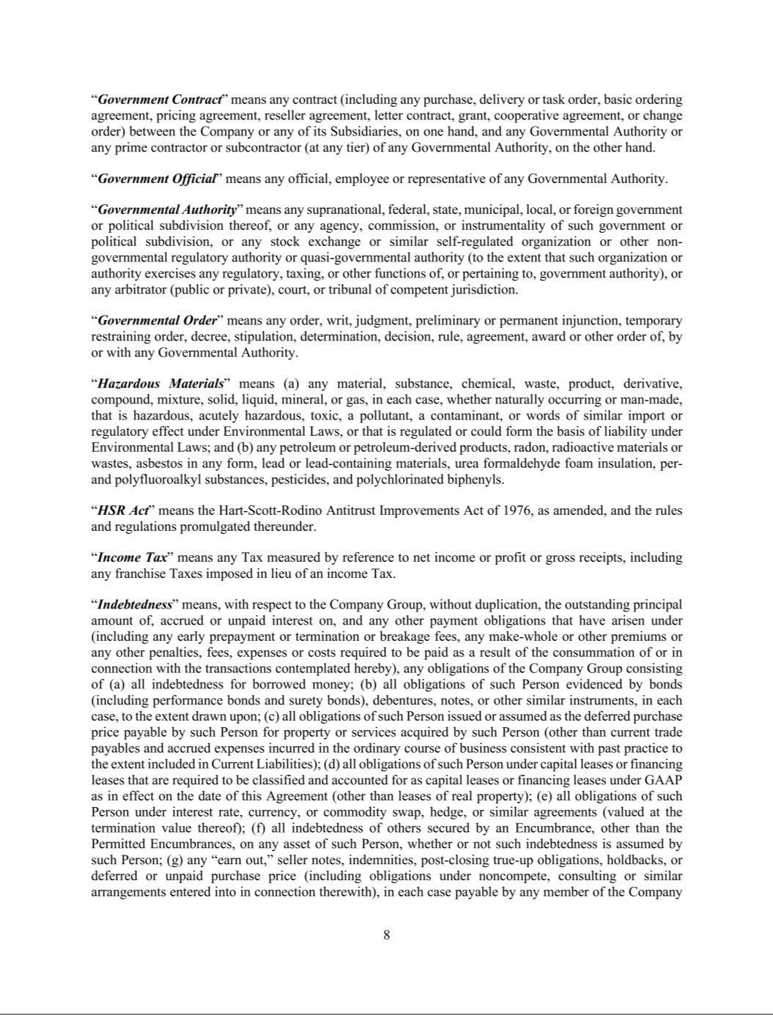

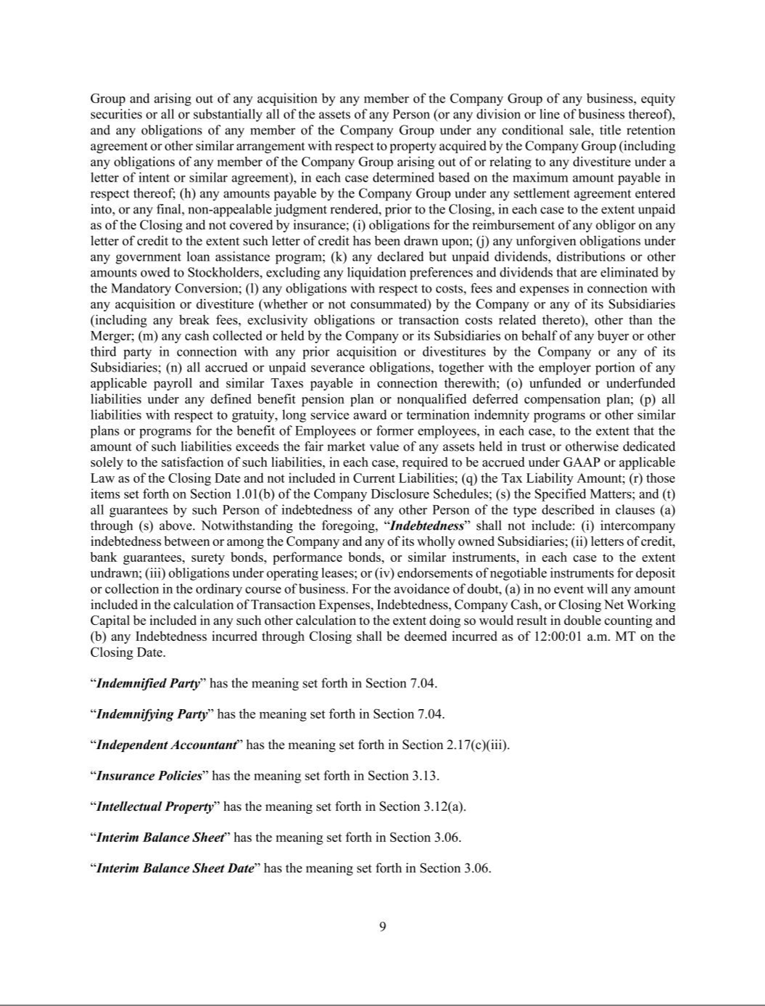

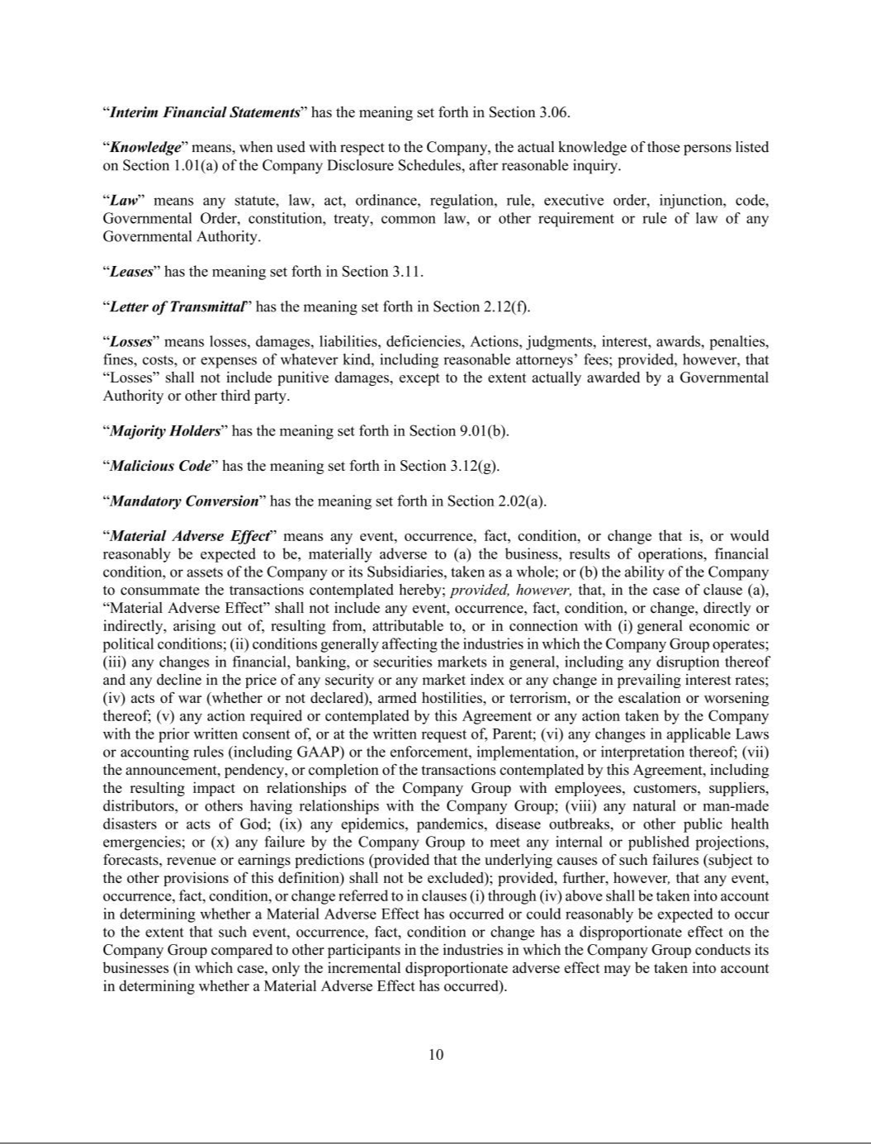

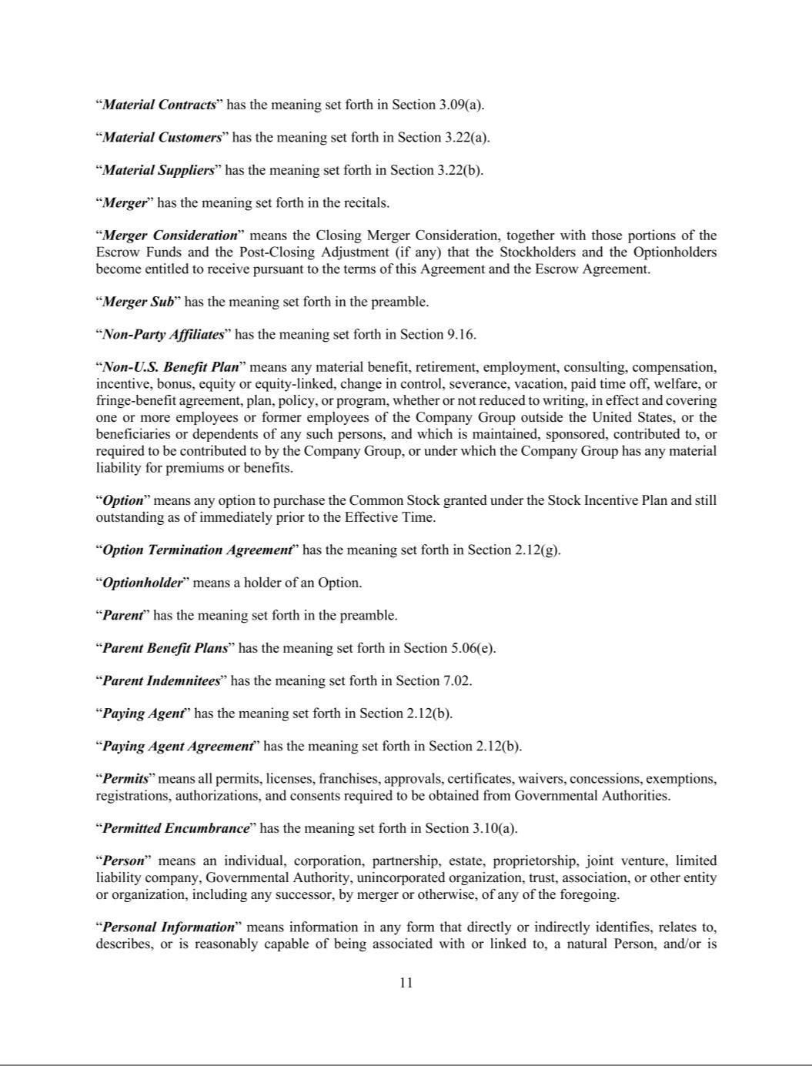

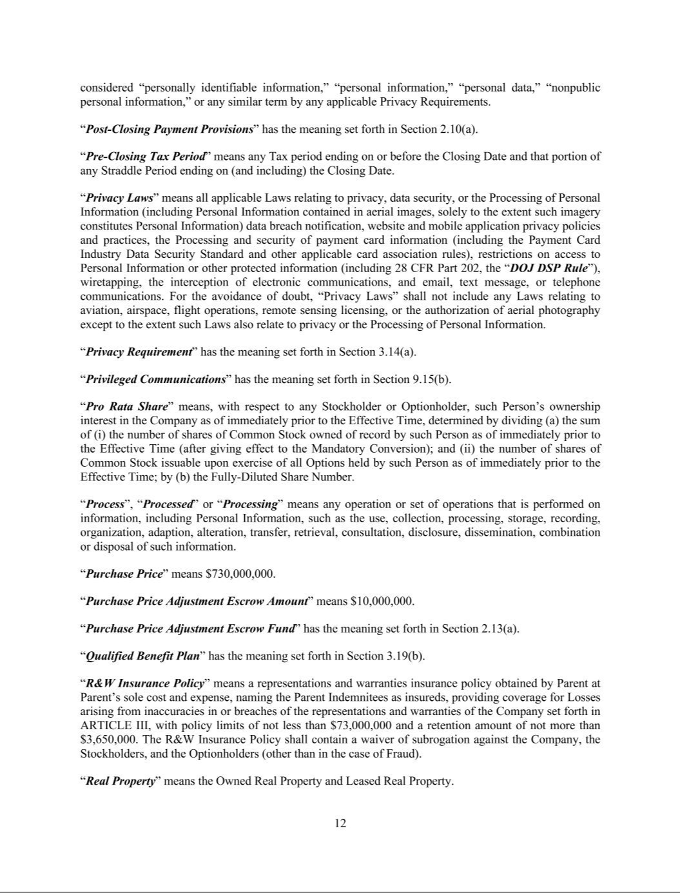

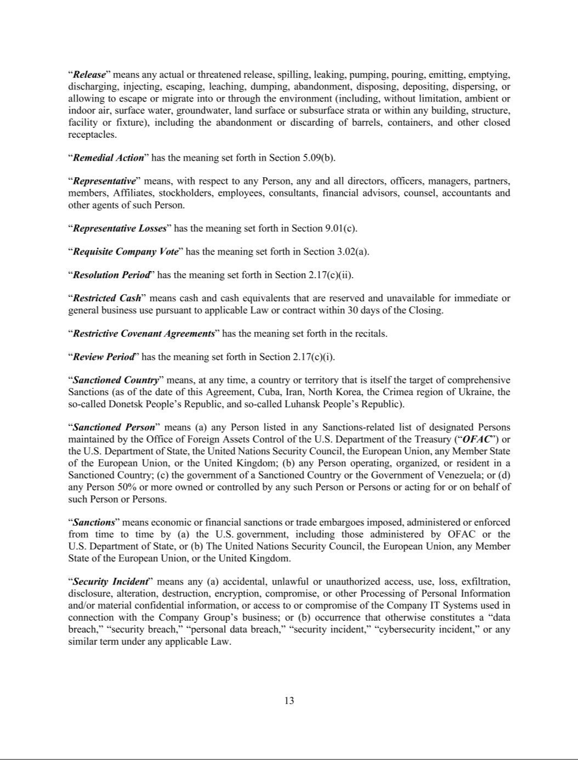

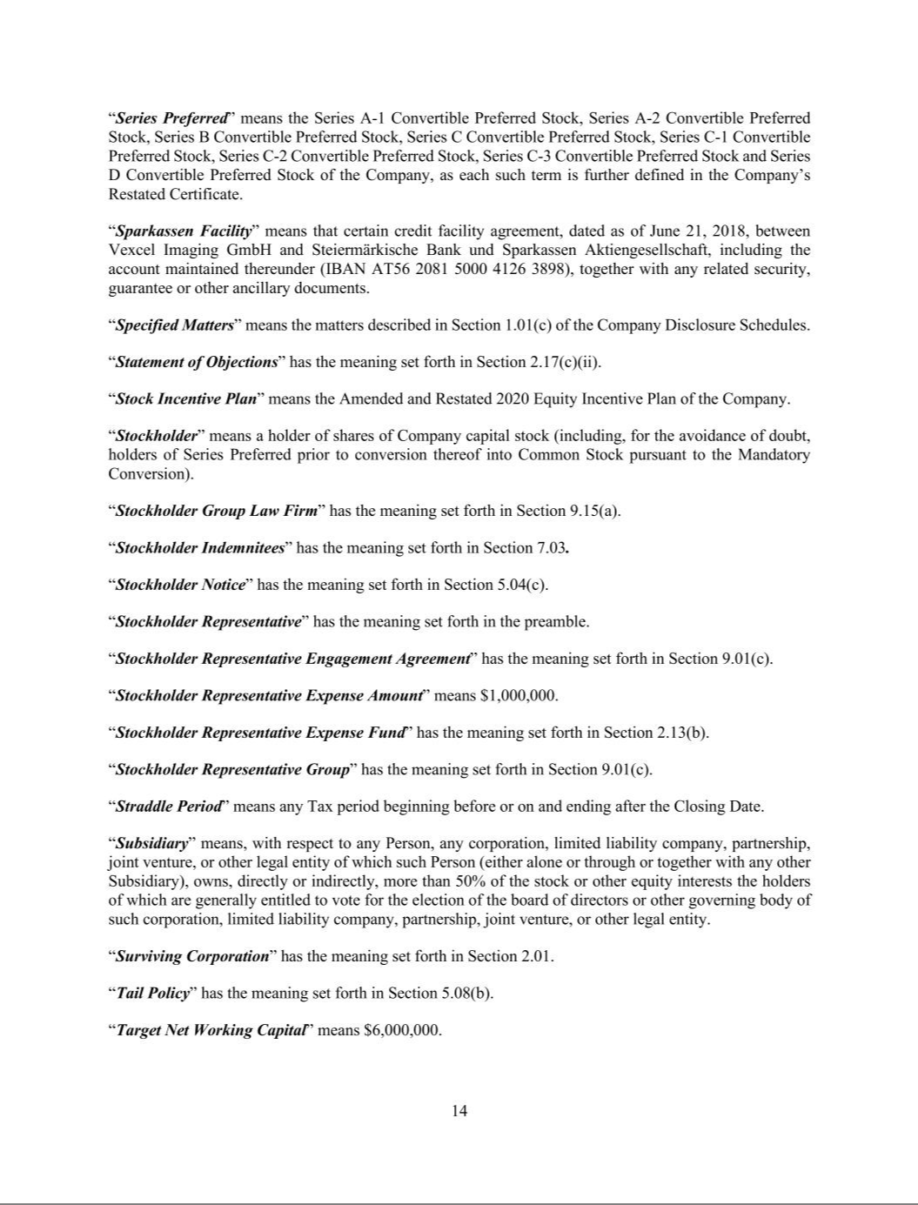

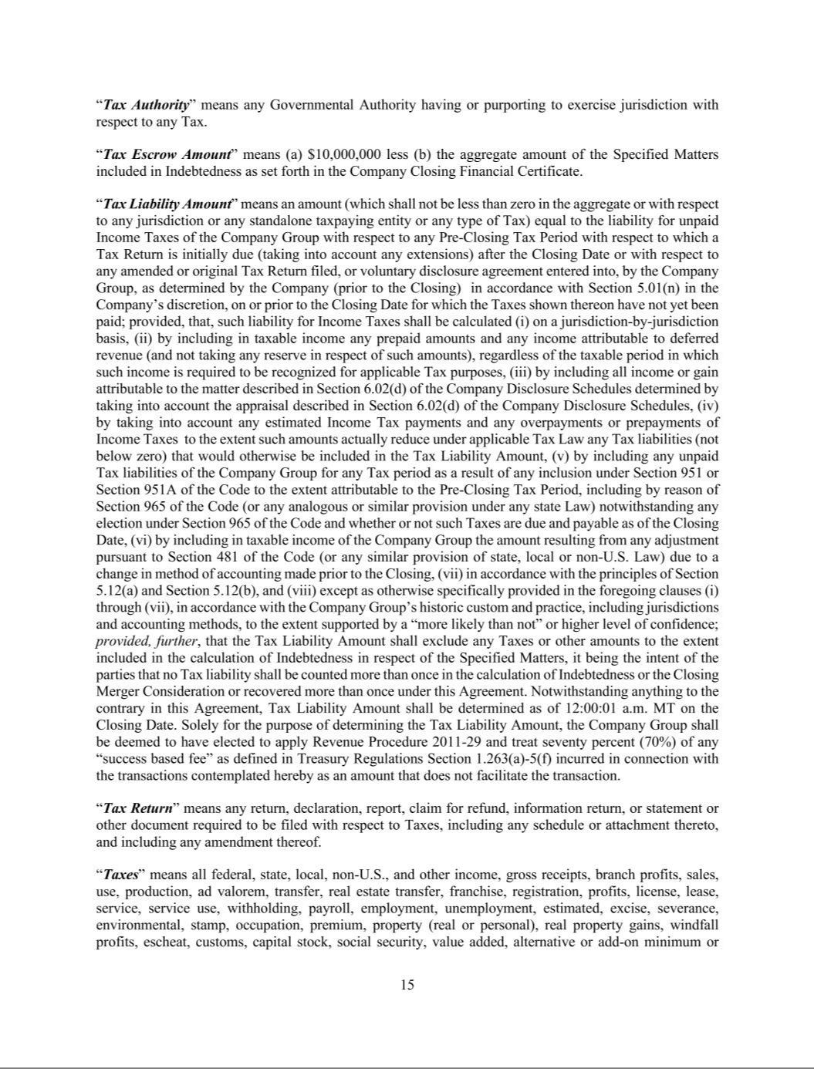

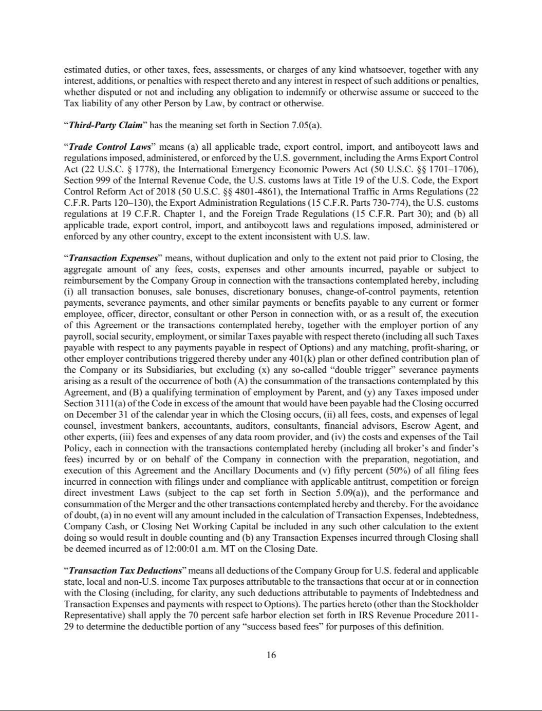

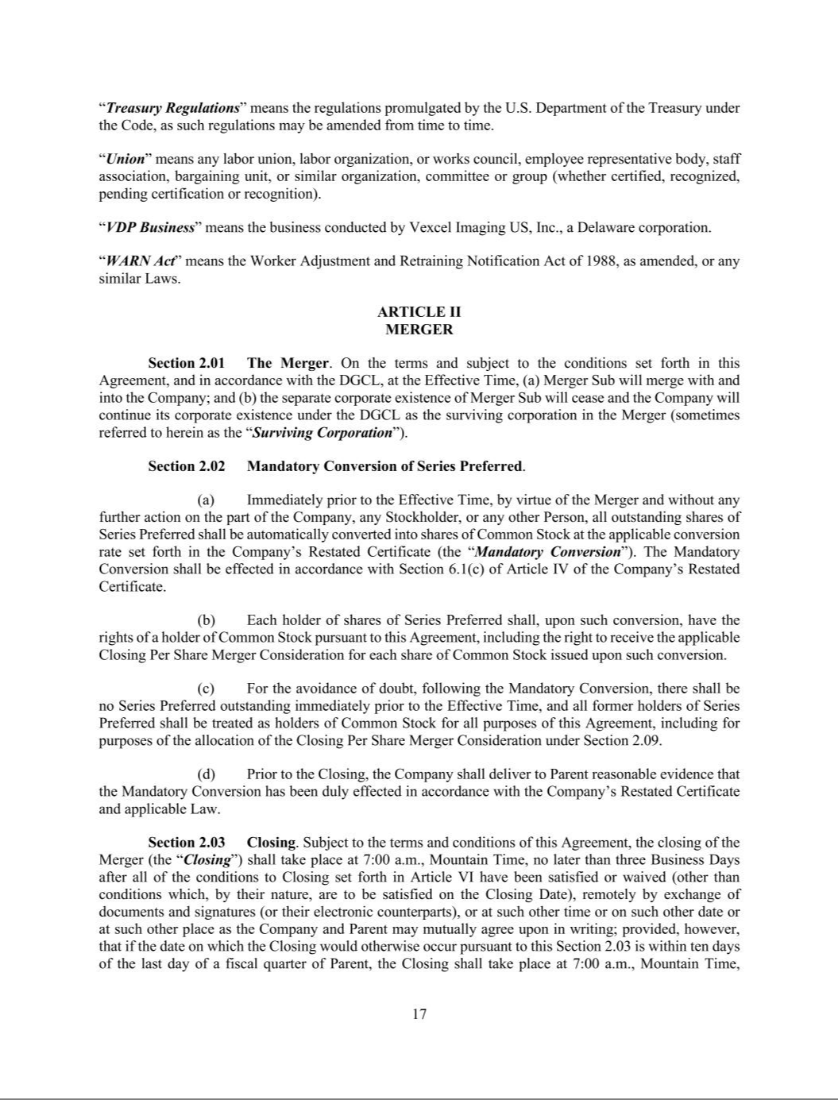

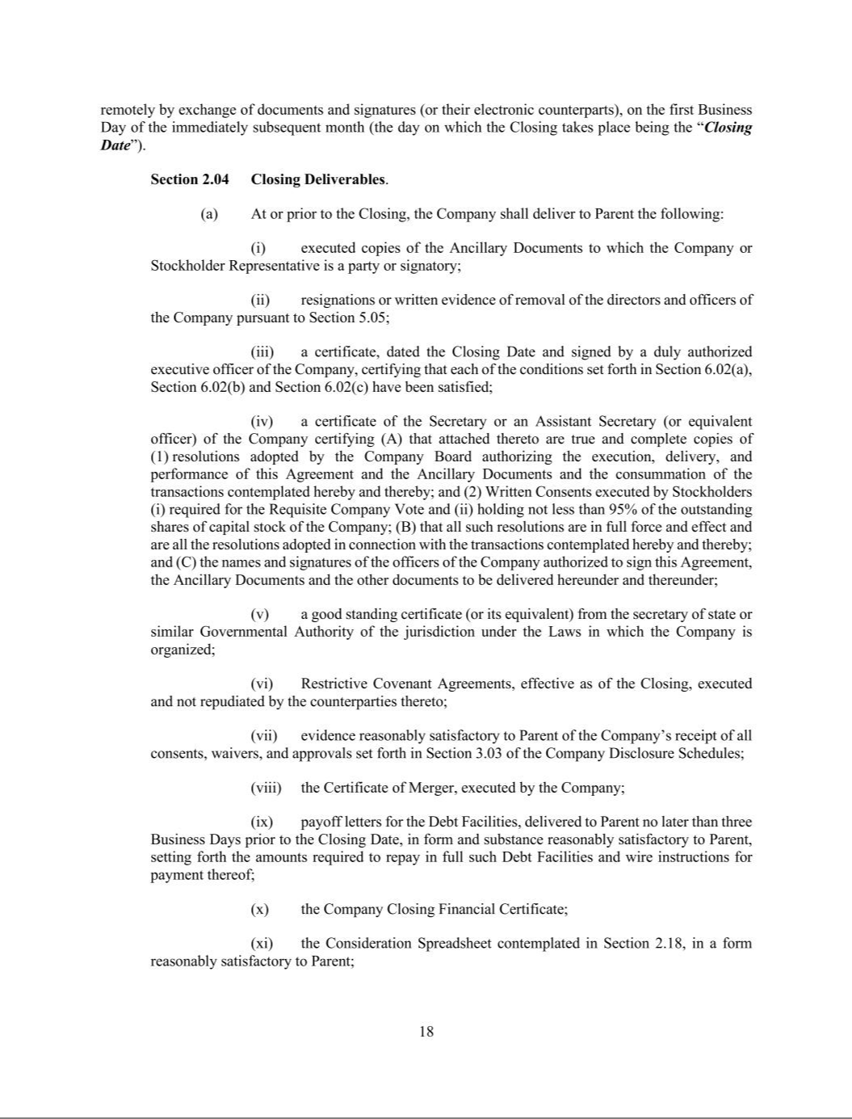

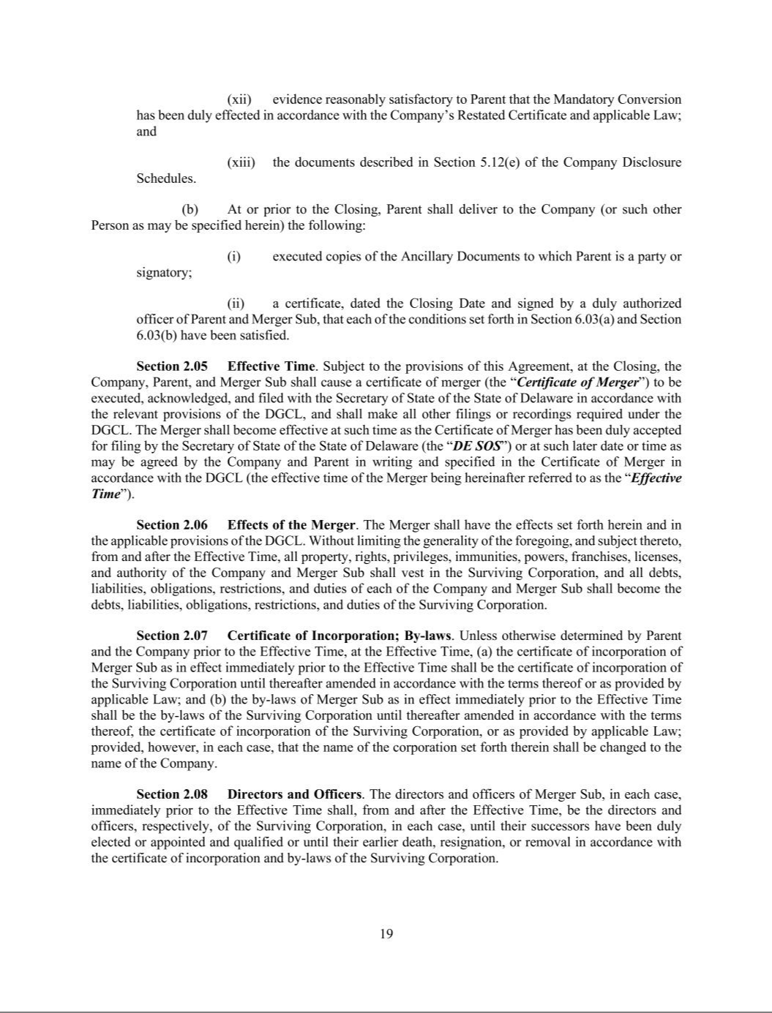

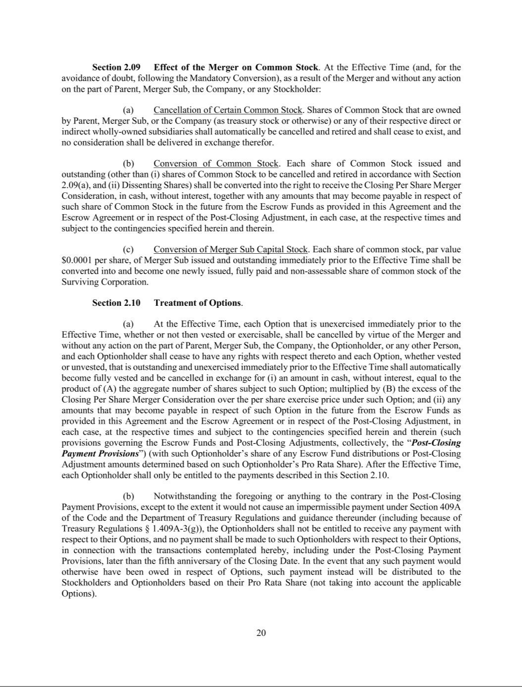

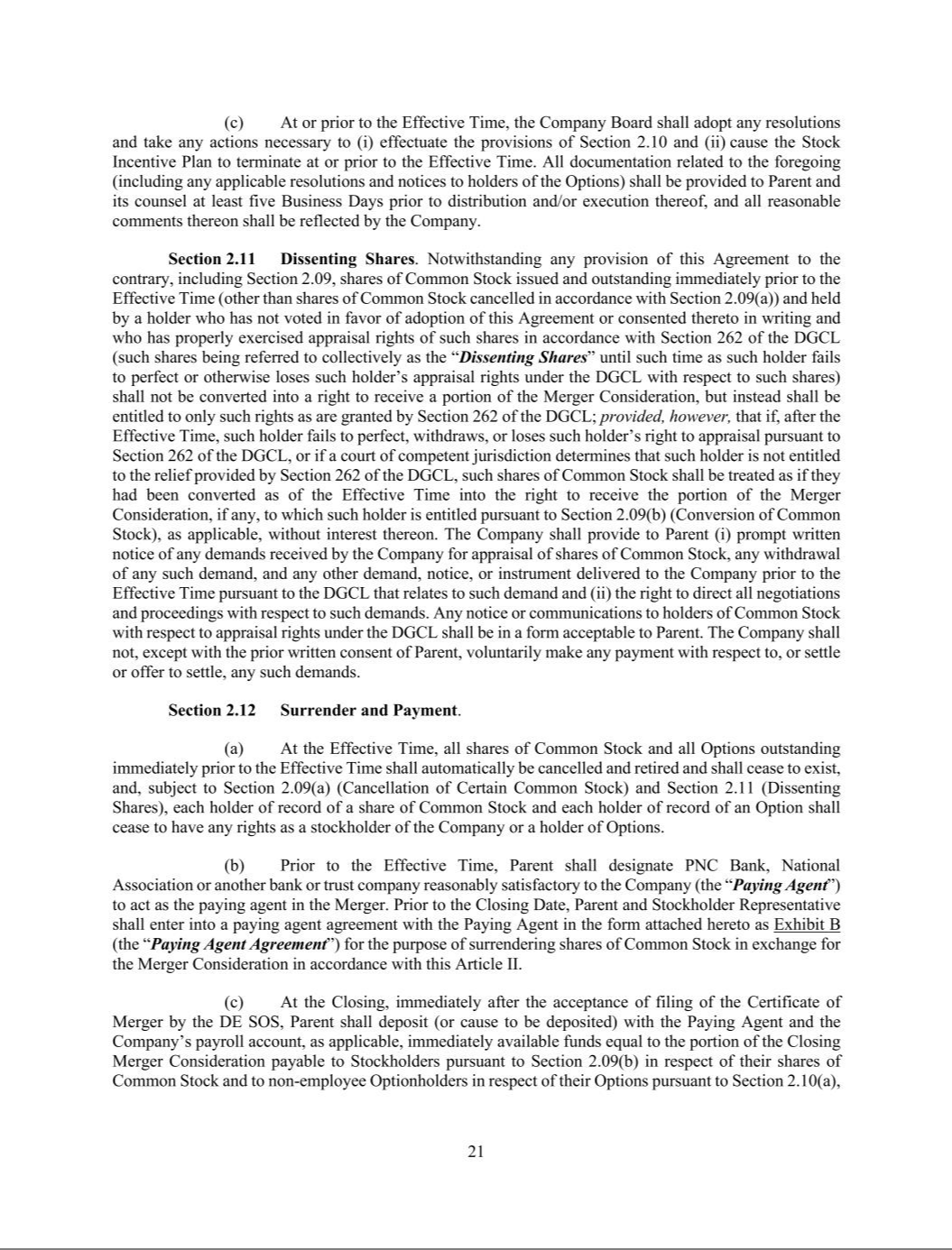

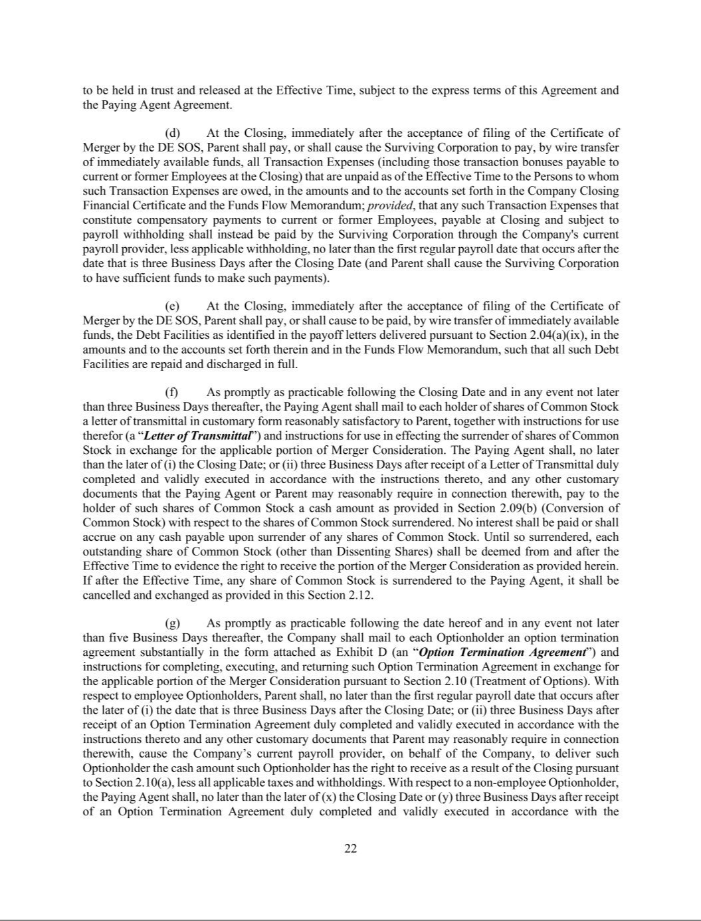

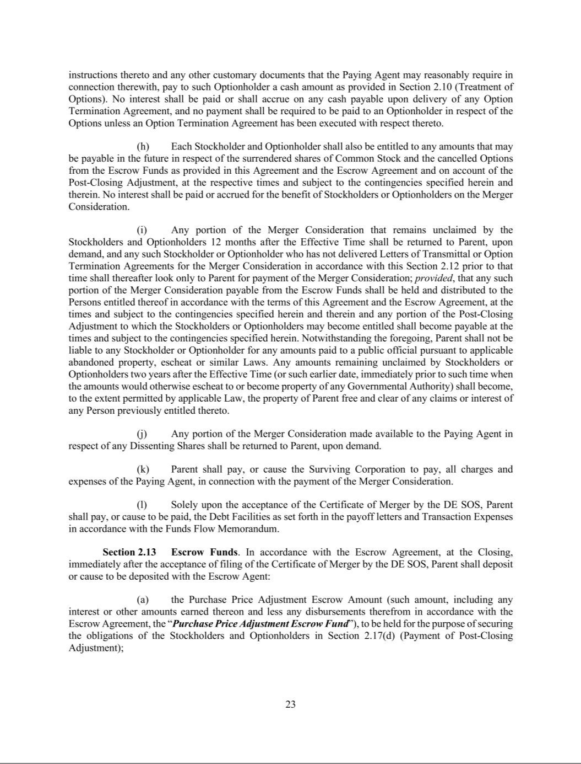

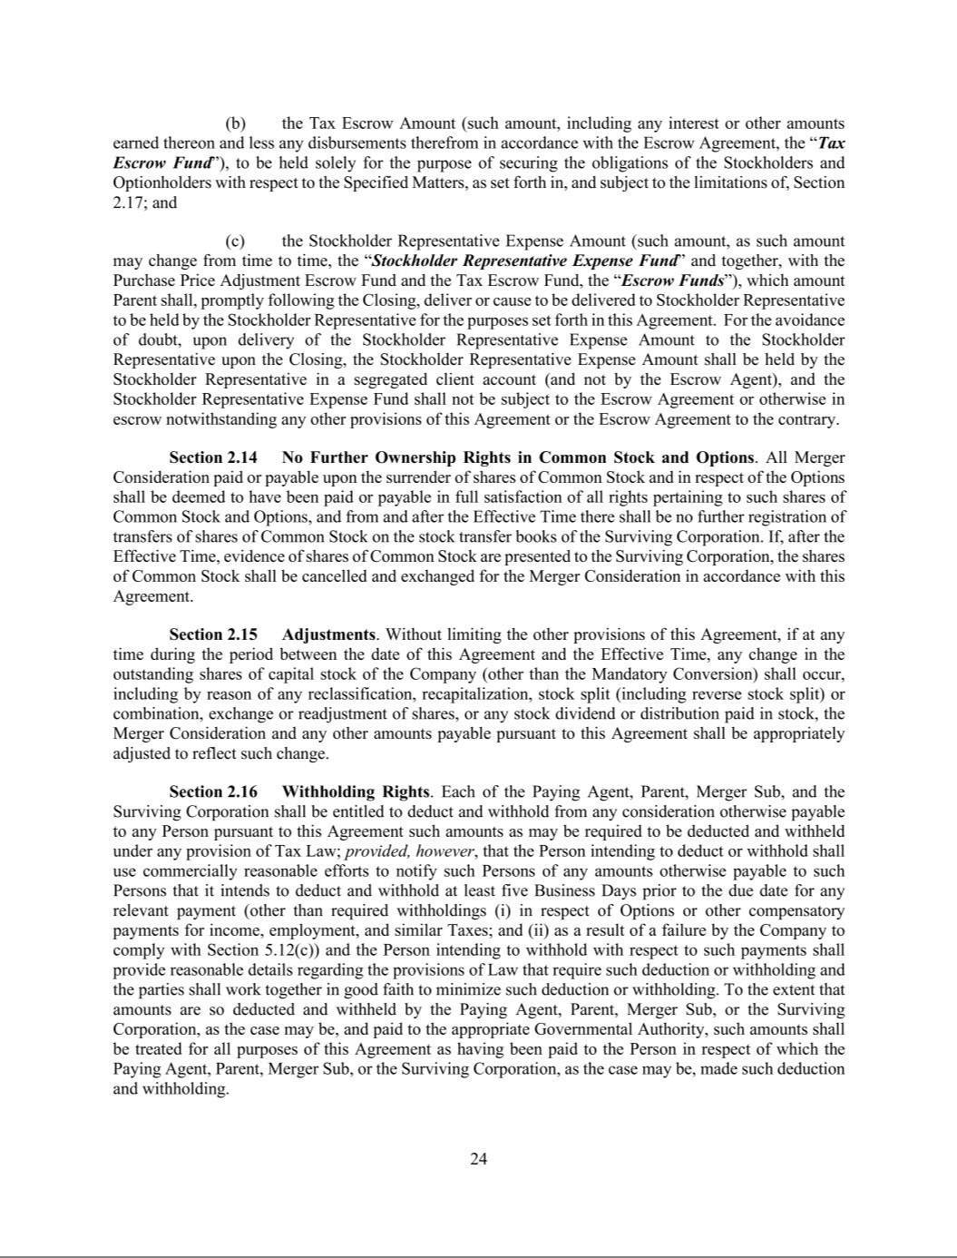

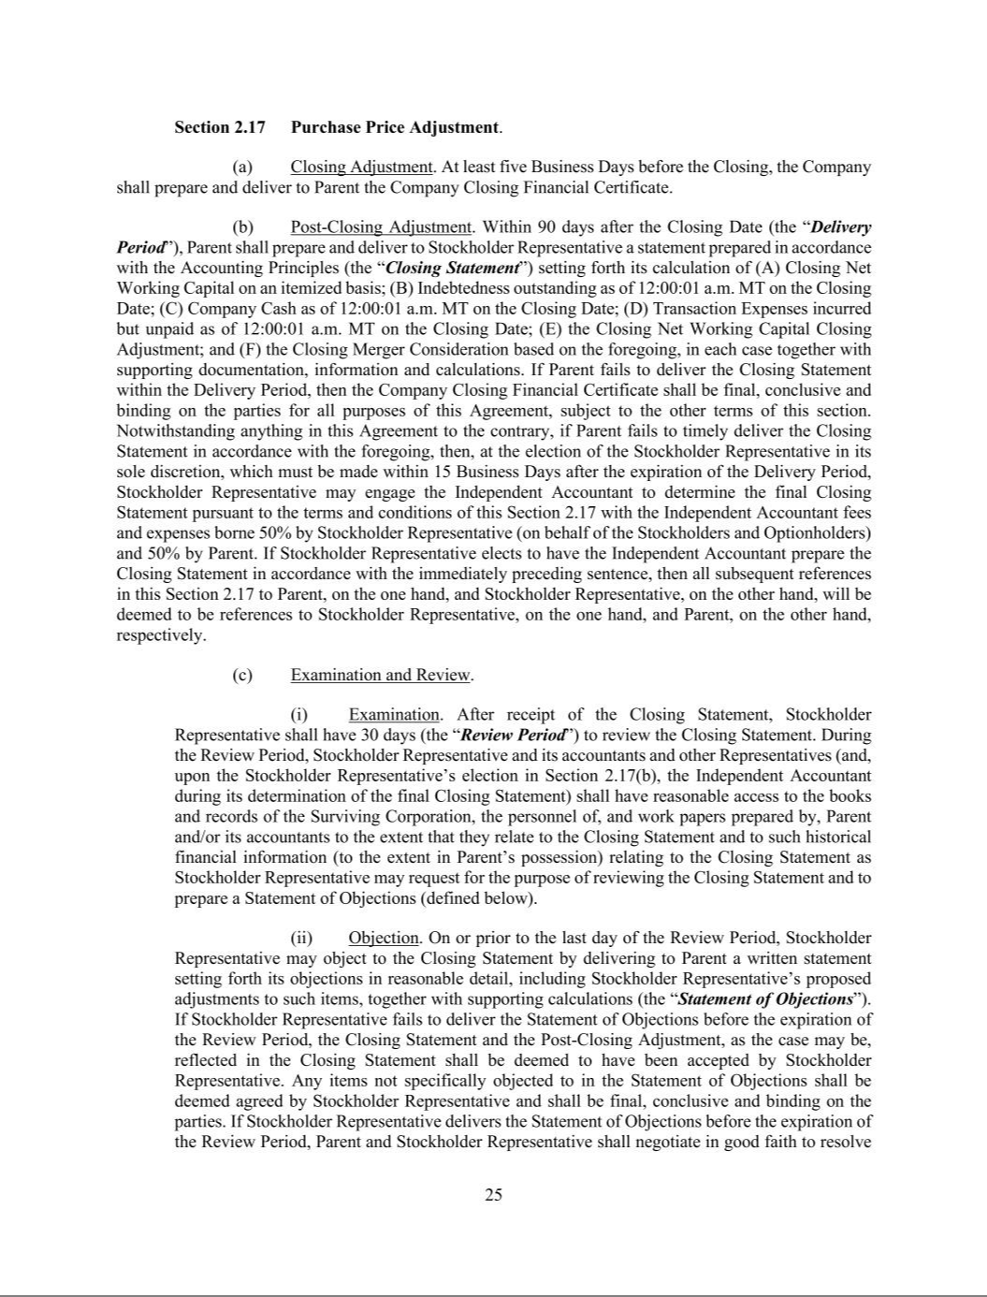

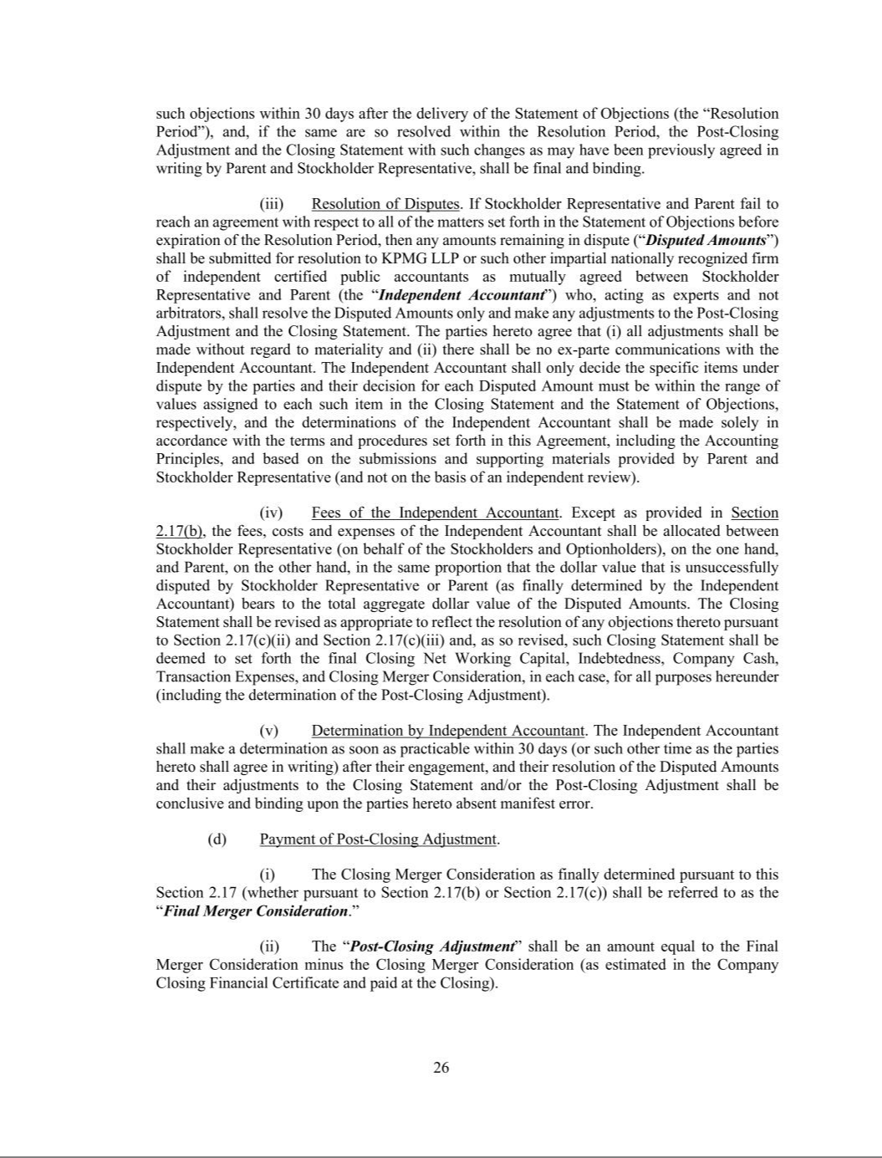

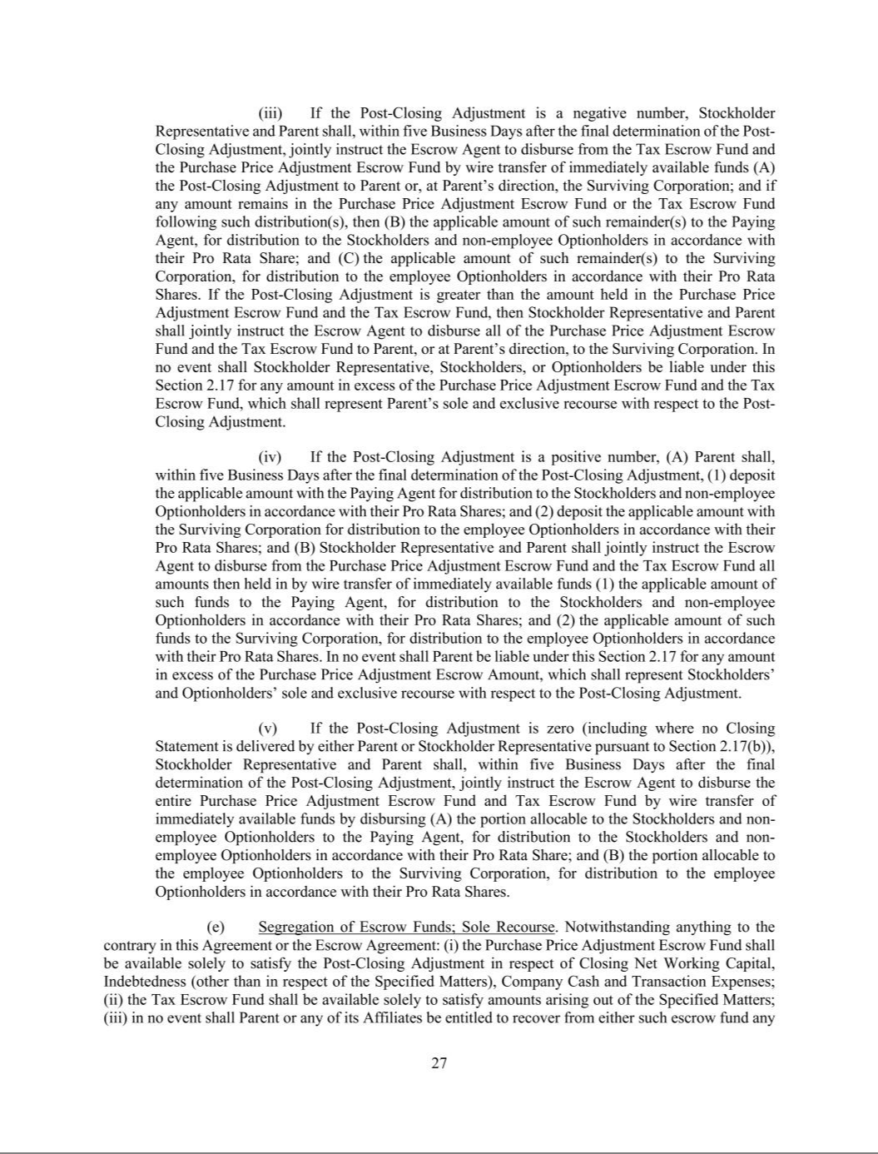

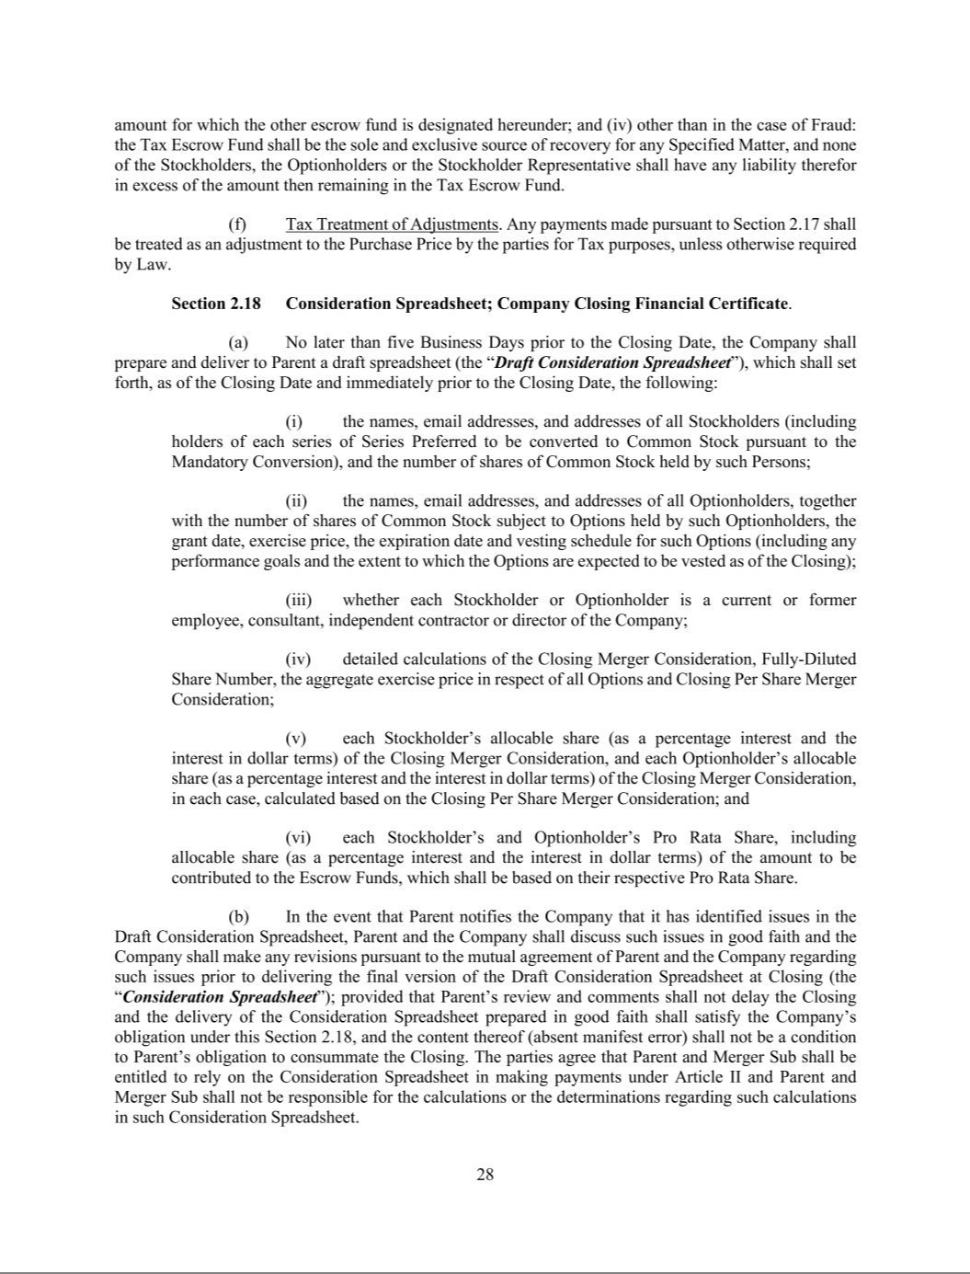

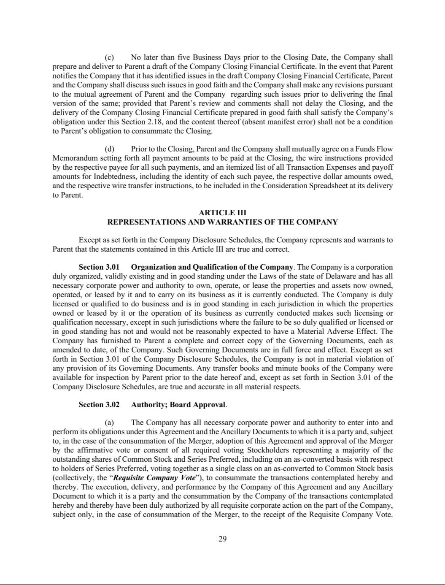

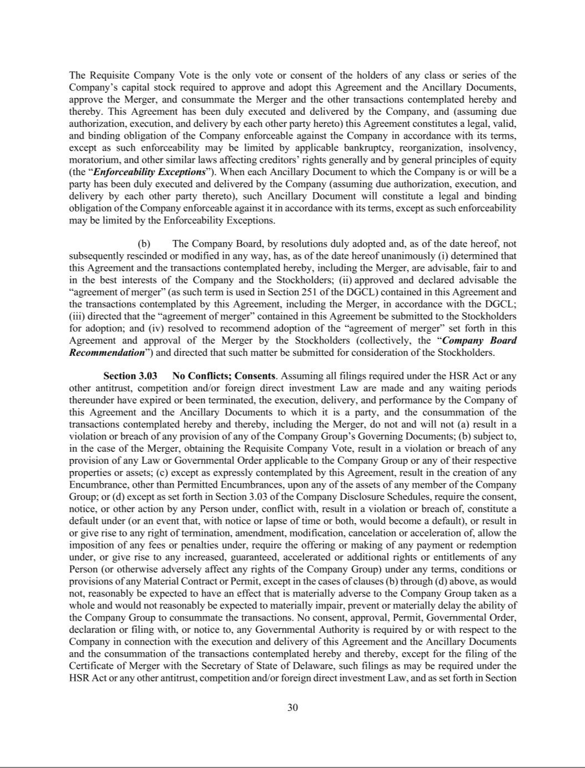

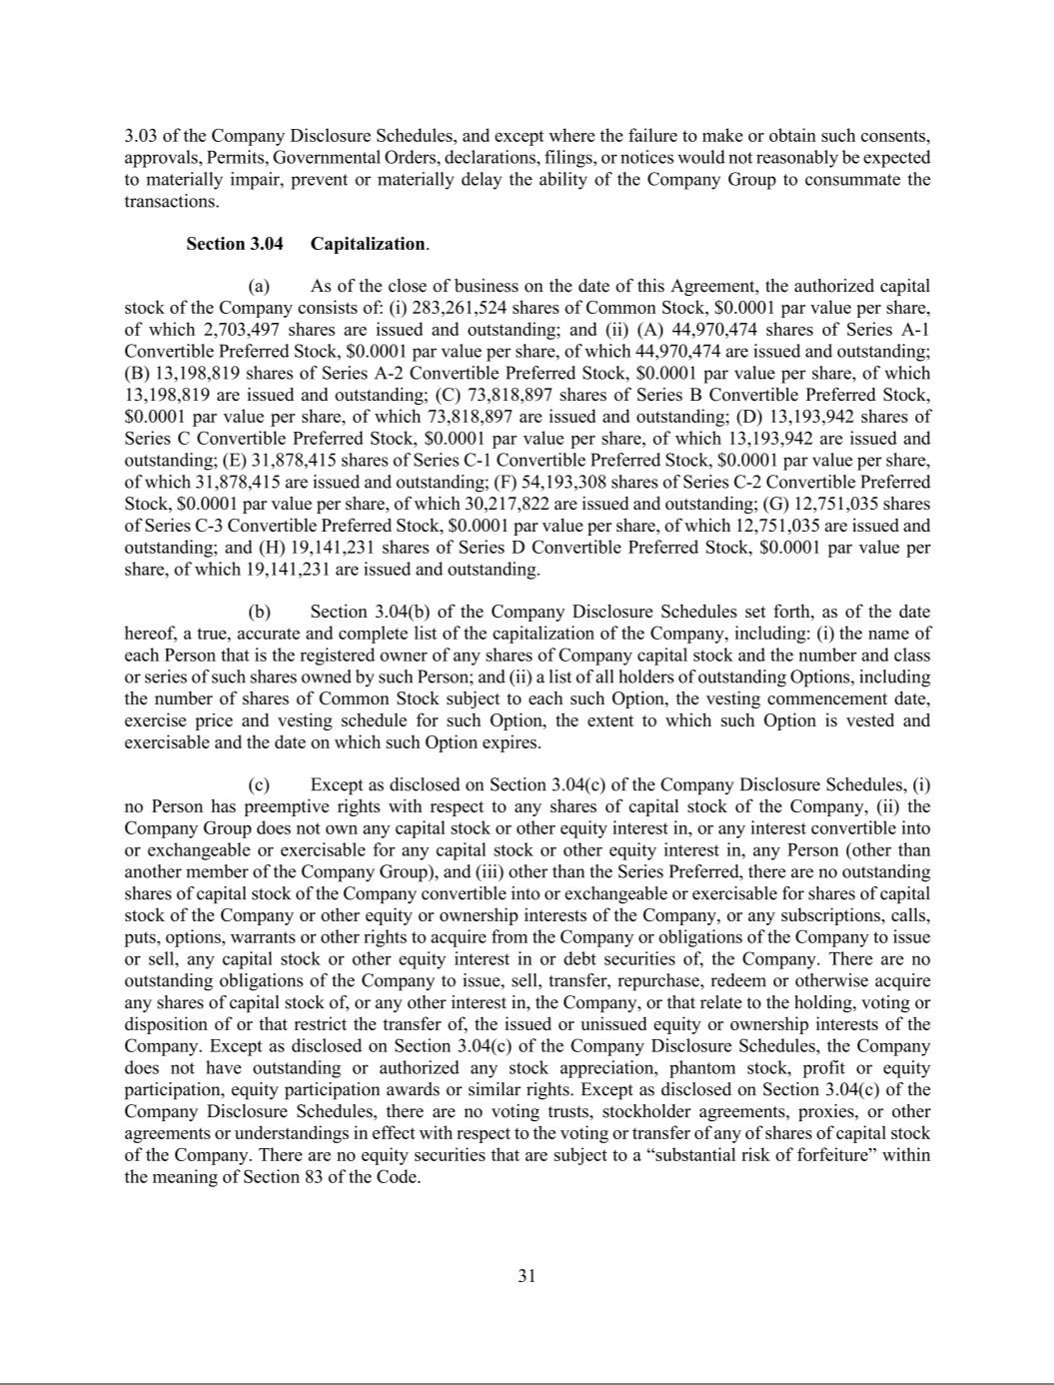

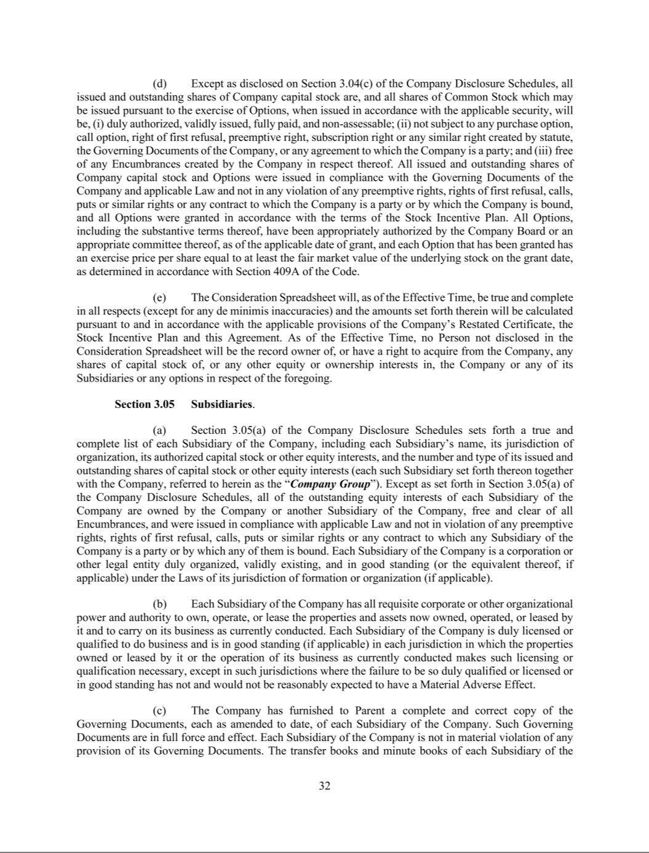

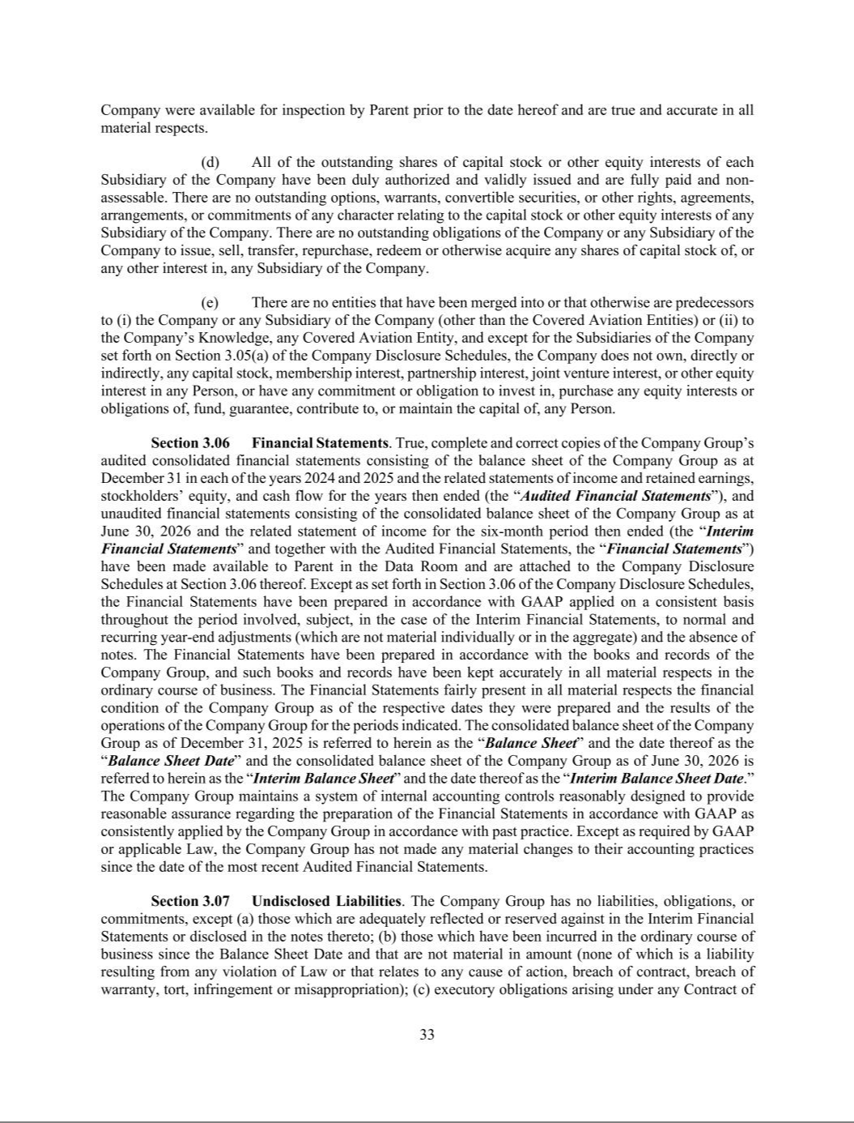

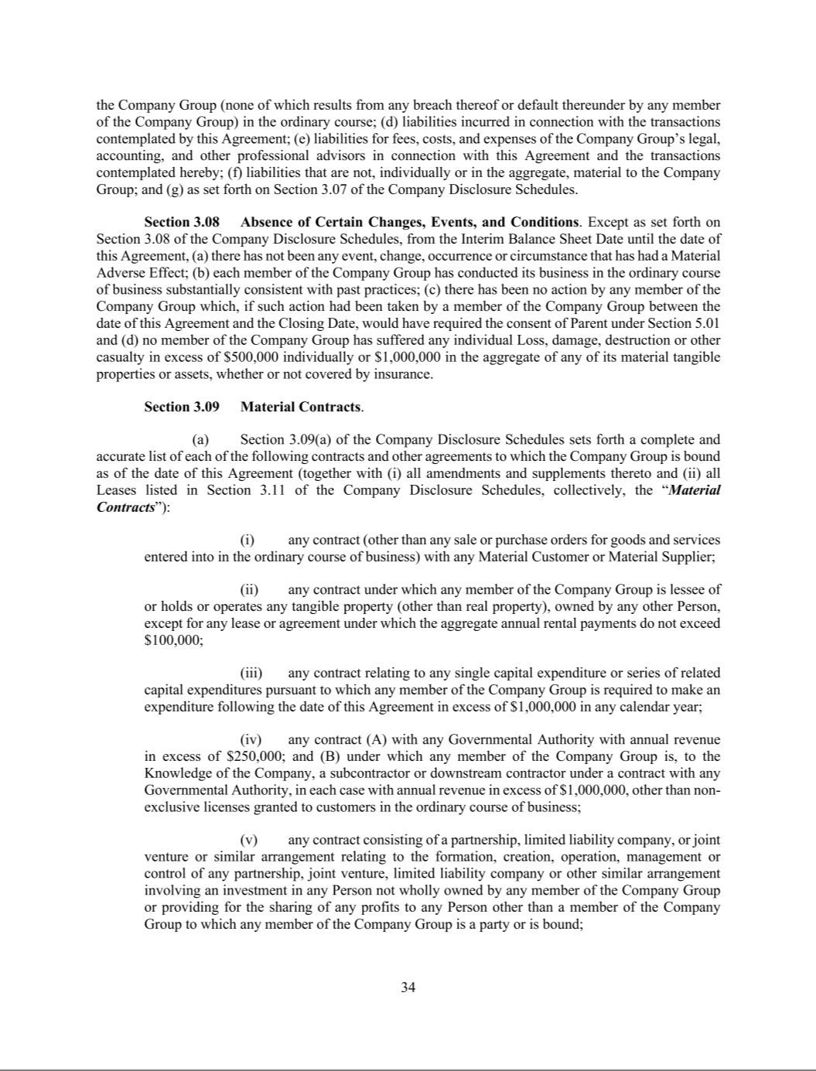

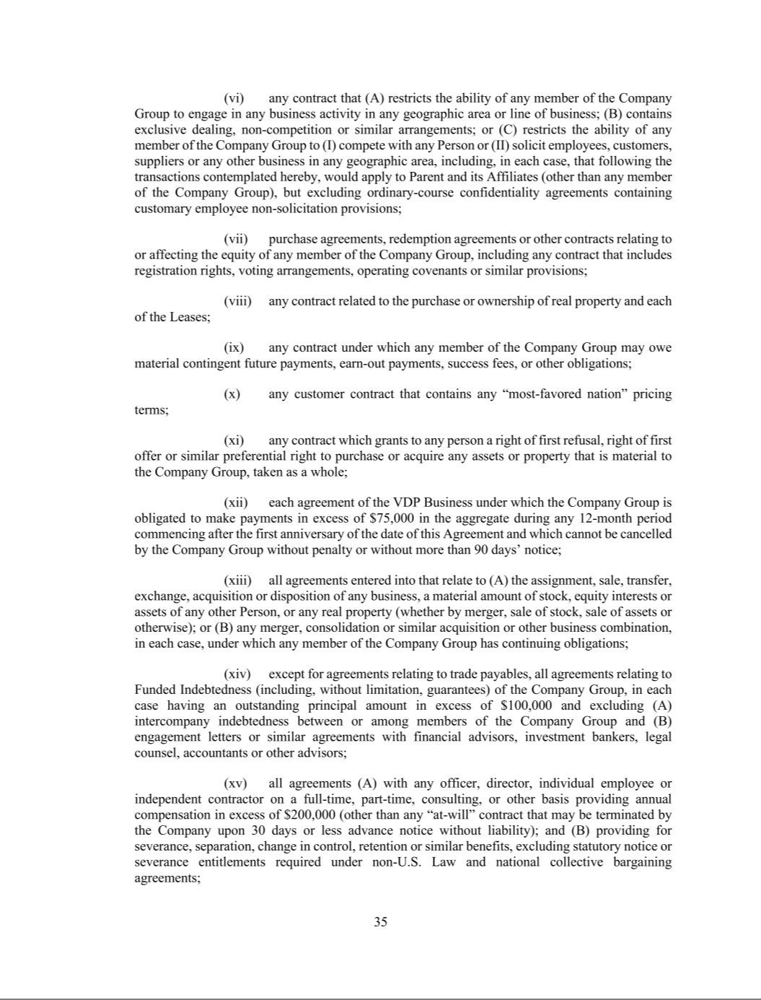

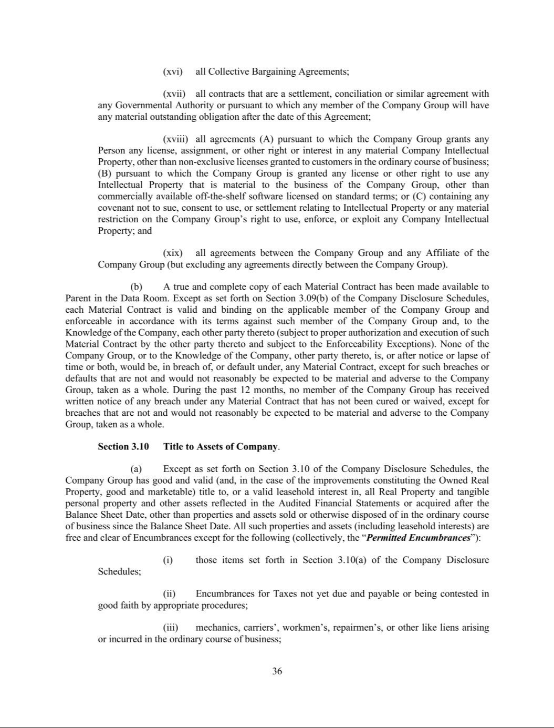

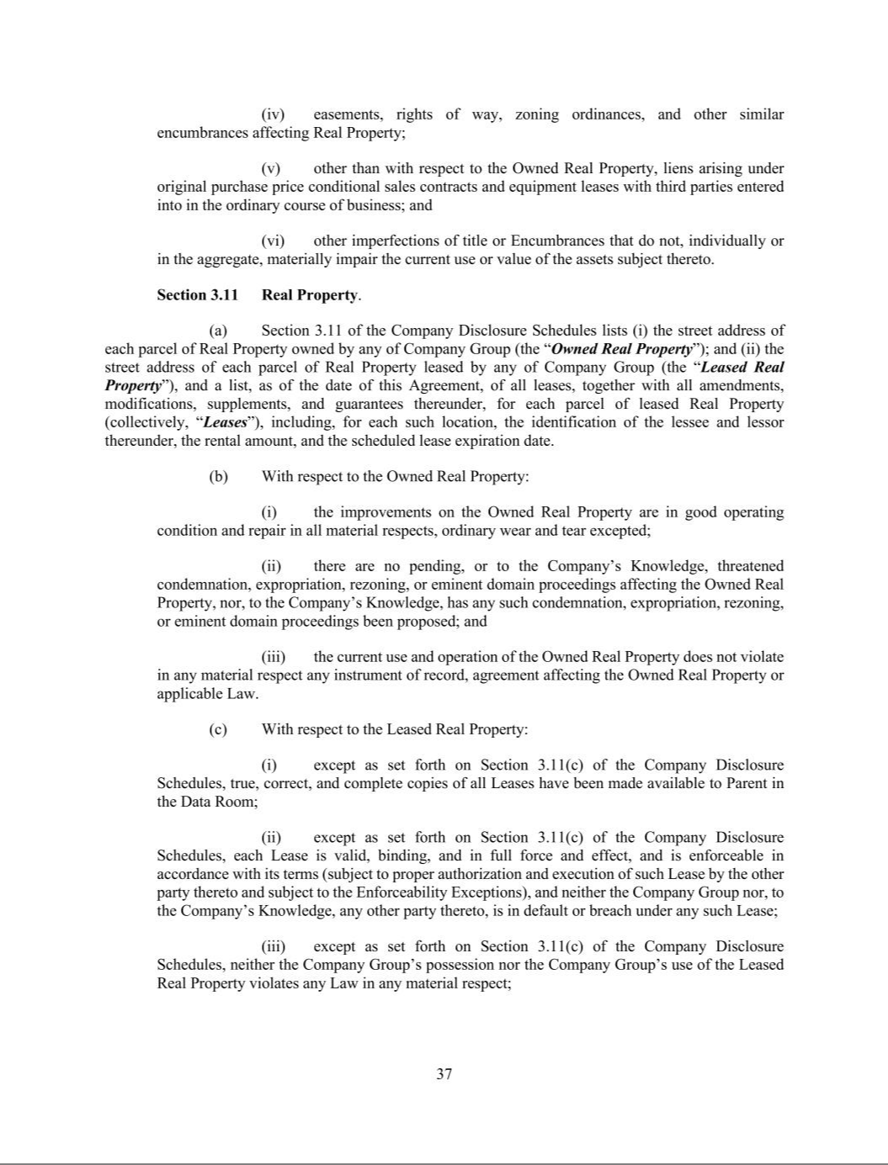

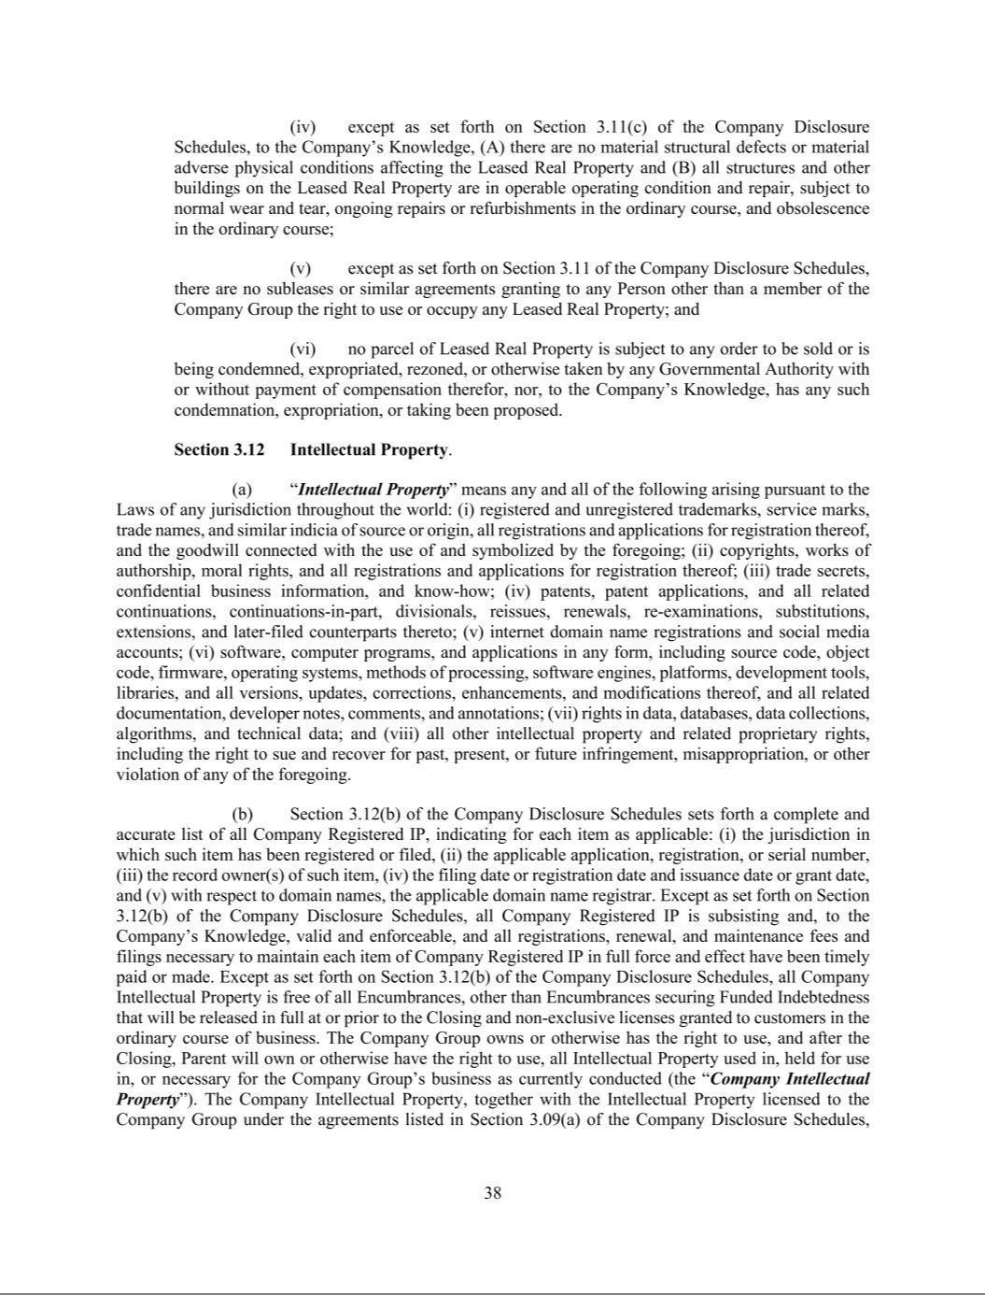

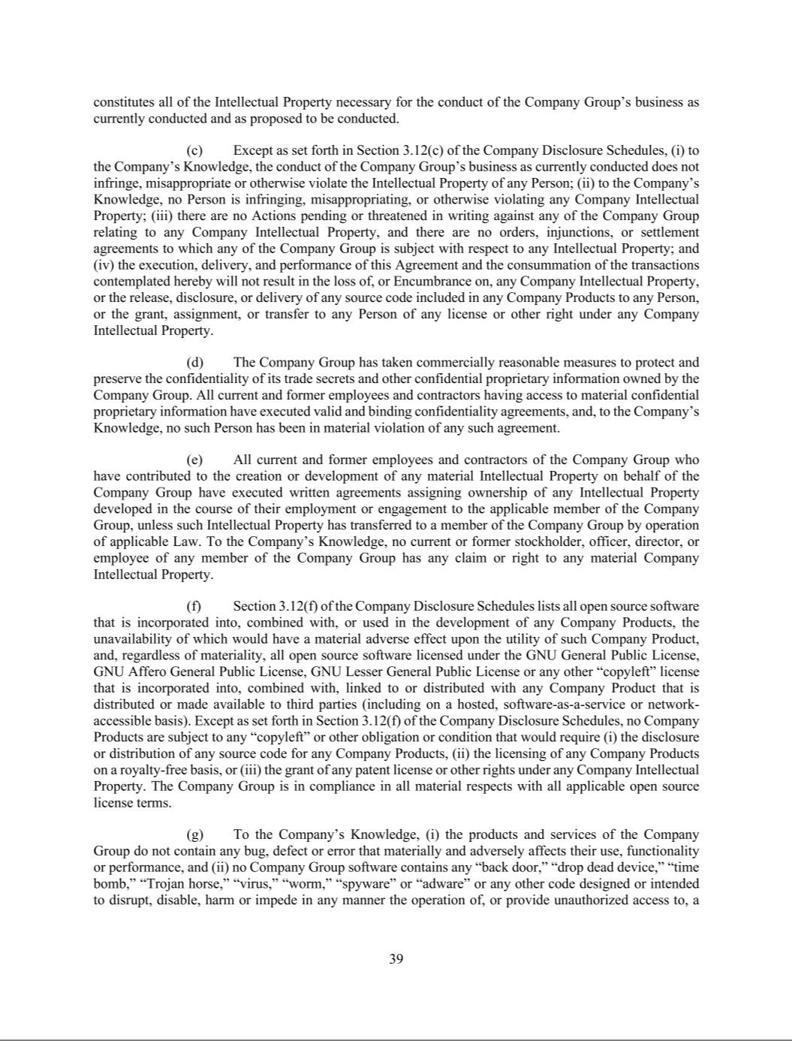

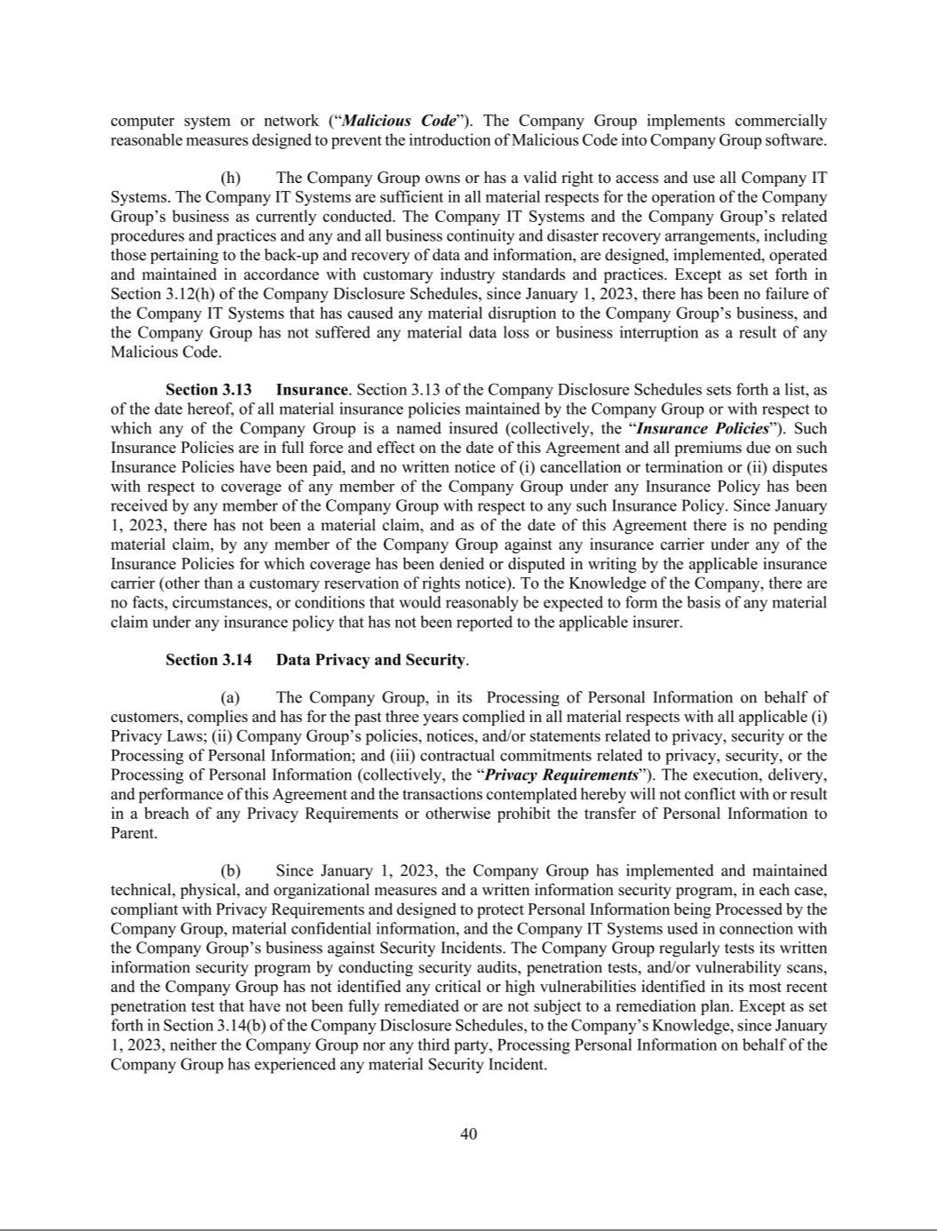

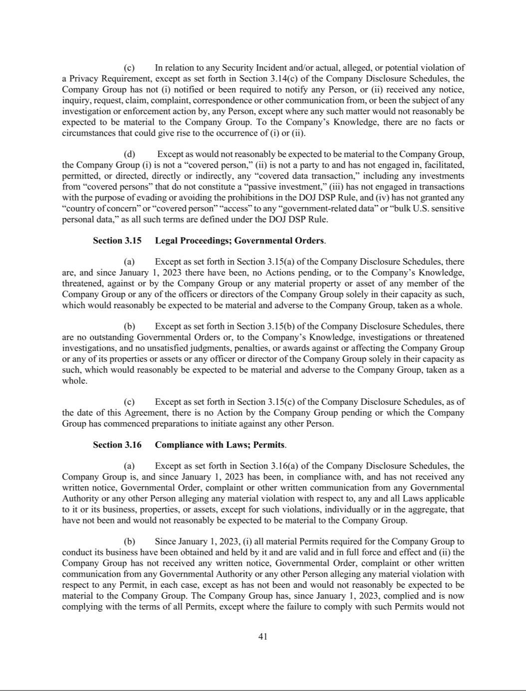

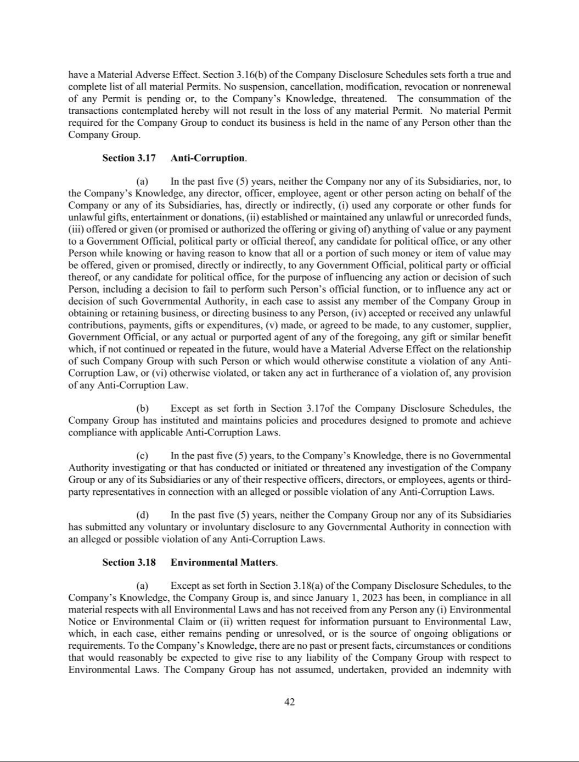

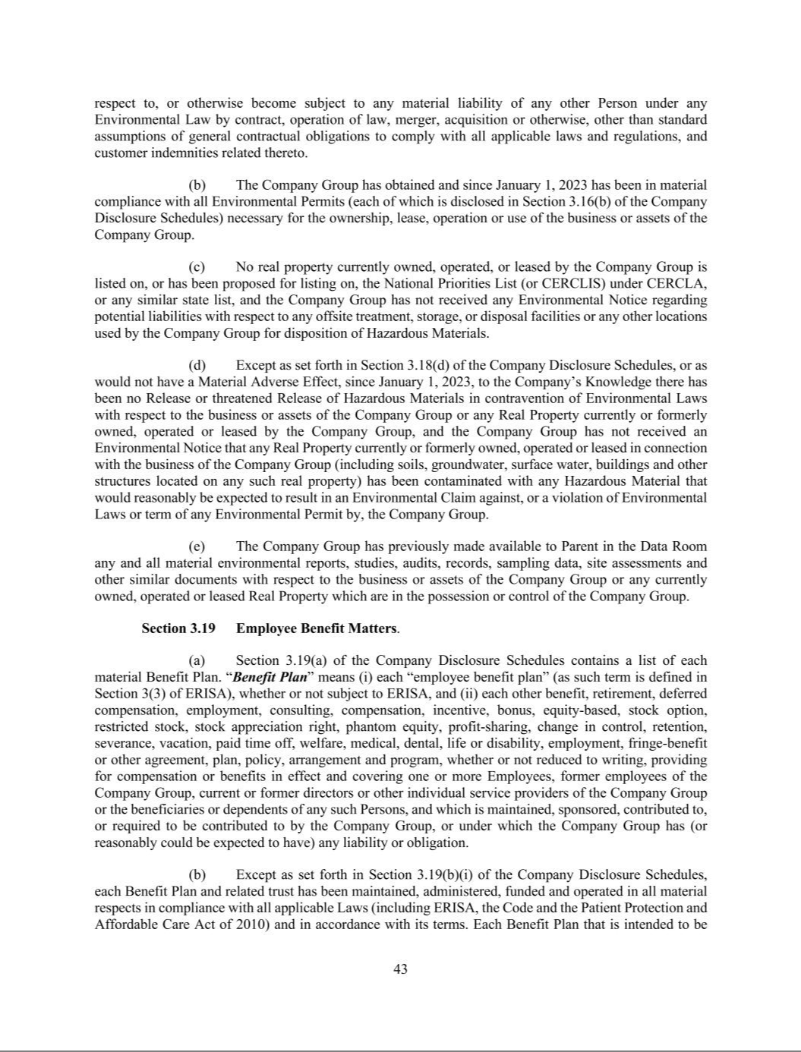

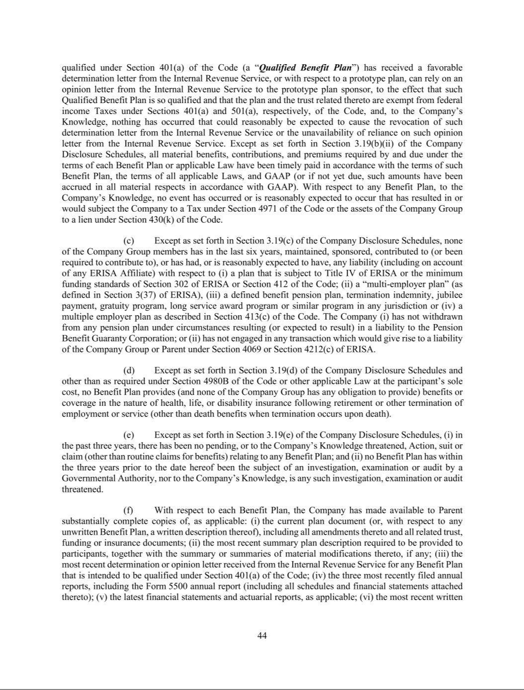

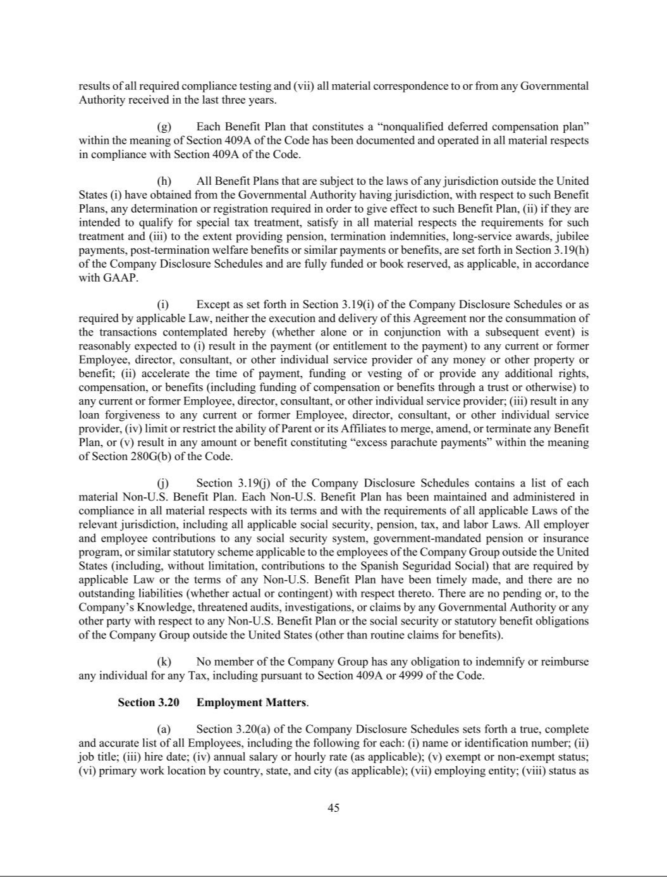

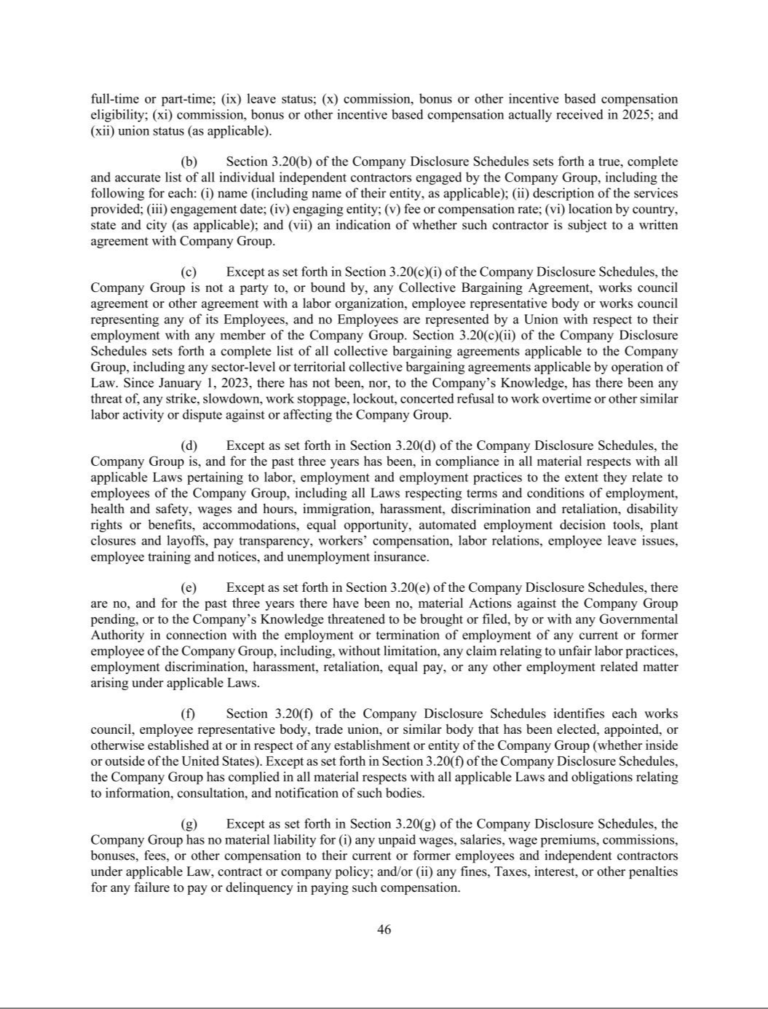

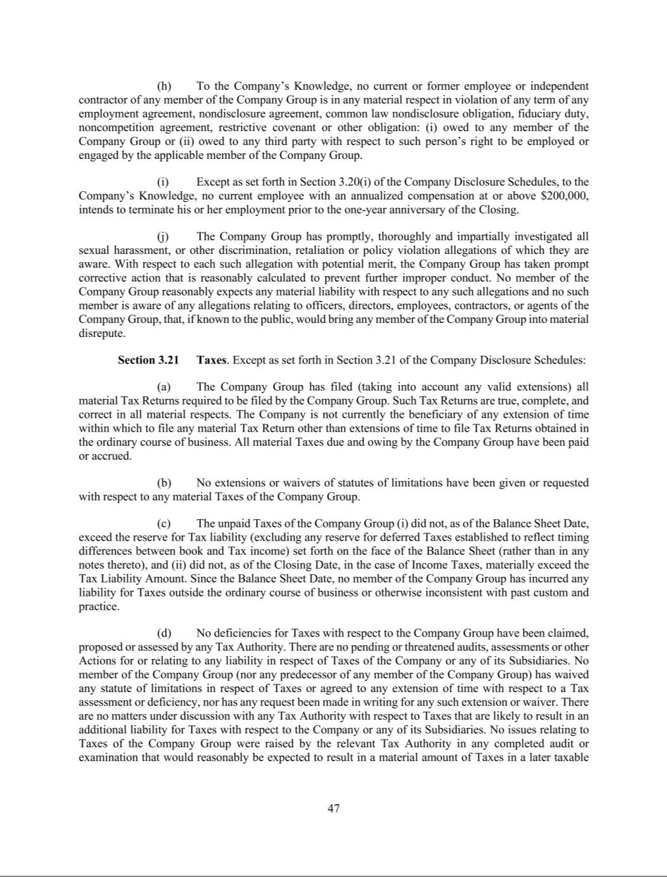

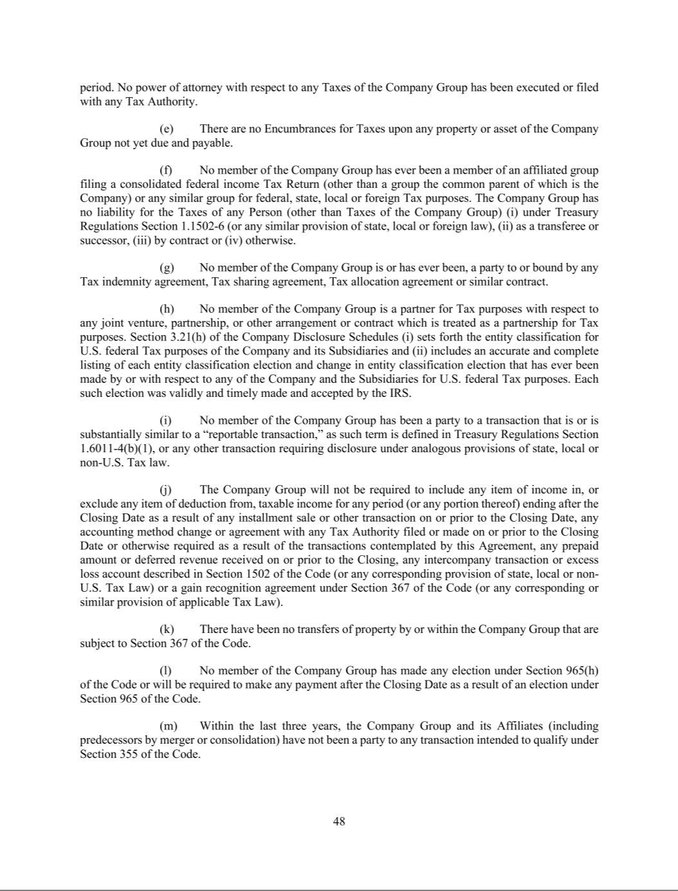

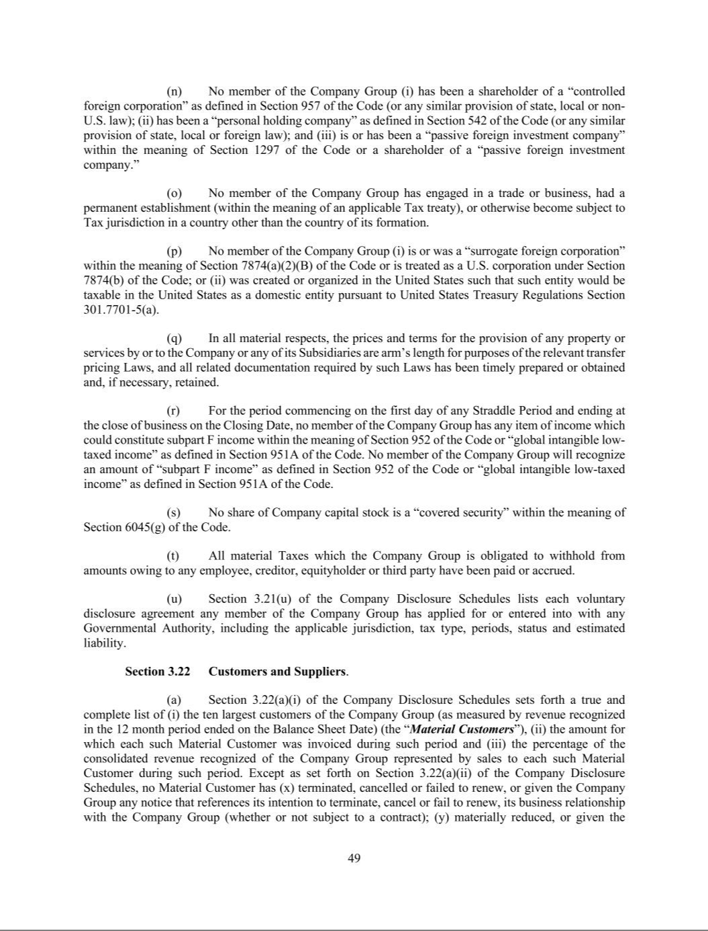

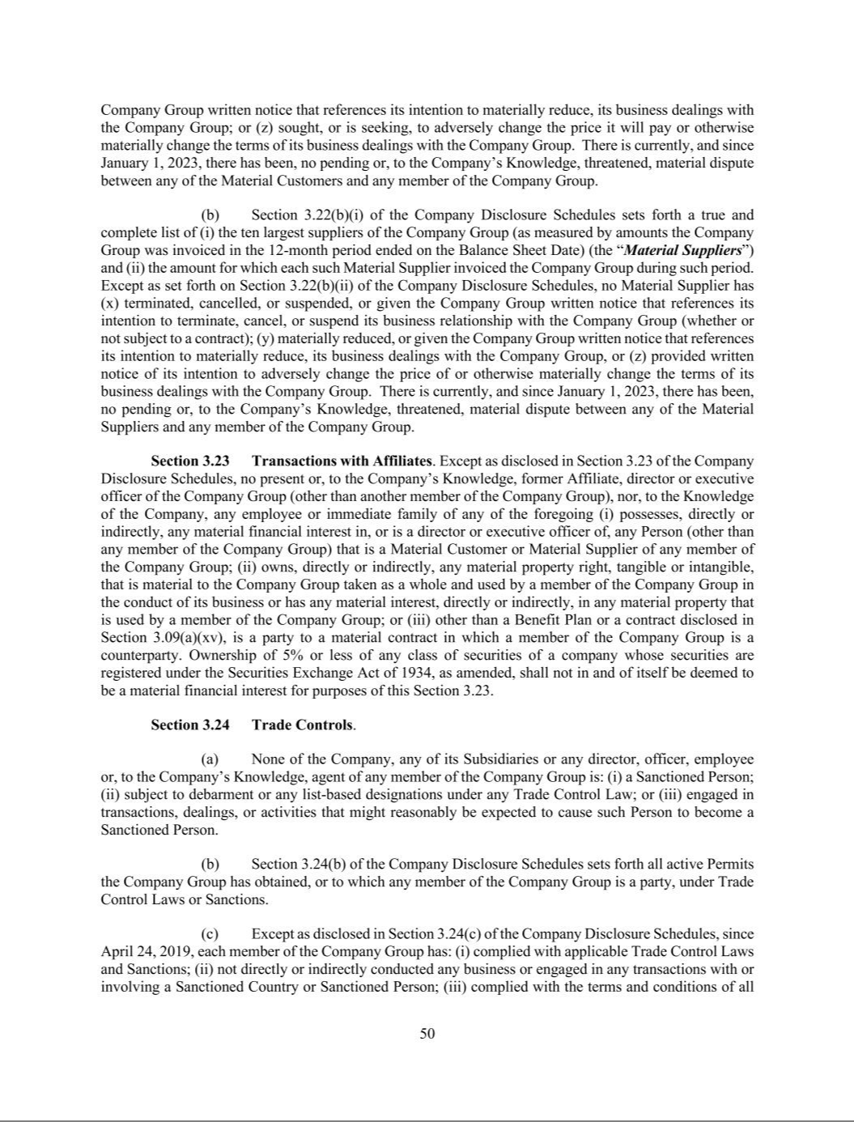

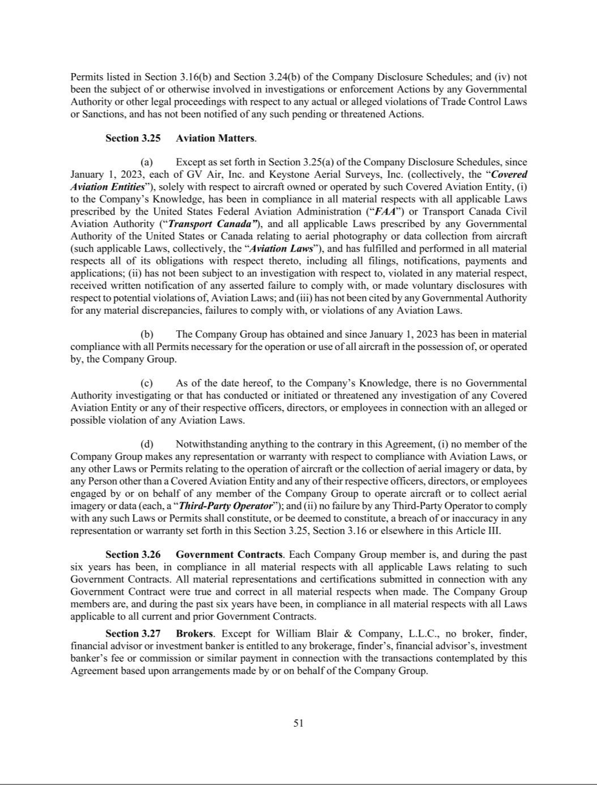

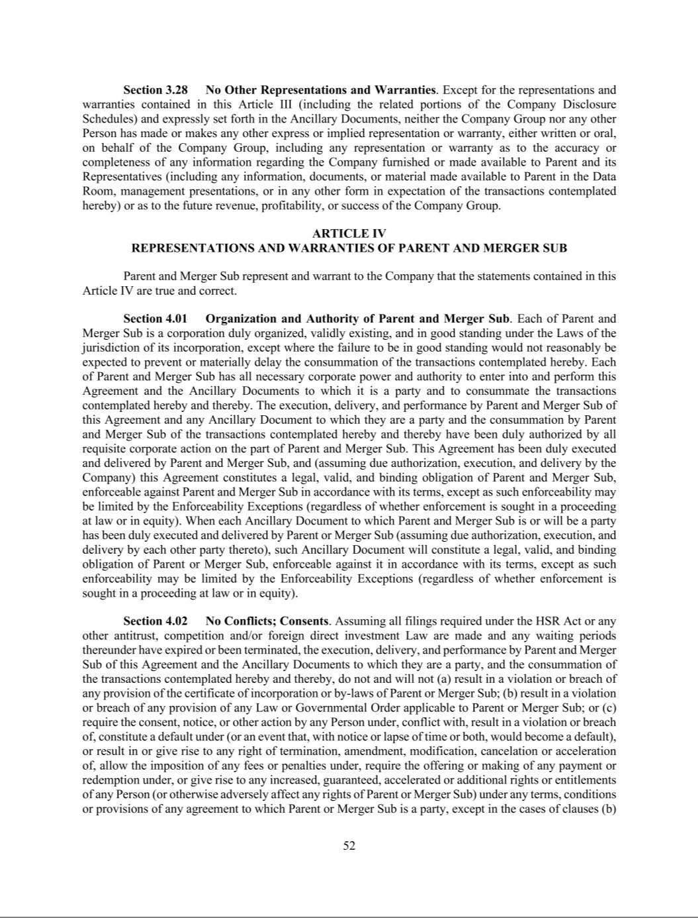

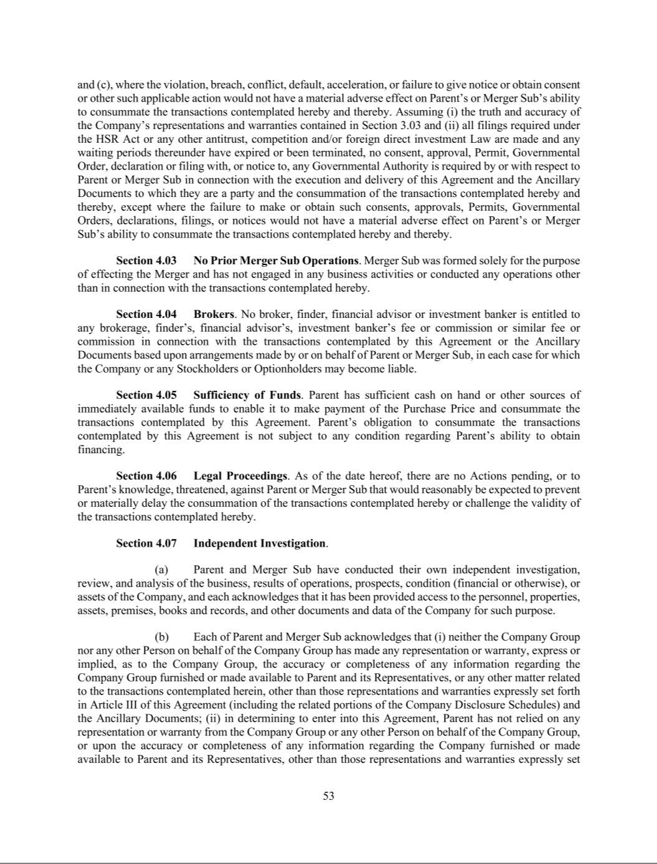

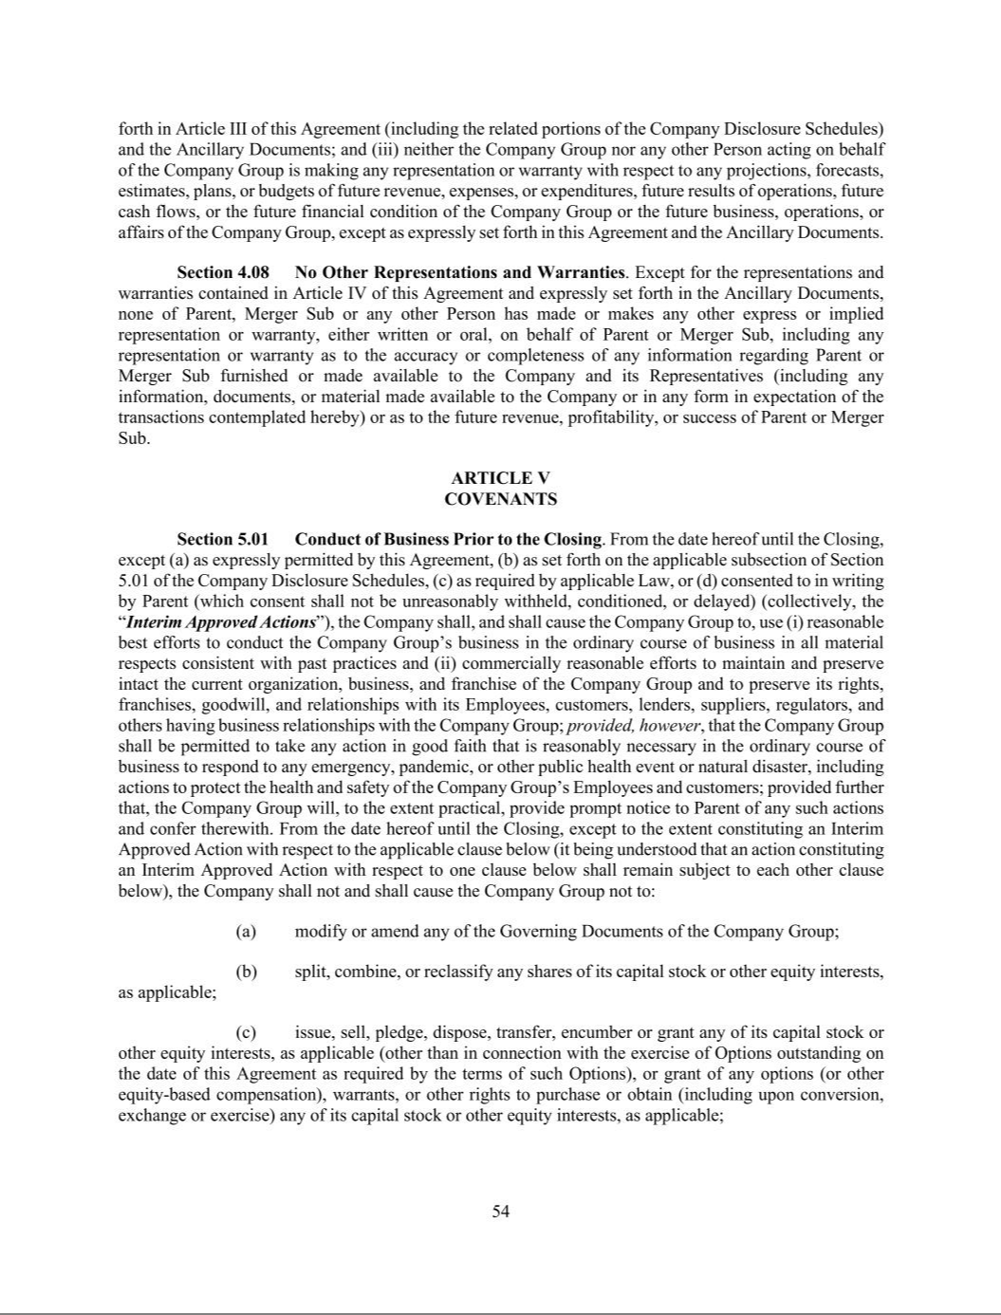

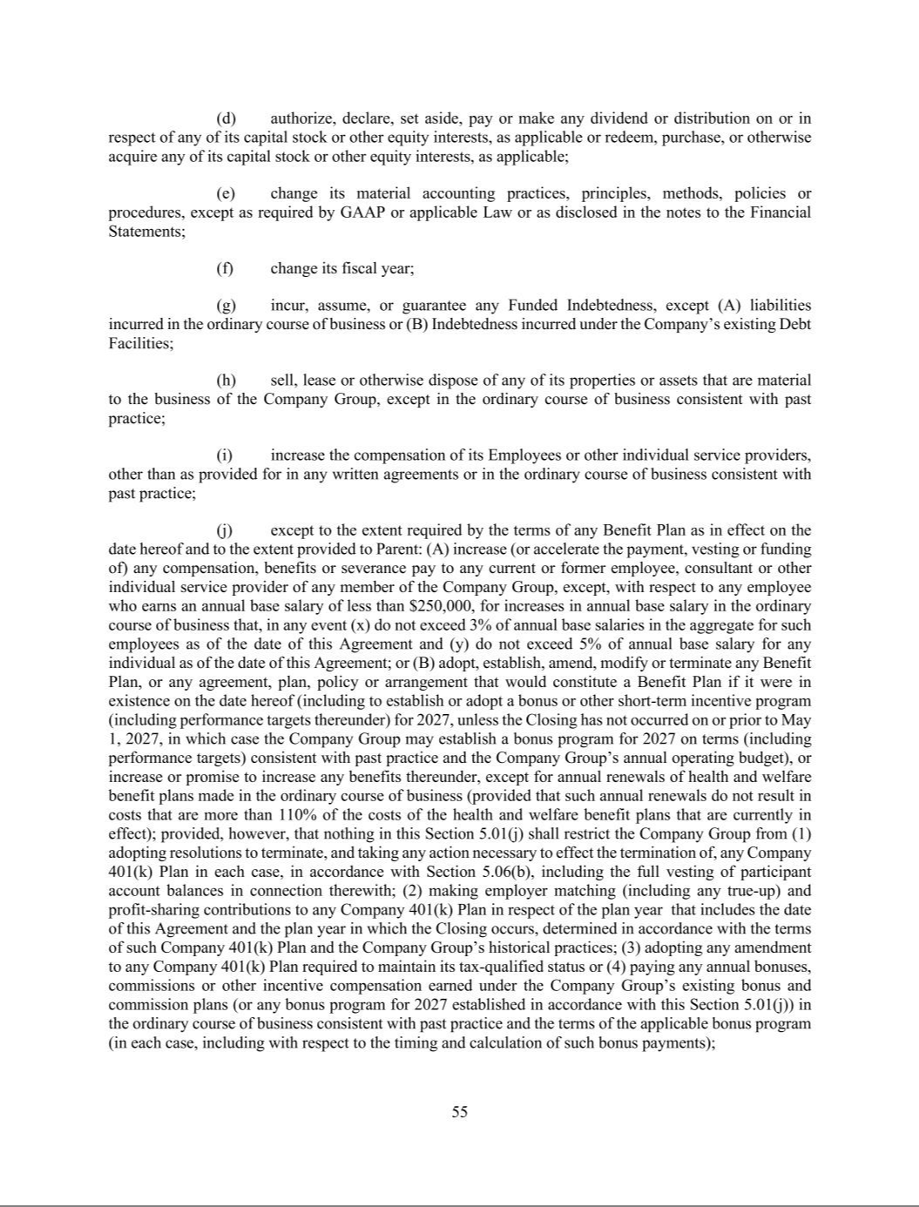

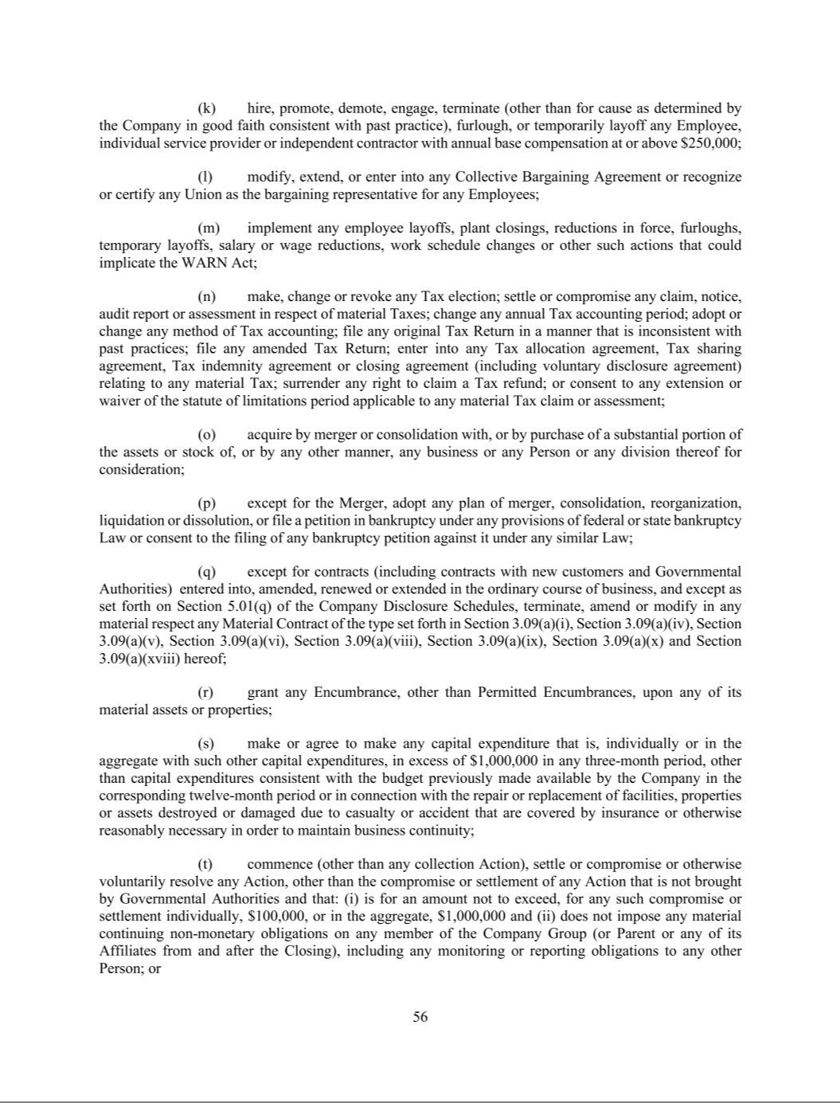

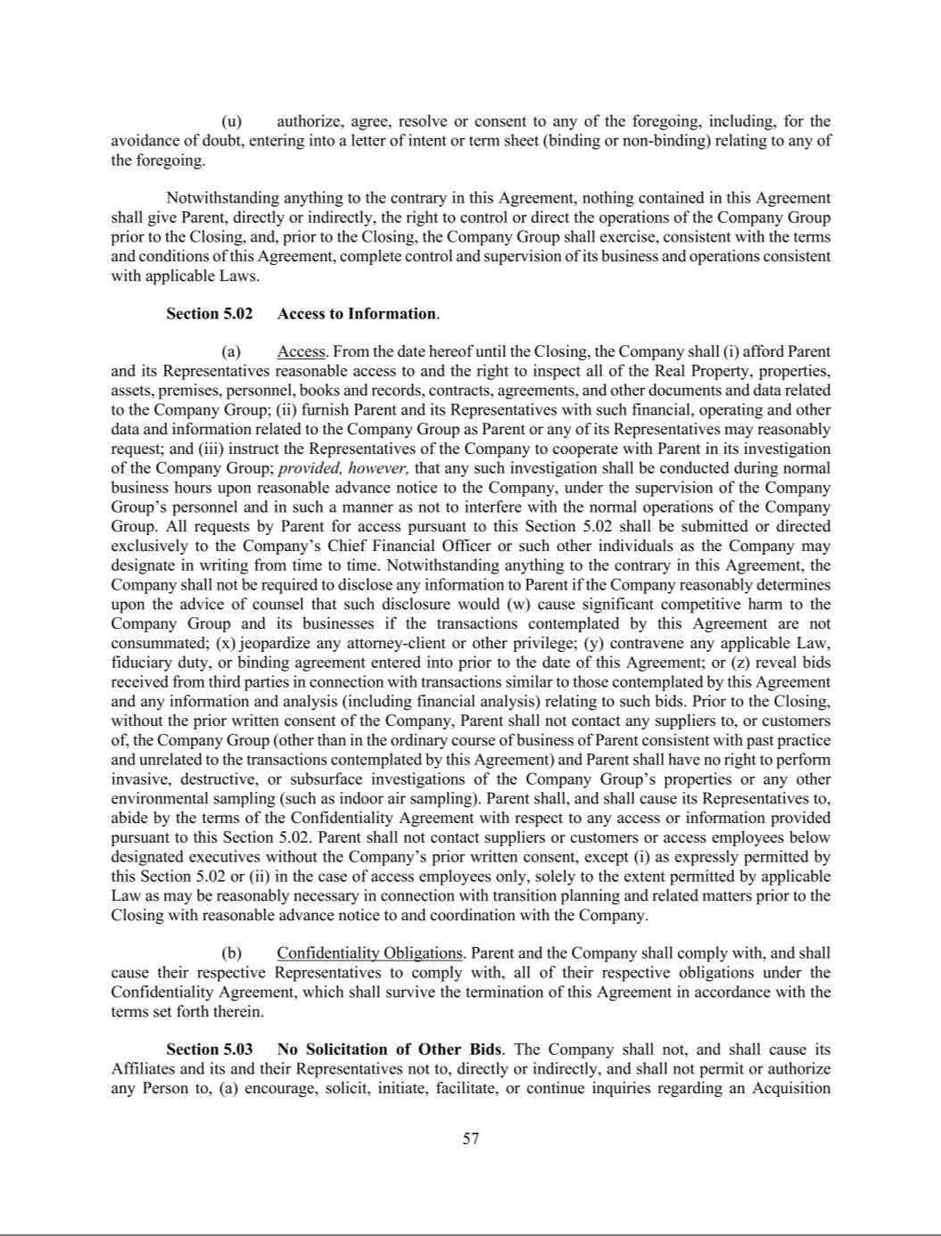

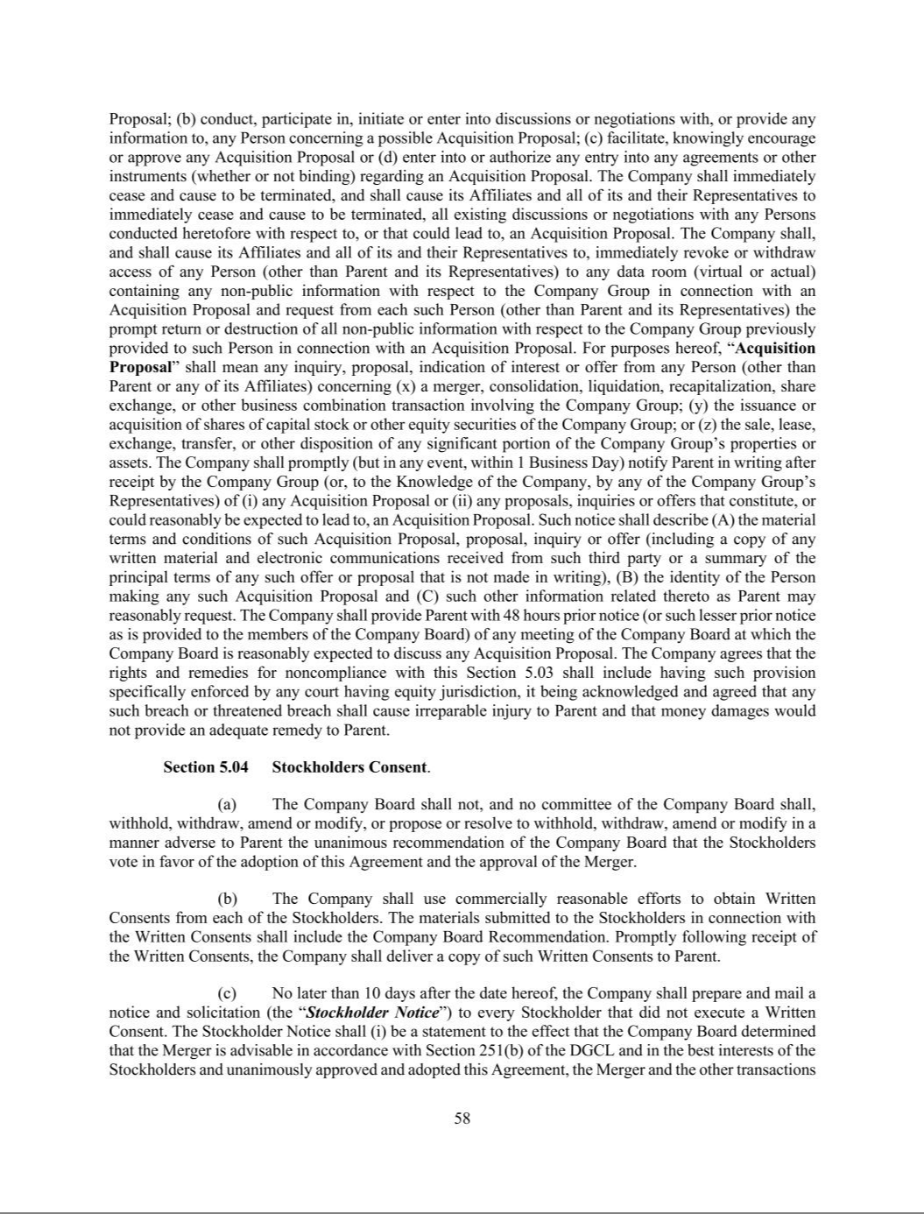

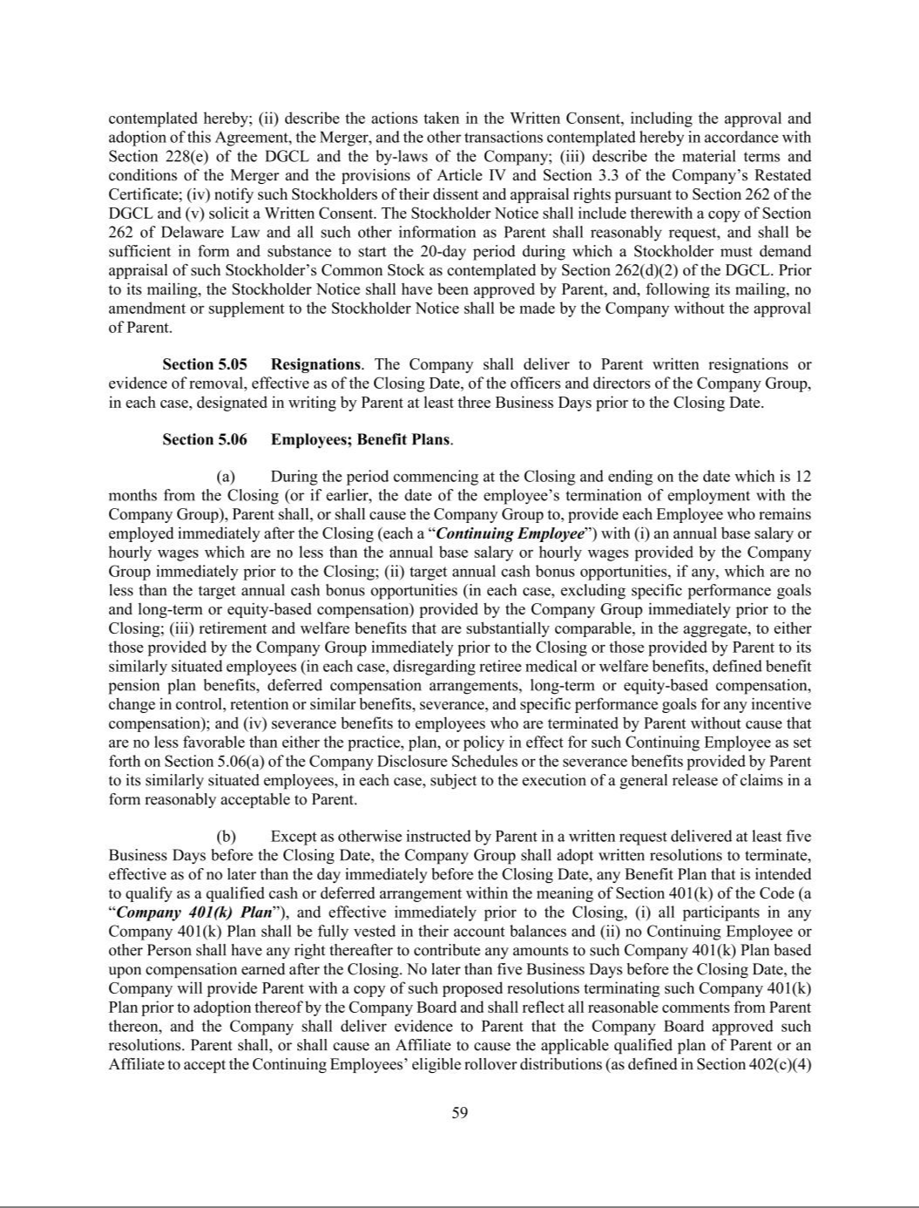

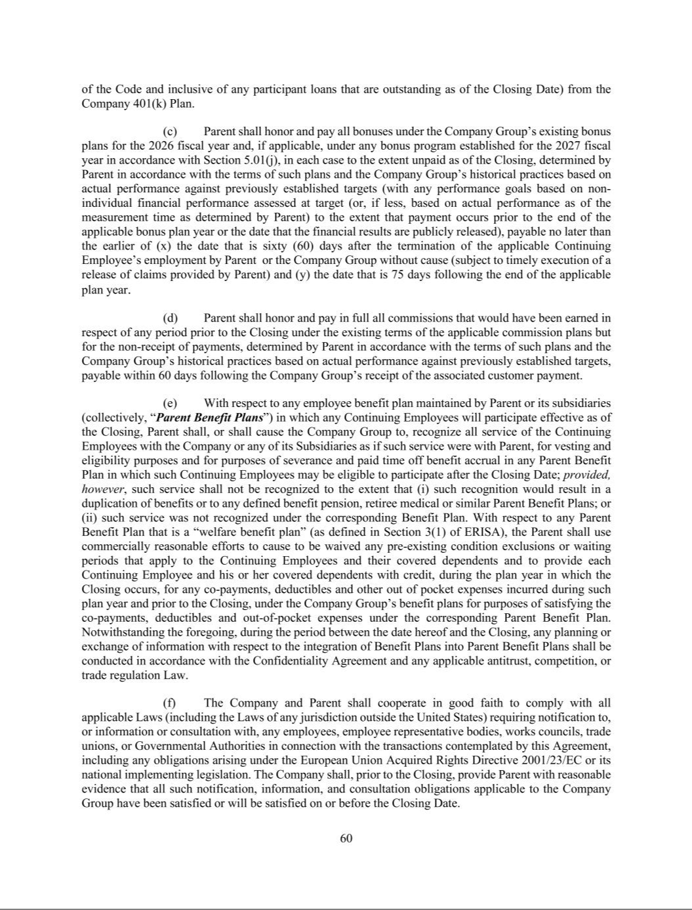

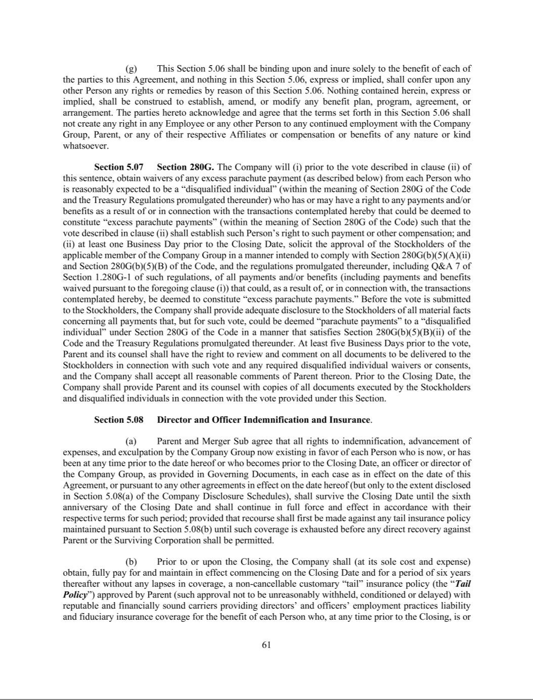

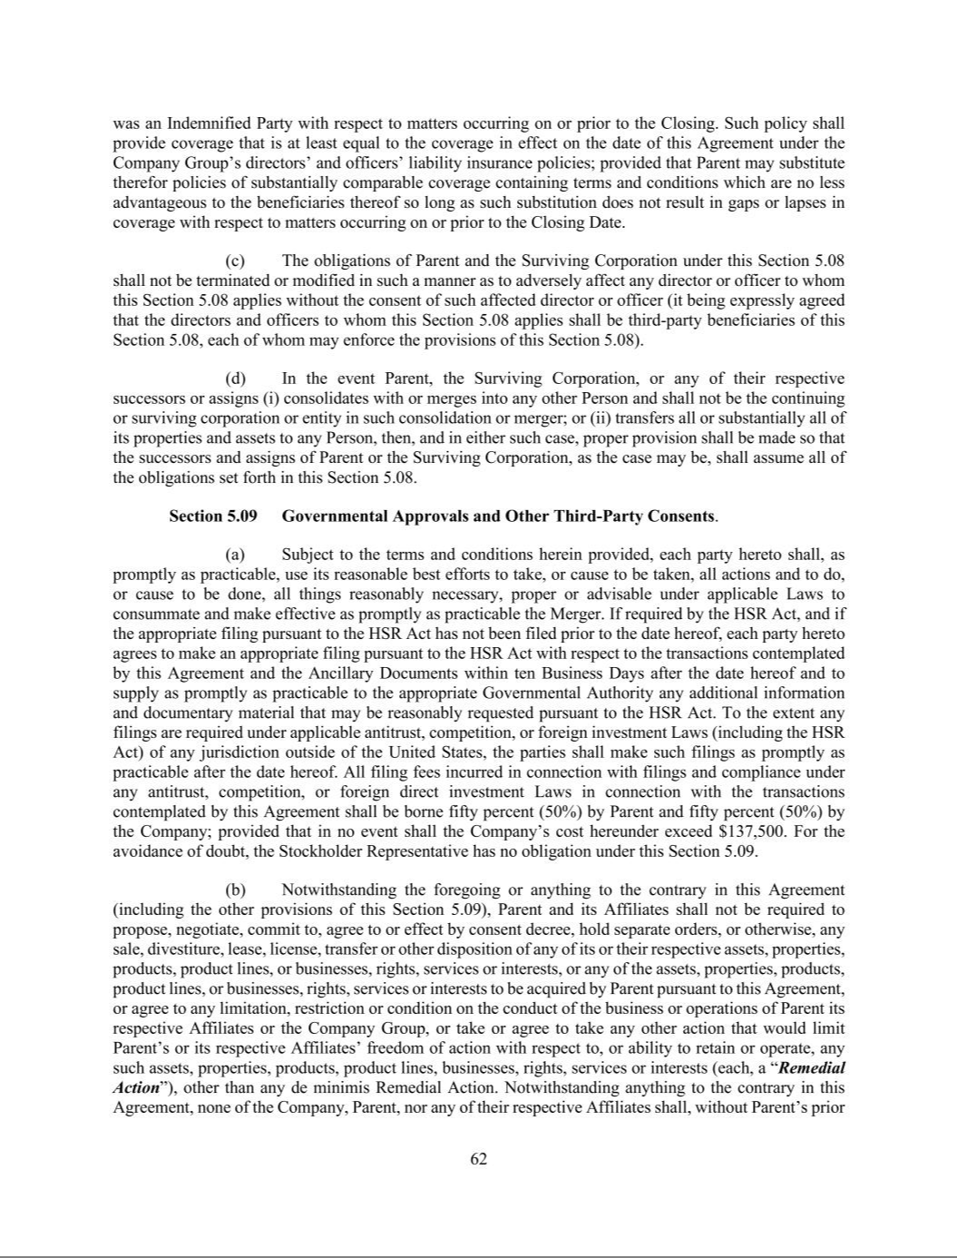

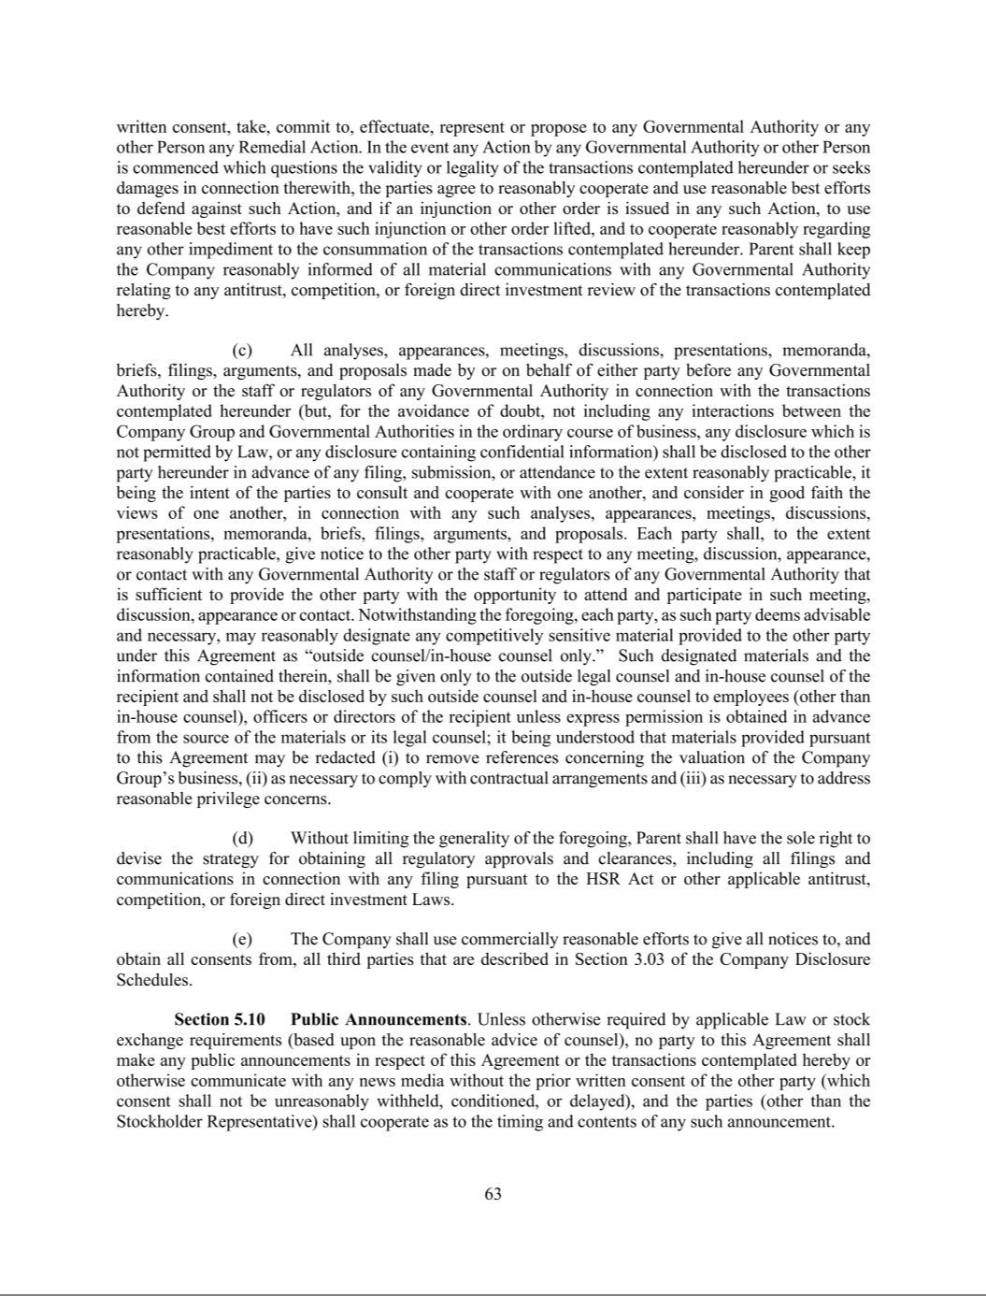

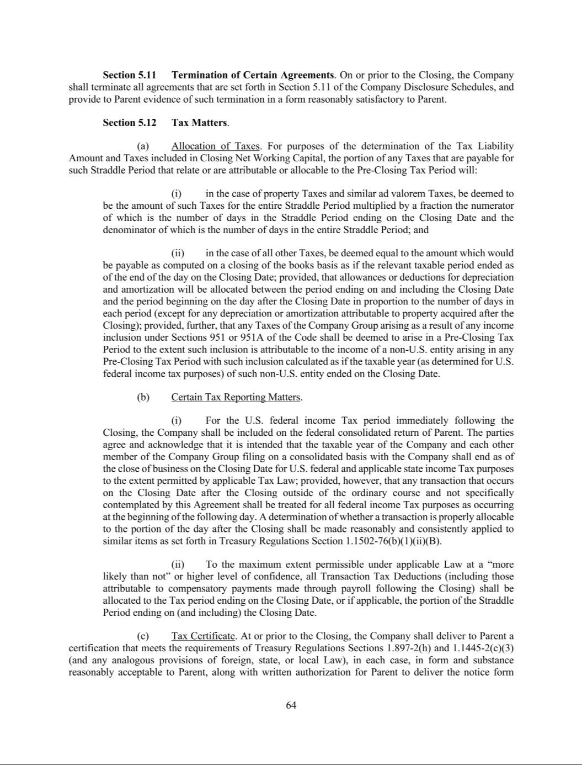

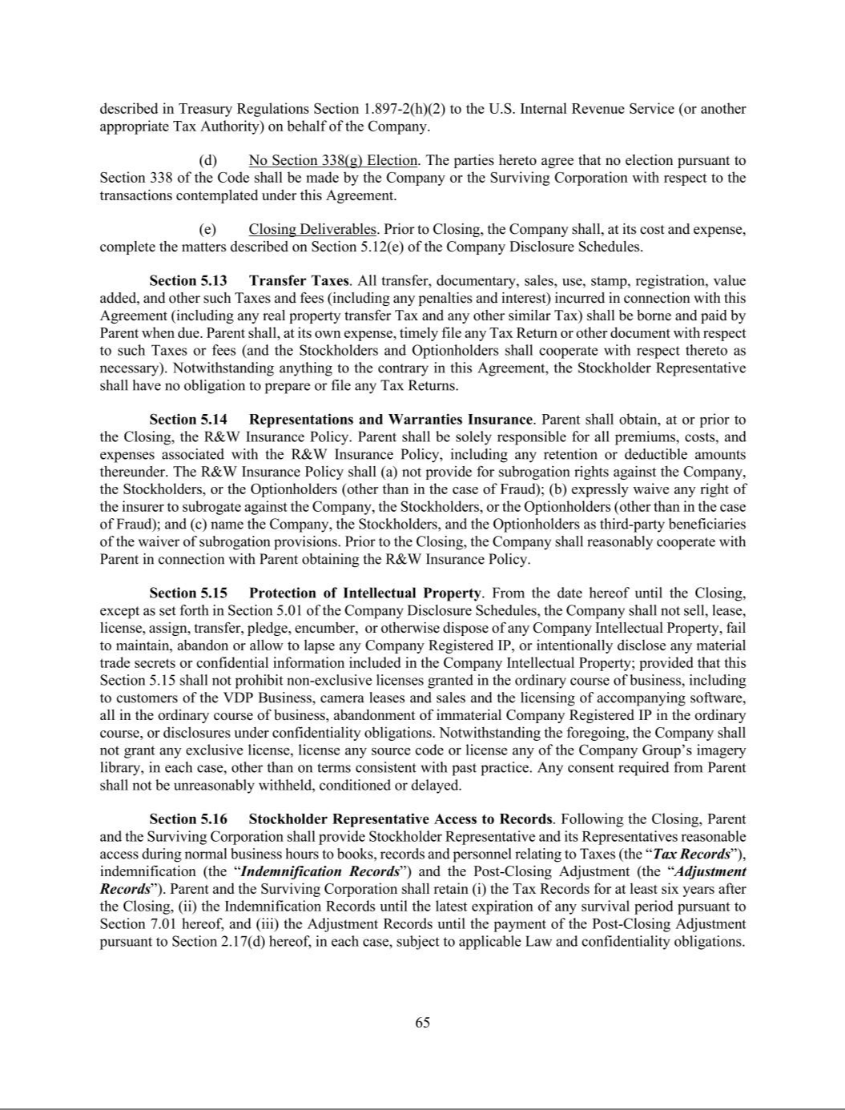

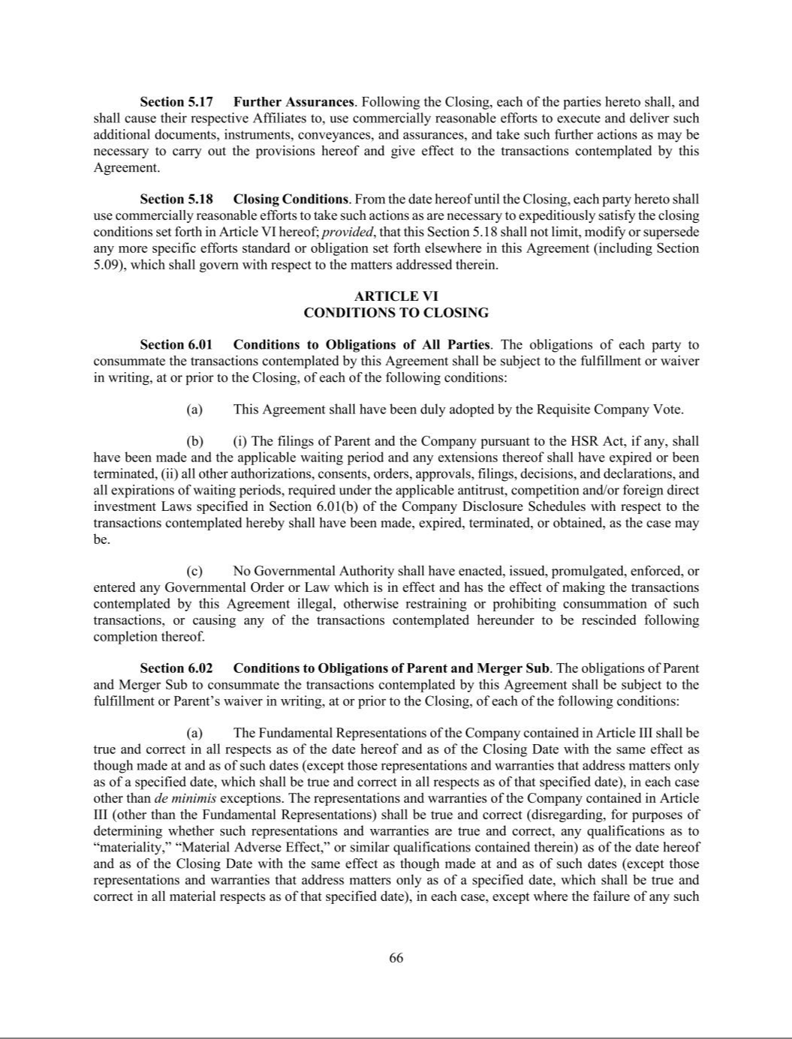

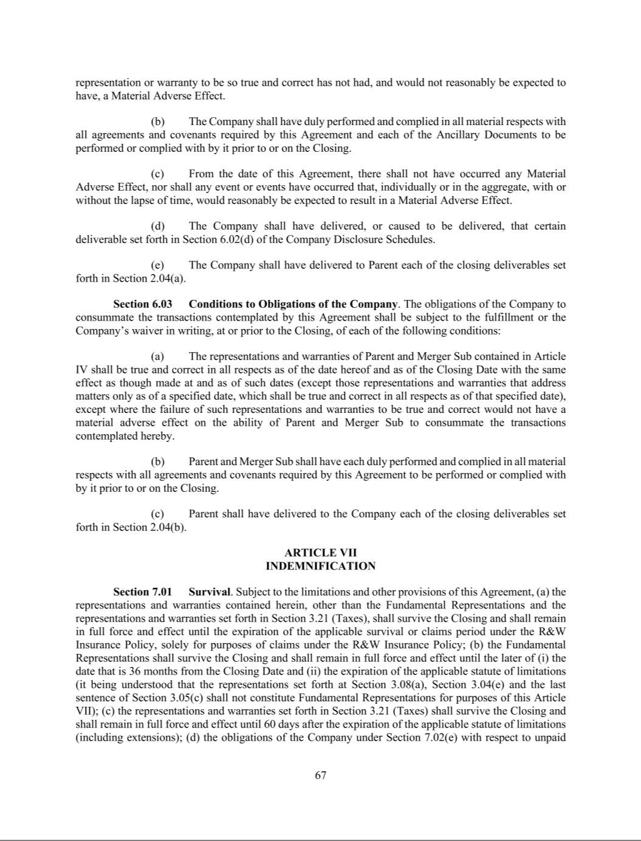

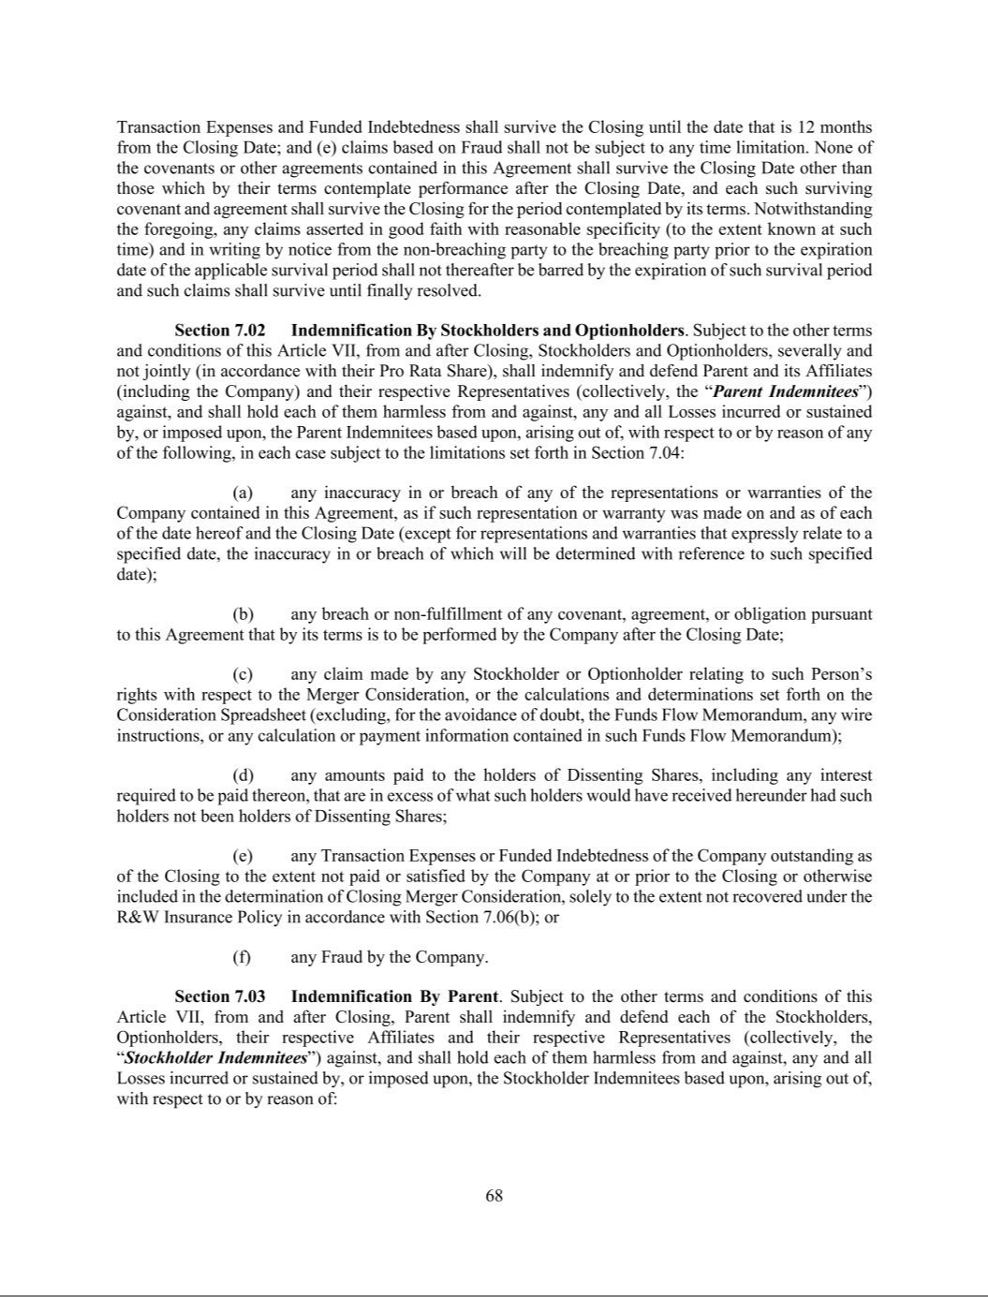

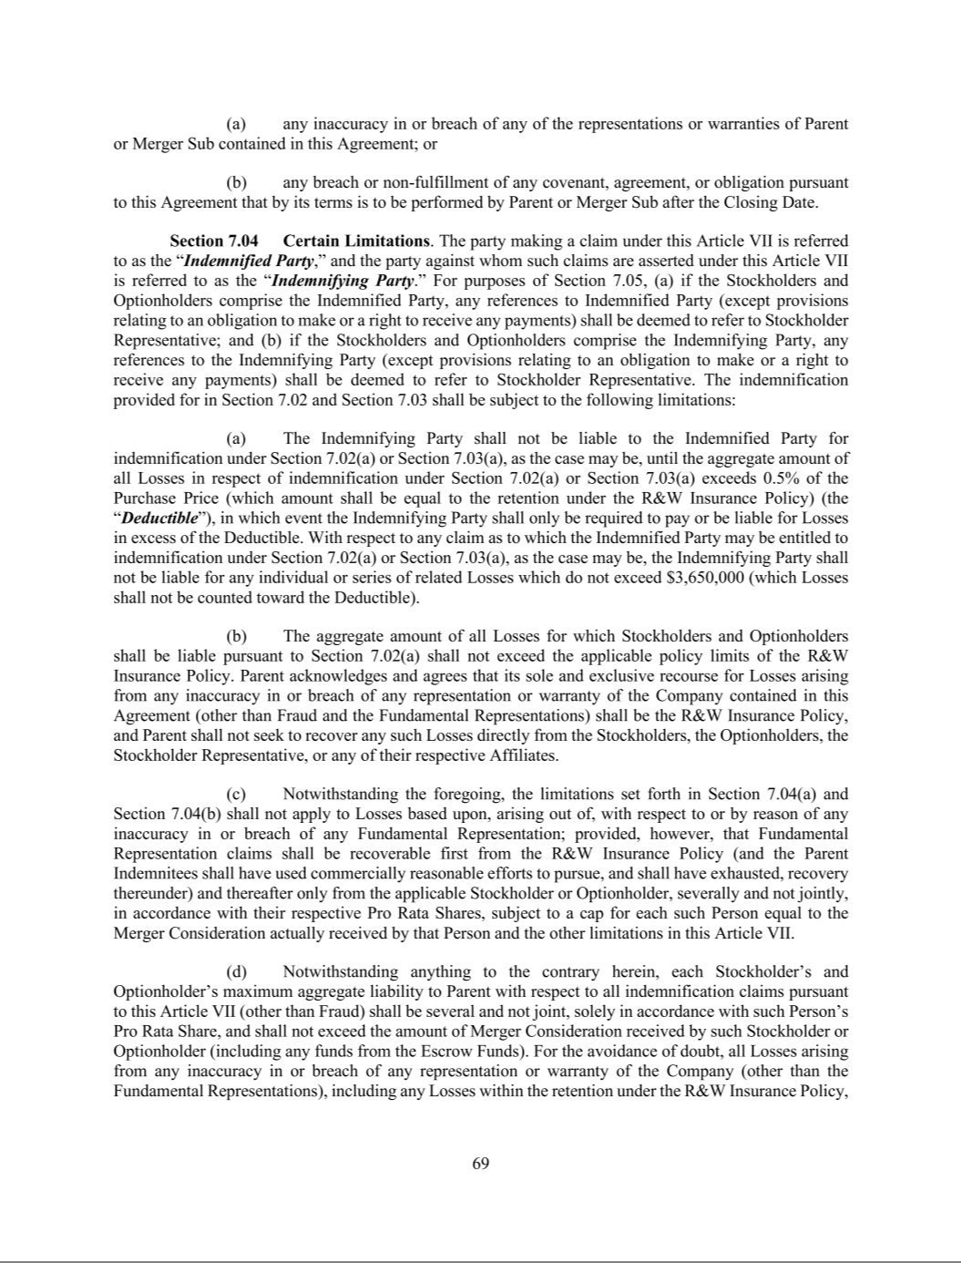

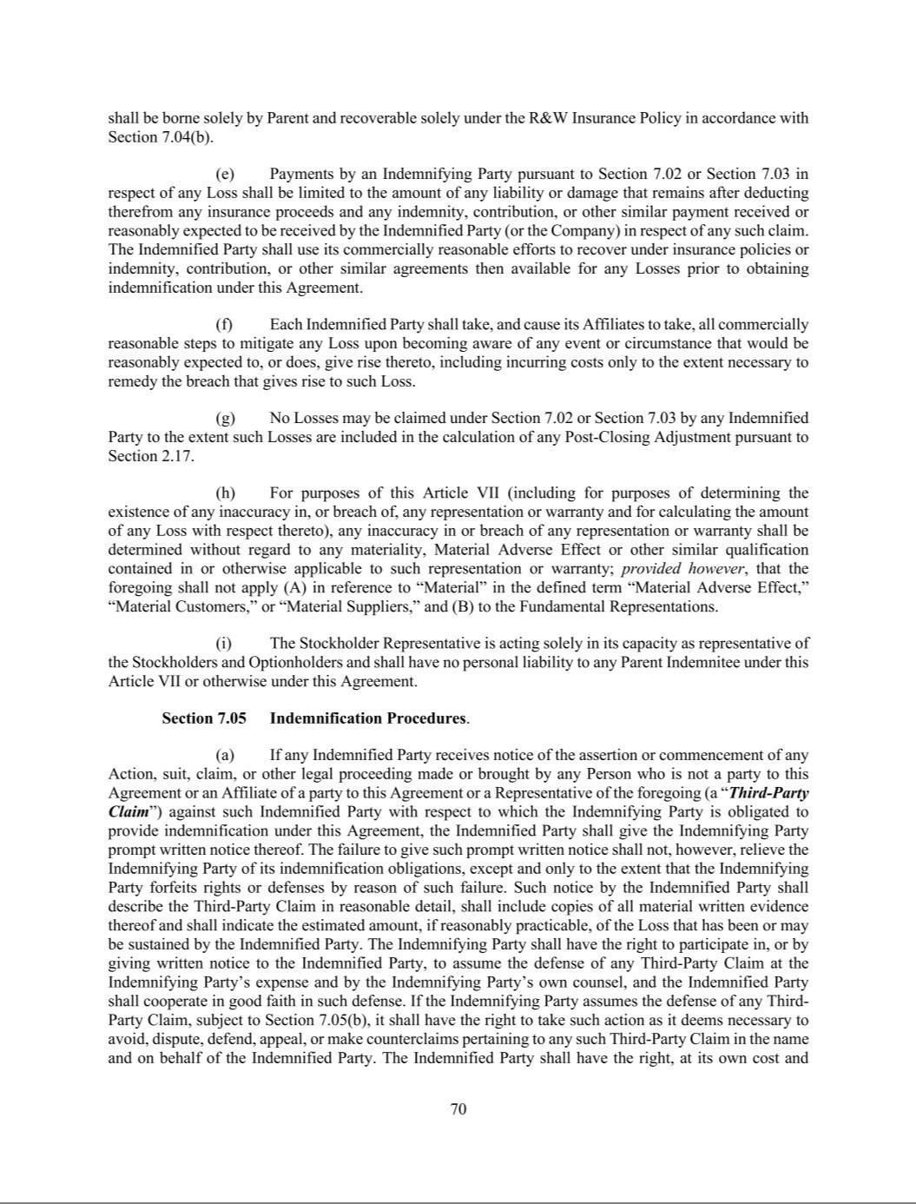

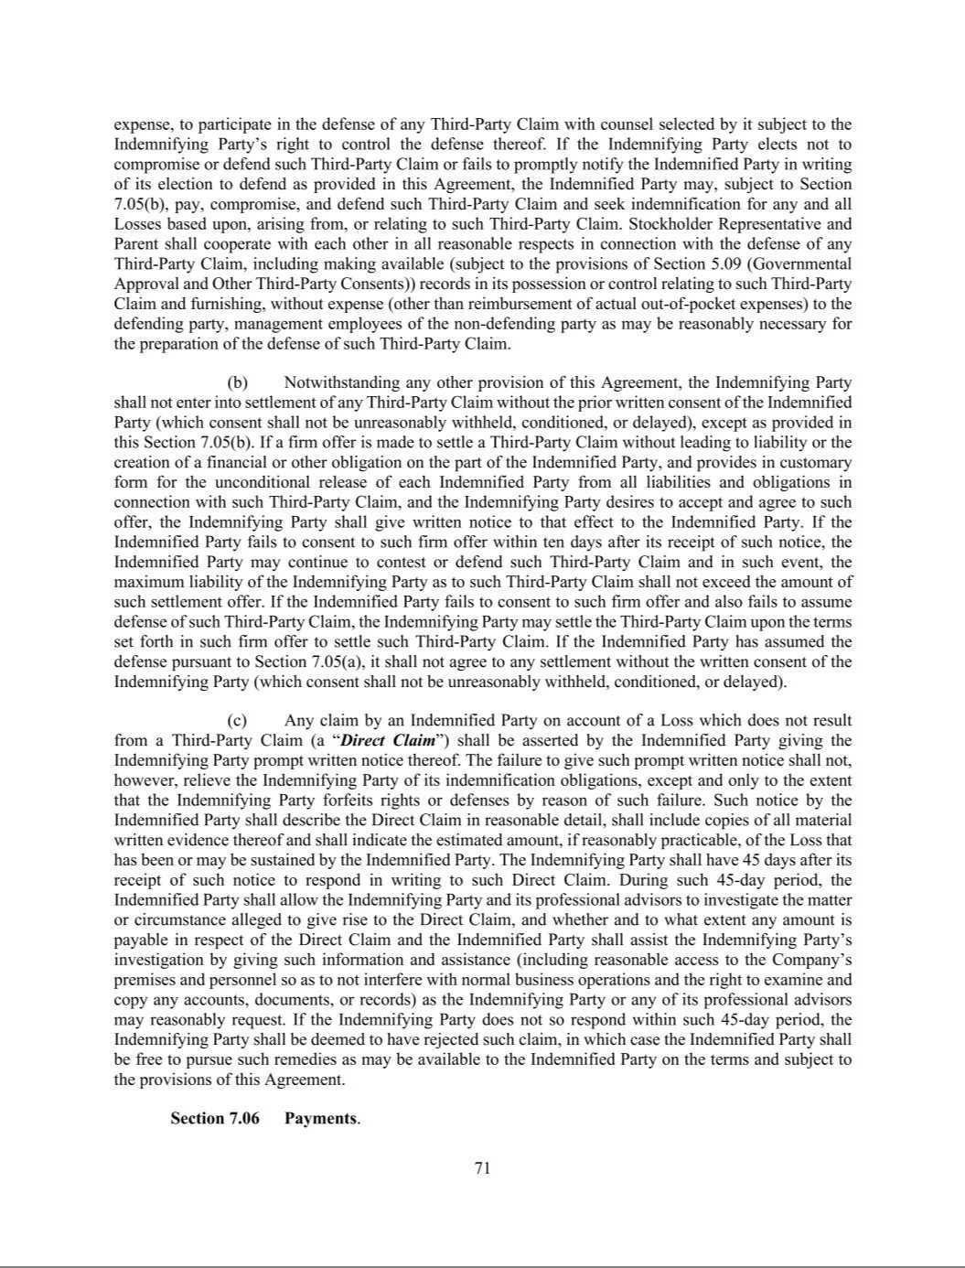

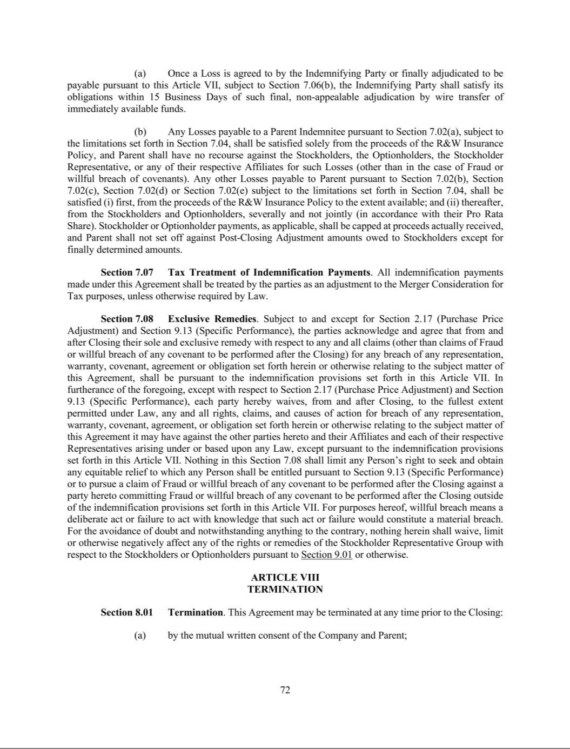

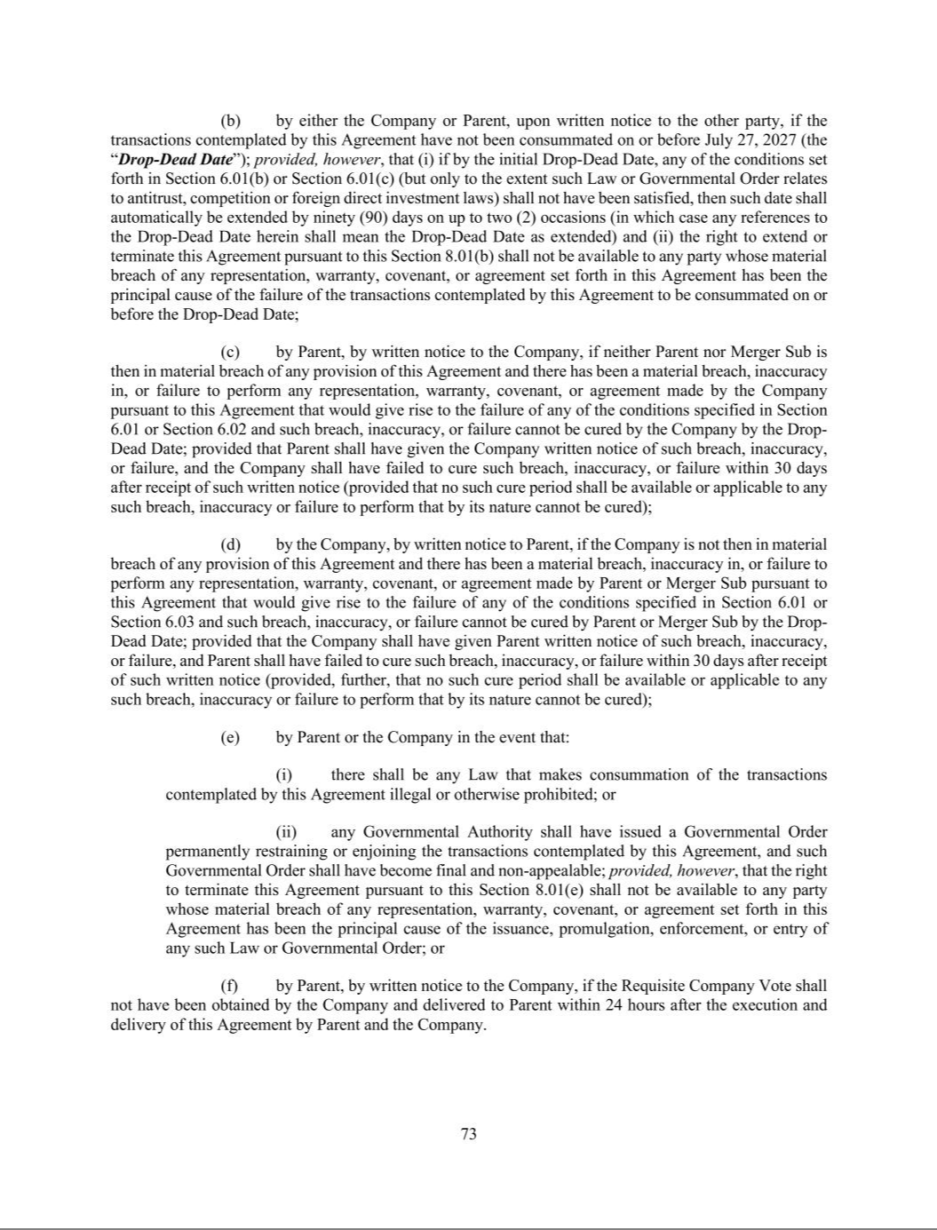

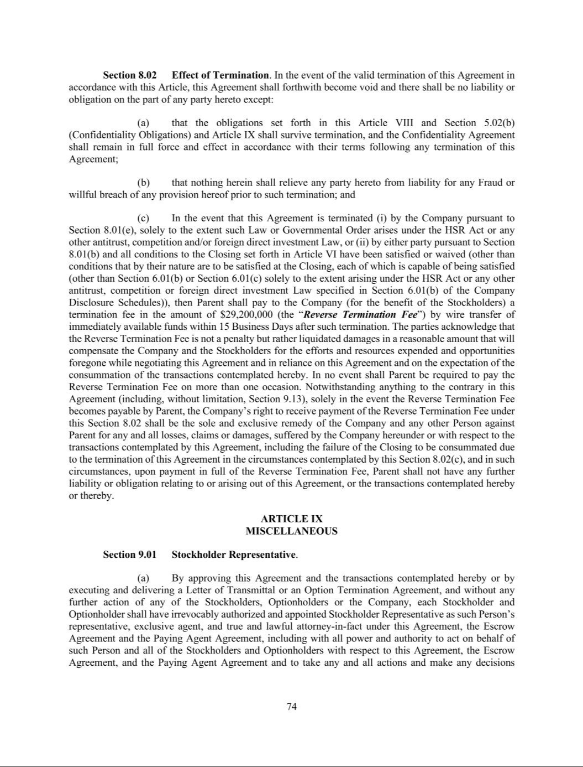

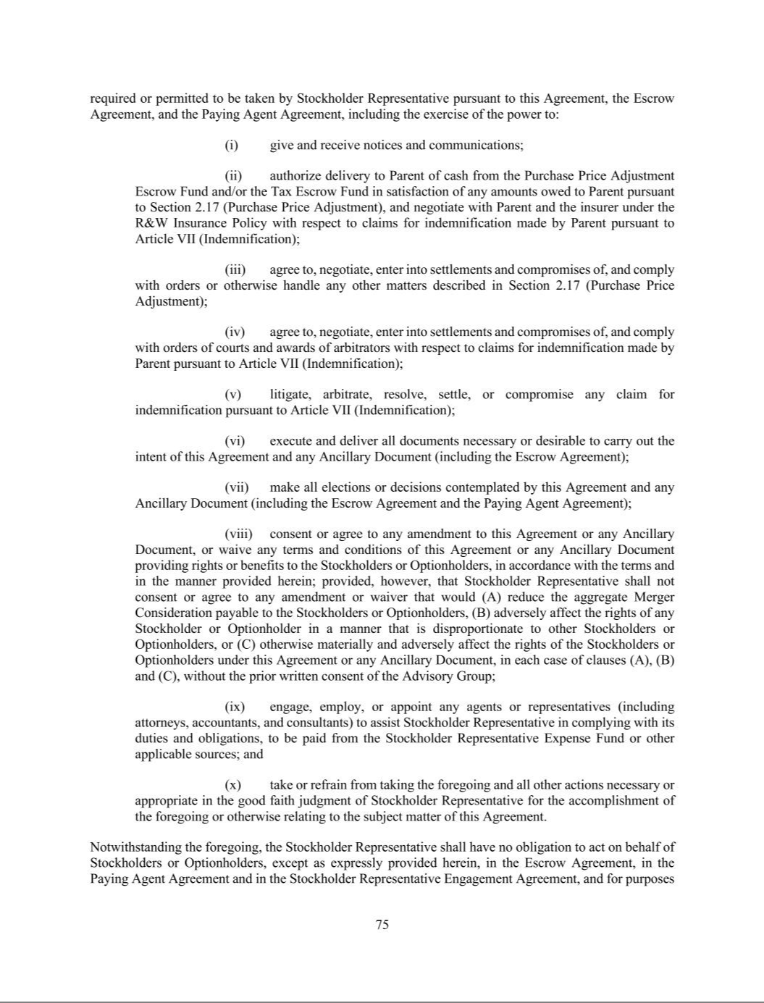

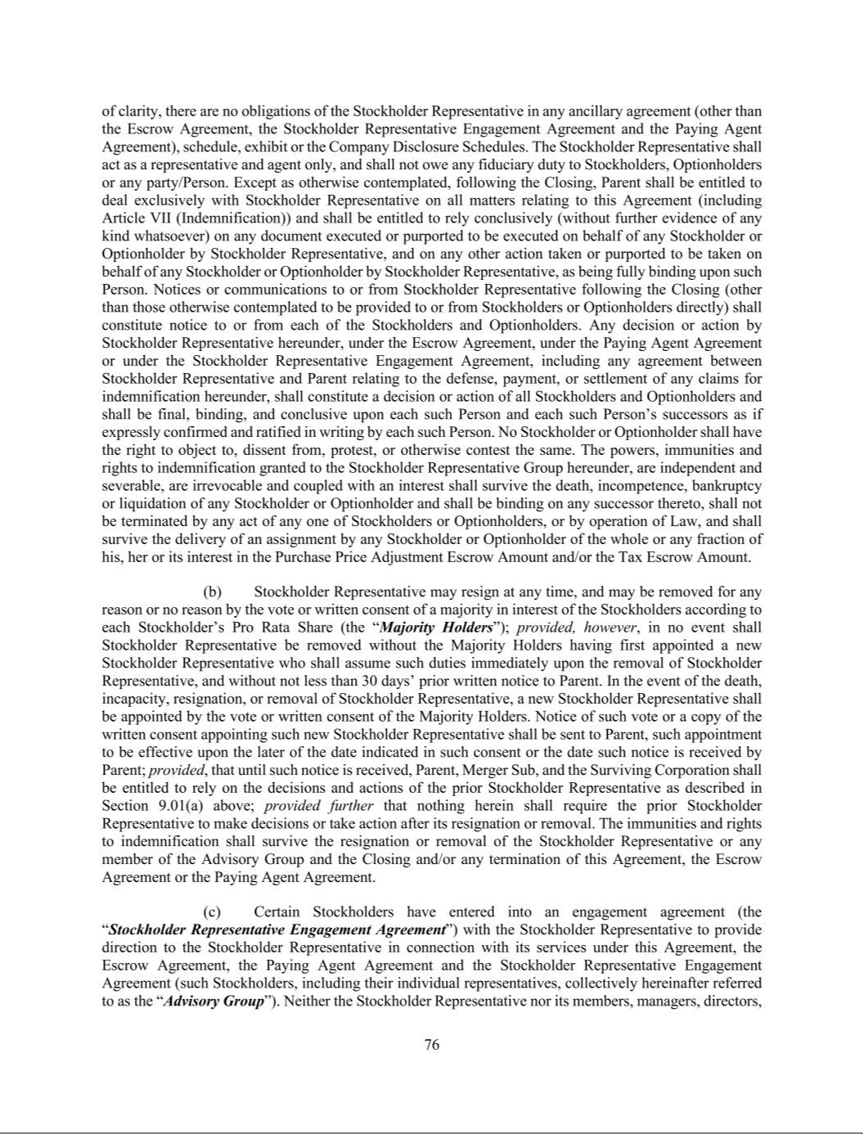

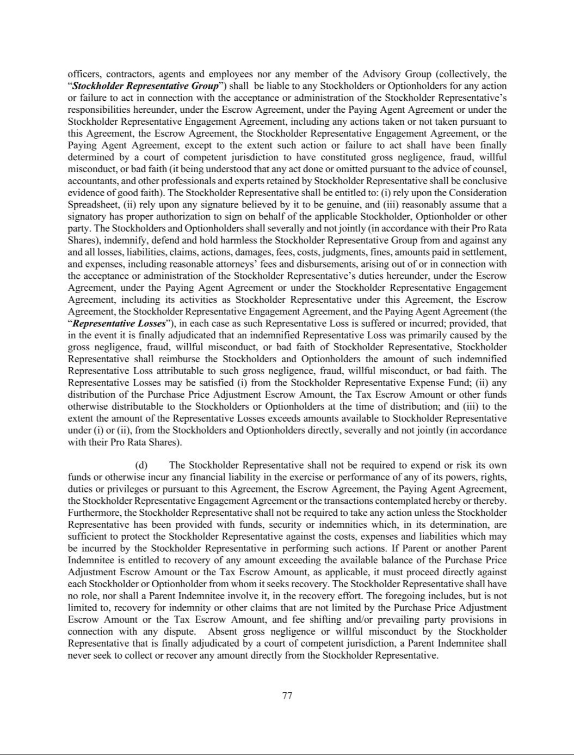

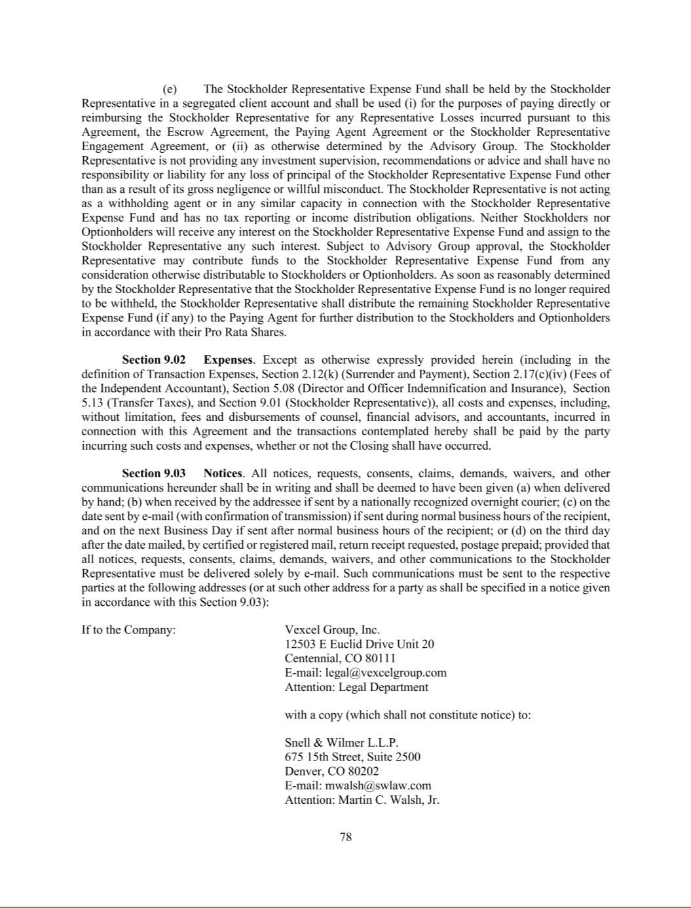

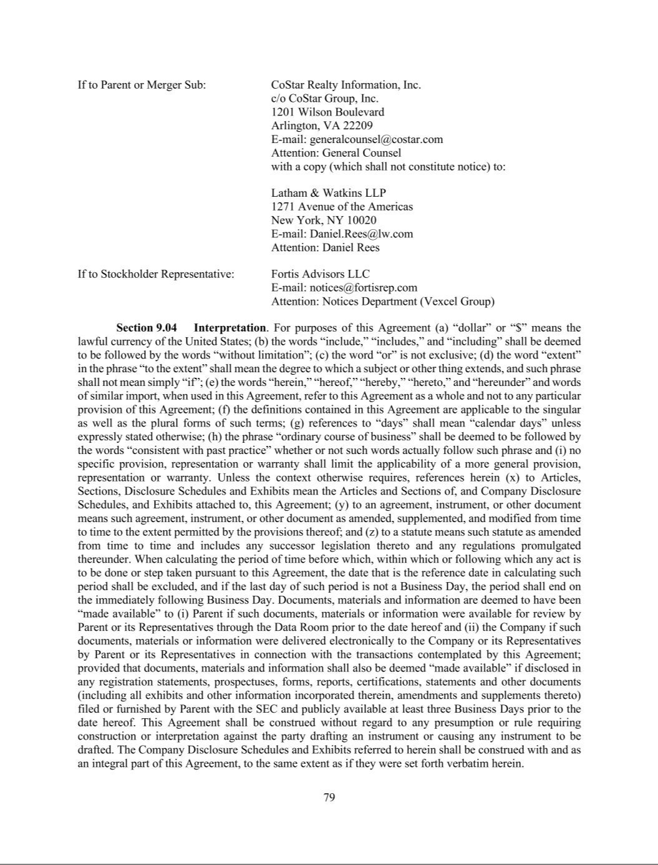

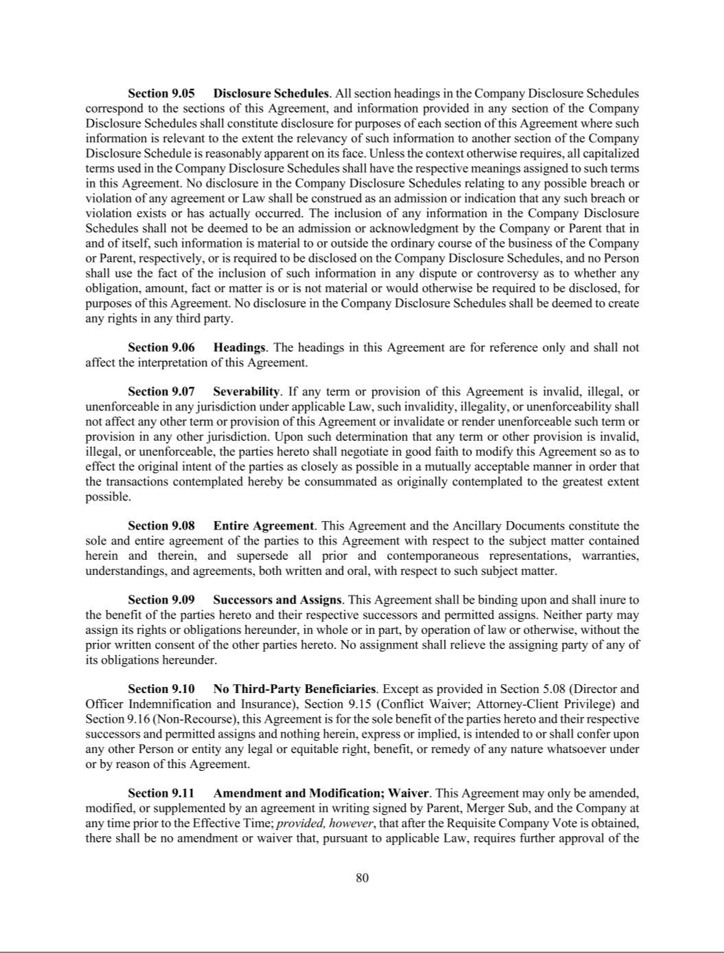

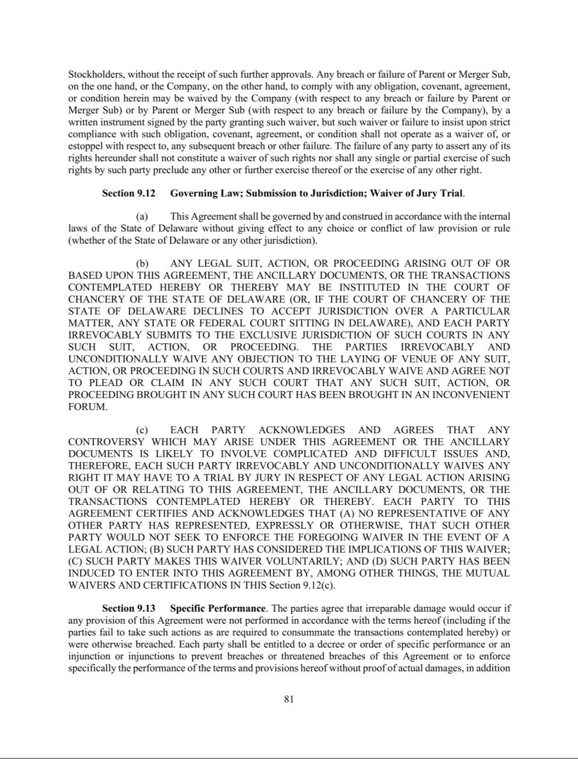

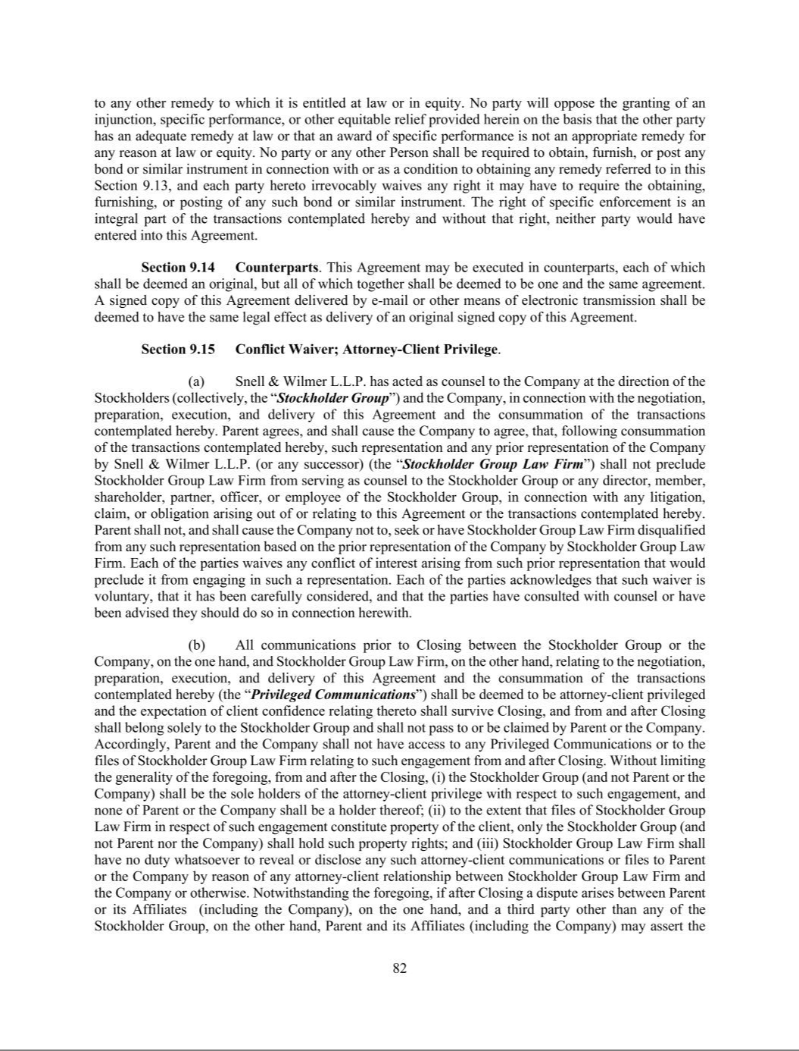

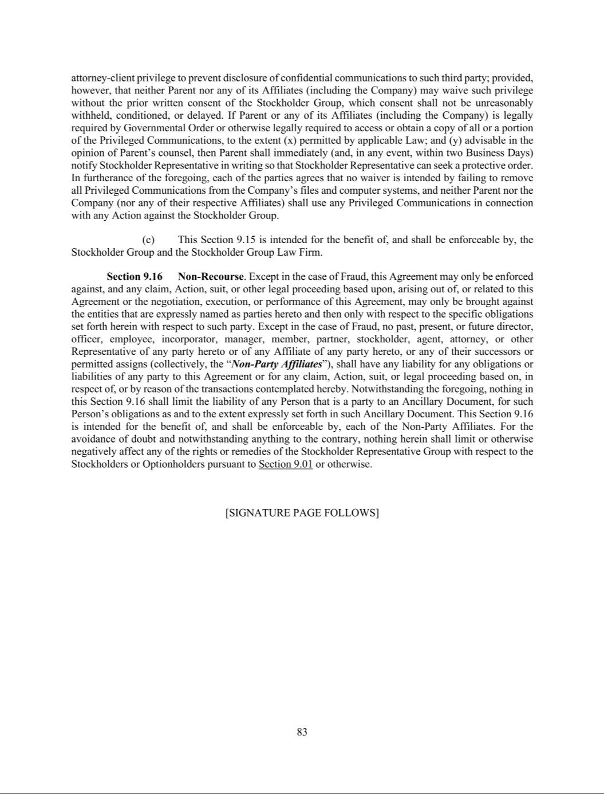

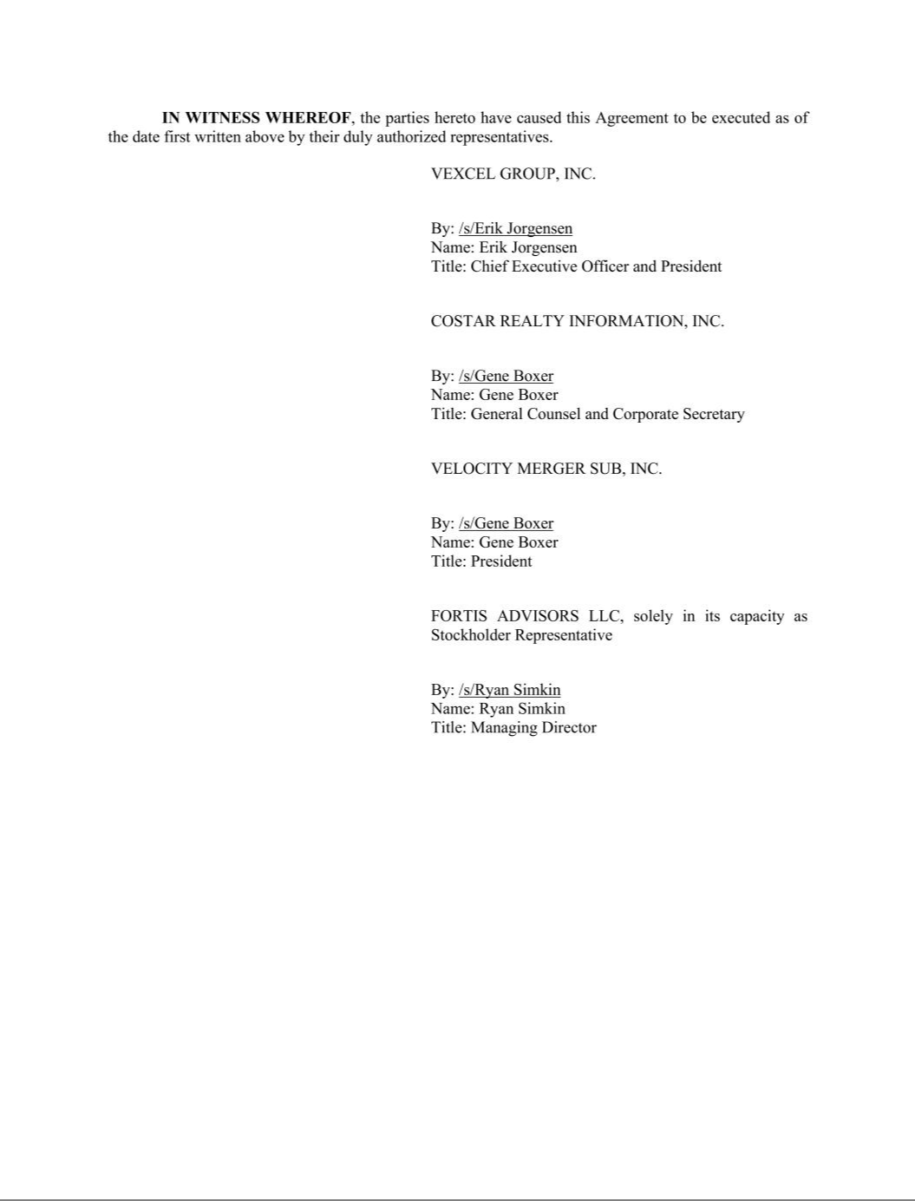











Exhibit 99.1


CoStar Group Reports Record Third Quarter Revenue of $952 Million; Profitability Surges with Net Income of $74 Million; Highest Ever Adjusted EBITDA of $229 Million, Doubling Year-over-Year; Raises Full-Year 2026 Adjusted EBITDA Guidance

ARLINGTON, VA – October 27, 2026 - CoStar Group, Inc. (NASDAQ: CSGP), a leading global provider of online real estate marketplaces, information, analytics, and 3D digital twin technology in the property markets, announced today that revenue for the quarter ended September 30, 2026 was $952 million, up 14% over revenue of $834 million for the quarter ended September 30, 2025. Net new bookings were $37 million for the quarter.

Net income for the third quarter of 2026 was $74 million, up $105 million year-over-year. Earnings per diluted share was $0.18 for the third quarter of 2026. Adjusted Net Income rose to $153 million in the third quarter, up 59% year-over-year. Adjusted EPS was $0.38 in the third quarter, up 65% year-over-year. EBITDA was $179 million, up $166 million year-over-year. Adjusted EBITDA was $229 million in the third quarter of 2026, doubling from the prior year period.

“CoStar Group generated outstanding profitability growth in the third quarter, delivering on our commitment to expand margins as we exit a period of investment,” said Andy Florance, Founder and Chief Executive Officer of CoStar Group. “Adjusted EBITDA doubled year-over-year and was considerably above the high end of our $190 million to $210 million guidance range. We achieved significant additional efficiencies in the quarter, bringing total anticipated cost savings this year to approximately $150 million versus our original guidance. Our ongoing deep expense review has identified potential additional savings of at least $200 million that we believe will improve efficiency without sacrificing revenue growth. We expect to realize these over the next 12 to 18 months, keeping us on track to achieve our 2028 Adjusted EBITDA target of $1.25 billion.”

Florance continued, “We are demonstrating our ability to meaningfully grow profitability and are confident in our strategy to fuel future growth. We are leveraging AI and our proprietary ground truth data, giving us a unique competitive advantage in providing value to our information clients. Furthermore, our global scale enables us to deliver best-in-class consumer-facing AI functionality on our marketplaces at significantly lower costs than our competitors. Our acquisition of Zonda and agreement to acquire Vexcel demonstrate our ability to further enhance our proprietary datasets and global scale, which are real differentiators in the world of AI.”

 | Year 2025-2026 Quarterly Results - Unaudited
 |  | (in millions, except per share data)
 |  |  |  | 2025 |  |  |  |  |  |  |  |  | 2026
 |  | Q1 |  | Q2 |  |  | Q3 |  | Q4 |  | Q1 |  | Q2 | Q3
Revenue | $732 |  |  | $781 |  |  | $834 |  | $900 |  | $897 |  | $925 | $952
Net income (loss) | $(15) |  |  | $6 |  |  | $(31) |  | $47 |  | $3 |  | $55 | $74
Earnings per share - diluted | $(0.04) |  |  | $0.01 |  |  | $(0.07) |  | $0.11 |  | $0.01 |  | $0.14 | $0.18
Weighted-average outstanding shares - diluted | 411 |  |  | 424 |  |  | 420 |  | 420 |  | 414 |  | 404 | 402
EBITDA | $(1) |  |  | $29 |  |  | $13 |  | $129 |  | $81 |  | $157 | $179
Adjusted EBITDA | $66 |  |  | $85 |  |  | $114 |  | $177 |  | $132 |  | $184 | $229
Adjusted Net Income | $63 |  |  | $74 |  |  | $96 |  | $131 |  | $94 |  | $128 | $153
Adjusted EPS | $0.15 |  |  | $0.17 |  |  | $0.23 |  | $0.31 |  | $0.23 |  | $0.32 | $0.38

2026 Outlook

The Company is increasing its Adjusted EBITDA guidance for the full year of 2026 to a range of $820 million to $840 million, which represents an increase of $30 million at the midpoint of the range from its guidance in July 2026, and a cumulative $60 million increase at the midpoint from its guidance in February 2026. For the fourth quarter of 2026, the Company expects Adjusted EBITDA in the range of $275 million to $295 million, representing a margin of 29% at the midpoint of the range.

The Company is increasing its revenue guidance for 2026 to a range of $3.75 billion to $3.77 billion, representing revenue growth of approximately 16% year-over-year at the midpoint of the range. The Company expects revenue for the fourth quarter of 2026 in the range of $976 million to $996 million, representing revenue growth of approximately 10% year-over-year at the midpoint of the range.

The Company is increasing its full year 2026 Adjusted EPS guidance in a range of $1.38 to $1.41 based on 405 million shares. For the fourth quarter of 2026, the Company expects Adjusted EPS in a range of $0.46 to $0.50 based on 400 million shares. These ranges include an estimated non-GAAP tax rate of 26% for the full year and the fourth quarter of 2026.

The preceding forward-looking statements reflect CoStar Group’s expectations as of October 27, 2026, including forward-looking non-GAAP financial measures on a consolidated basis, based on current estimates, expectations, observations, and trends. Given the risk factors, rapidly evolving economic environment, and uncertainties and assumptions discussed in this release and in our quarterly reports on Form 10-Q and annual reports on Form 10-K, actual results may differ materially. Other than in publicly available statements, the Company does not intend to update its forward-looking statements until its next quarterly results announcement.

Reconciliations of EBITDA, Adjusted EBITDA, Adjusted Net Income, and Adjusted EPS to the most directly comparable GAAP measures are shown in detail below, along with definitions for those terms. A reconciliation of forward-looking non-GAAP guidance (except for 2028 Adjusted EBITDA guidance) to the most directly comparable GAAP measure, net income (loss), can be found within the tables included in this release. A reconciliation of the 2028 Adjusted EBITDA guidance to the most directly comparable GAAP measure is not available on a forward-looking basis without unreasonable effort due to the unknown effect, timing, and potential significance of certain income statement items.

Non-GAAP Financial Measures

For information regarding the purpose for which management uses the non-GAAP financial measures disclosed in this release and why management believes they provide useful information to investors regarding the Company’s financial condition and results of operations, please refer to the Company’s latest periodic report.

EBITDA is our net income (loss) before interest income or expense, net; other income or expense, net; income taxes; depreciation; and amortization. We typically disclose EBITDA on a consolidated and on an operating segment basis in our earnings releases, investor conference calls, and filings with the SEC.

Adjusted EBITDA is different from EBITDA because we further adjust EBITDA for stock-based compensation expense; acquisition- and integration-related costs; restructuring and related costs, including certain advisory fees; and settlements and impairments incurred outside our ordinary course of business, including judgments and related recoveries thereon. Adjusted EBITDA margin represents Adjusted EBITDA divided by revenue for the period.

Adjusted Net Income represents our net income (loss) adjusted for stock-based compensation expense; acquisition- and integration-related costs, including gains or losses on equity investments acquired in prospective targets and related to deal-contingent financial instruments; restructuring costs; settlement and impairment costs incurred outside our ordinary course of business, including judgments and related, non-recurring interest and recoveries thereon; and amortization of acquired intangible assets and other related costs, and then subtracting an assumed provision for income taxes. In 2026, we are assuming a 26% tax rate to approximate our statutory corporate tax rate, excluding the impact of discrete items, to determine Adjusted Net Income for each quarterly period, year-to-date period and annual period.

Adjusted EPS represents Adjusted Net Income divided by the number of diluted shares outstanding for the period used in the calculation of GAAP earnings per diluted share. For periods with GAAP net losses and Adjusted Net Income, the weighted average outstanding shares used to calculate Adjusted EPS includes potentially dilutive securities that were excluded from the calculation of GAAP earnings per share as the effect was anti-dilutive.

Operating Metrics

Net new bookings is calculated based on the annualized amount of change in the Company's sales bookings resulting from new subscription-based contracts, changes to existing subscription-based contracts, and cancellations of subscription-based contracts for the period reported. Information regarding net new bookings is not comparable to, nor should it be substituted for, an analysis of the Company's revenue over time.

Earnings Conference Call

Management will conduct a conference call to discuss the third quarter 2026 results and the Company’s outlook at 5:00 PM ET on October 27, 2026. A live audio webcast of the conference will be available in listen-only mode through the Investors section of the CoStar Group website: https://investors.costargroup.com. A replay of the webcast audio will also be available in the Investors section of our website for a period of time following the call.

CoStar Group, Inc.

Condensed Consolidated Statements of Operations - Unaudited

(in millions, except per share data)

 |  | Three Months Ended |  |  |  |  |  | Nine Months Ended
 |  | September 30, |  |  |  |  |  | September 30,
 |  | 2026 |  |  | 2025 |  |  | 2026 |  |  | 2025
Revenue | $ | 952 |  | $ | 834 |  | $ | 2,774 |  | $ | 2,347
Cost of revenue |  | 211 |  |  | 172 |  |  | 604 |  |  | 493
Gross profit |  | 741 |  |  | 662 |  |  | 2,170 |  |  | 1,854
Operating expenses:
Selling and marketing (excluding customer base amortization) |  | 366 |  |  | 418 |  |  | 1,182 |  |  | 1,182
Software development |  | 109 |  |  | 106 |  |  | 330 |  |  | 297
General and administrative |  | 138 |  |  | 157 |  |  | 378 |  |  | 420
Customer base amortization |  | 44 |  |  | 32 |  |  | 117 |  |  | 76
 |  | 657 |  |  | 713 |  |  | 2,007 |  |  | 1,975
Income (loss) from operations |  | 84 |  |  | (51) |  |  | 163 |  |  | (121)
Interest income (expense), net |  | (1) |  |  | 26 |  |  | 7 |  |  | 97
Other income (expense), net |  | 1 |  |  | (21) |  |  | — |  |  | (7)
Income (loss) before income taxes |  | 84 |  |  | (46) |  |  | 170 |  |  | (31)
Income tax expense (benefit) |  | 10 |  |  | (15) |  |  | 38 |  |  | 9
Net income (loss) | $ | 74 |  | $ | (31) |  | $ | 132 |  | $ | (40)
Earnings per share - basic | $ | 0.18 |  | $ | (0.07) |  | $ | 0.32 |  | $ | (0.09)
Earnings per share - diluted | $ | 0.18 |  | $ | (0.07) |  | $ | 0.32 |  | $ | (0.09)
Weighted-average outstanding shares - basic |  | 401.6 |  |  | 419.9 |  |  | 406.2 |  |  | 416.7
Weighted-average outstanding shares - diluted
Weighted-average outstanding shares - diluted |  | 401.9 |  |  | 419.9 |  |  | 406.7 |  |  | 416.7

CoStar Group, Inc.

Condensed Consolidated Balance Sheets - Unaudited

(in millions)

 |  | September 30, 2026 |  |  | December 31, 2025
ASSETS
Current assets:
Cash and cash equivalents | $ | 500 |  | $ | 1,633
Restricted cash |  | — |  |  | 100
Accounts receivable |  | 316 |  |  | 263
Less: Allowance for credit losses |  | (36) |  |  | (29)
Accounts receivable, net |  | 280 |  |  | 234
Income taxes receivable |  | 26 |  |  | 18
Prepaid expenses and other current assets |  | 140 |  |  | 134
Total current assets |  | 946 |  |  | 2,119
Deferred income taxes, net |  | 8 |  |  | 47
Property and equipment, net |  | 1,456 |  |  | 1,323
Lease right-of-use assets |  | 126 |  |  | 123
Goodwill |  | 5,428 |  |  | 4,944
Intangible assets, net |  | 2,062 |  |  | 1,771
Deferred commission costs, net |  | 188 |  |  | 184
Deposits and other assets |  | 51 |  |  | 27
Total assets | $ | 10,265 |  | $ | 10,538
LIABILITIES AND STOCKHOLDERS’ EQUITY
Current liabilities:
Accounts payable | $ | 56 |  | $ | 42
Accrued wages and commissions |  | 148 |  |  | 145
Accrued expenses |  | 199 |  |  | 203
Litigation accrual |  | — |  |  | 99
Lease liabilities |  | 32 |  |  | 28
Deferred revenue |  | 250 |  |  | 205
Other current liabilities |  | 31 |  |  | 24
Total current liabilities |  | 716 |  |  | 746
Long-term debt, net |  | 994 |  |  | 993
Deferred income taxes, net |  | 335 |  |  | 238
Income taxes payable |  | 30 |  |  | 27
Lease and other long-term liabilities |  | 198 |  |  | 163
Total liabilities |  | 2,273 |  |  | 2,167
Stockholders' equity attributable to CoStar Group |  | 7,975 |  |  | 8,334
Equity attributable to noncontrolling interest |  | 17 |  |  | 37
Total equity |  | 7,992 |  |  | 8,371
Total liabilities and stockholders' equity | $ | 10,265 |  | $ | 10,538

CoStar Group, Inc.

Condensed Consolidated Statements of Cash Flows - Unaudited

(in millions)

Nine Months Ended

September 30,

 | 2026 |  |  |  | 2025
Operating activities:
Net income (loss) | $ | 132 |  | $ | (40)
Adjustments to reconcile net income (loss) to net cash provided by operating activities:
Depreciation and amortization |  | 265 |  |  | 182
Amortization of deferred commissions costs |  | 93 |  |  | 110
Non-cash lease expense |  | 23 |  |  | 22
Stock-based compensation expense |  | 112 |  |  | 153
Deferred income taxes, net |  | 40 |  |  | 6
Credit loss expense |  | 25 |  |  | 26
Other operating activities, net |  | 12 |  |  | (6)
Changes in operating assets and liabilities, net of acquisitions:
Accounts receivable |  | (53) |  |  | (32)
Prepaid expenses, other current assets and other assets |  | (12) |  |  | (19)
Deferred commissions |  | (97) |  |  | (117)
Accounts payable and other liabilities |  | (6) |  |  | 11
Litigation accrual |  | (99) |  |  | —
Lease liabilities |  | (4) |  |  | (24)
Income taxes payable, net |  | (6) |  |  | (21)
Deferred revenue |  | 30 |  |  | 17
Net cash provided by operating activities |  | 455 |  |  | 268
Investing activities:
Cash paid for acquisitions, net of cash acquired |  | (789) |  |  | (2,347)
Purchases of property, equipment, and other assets for new campuses |  | (134) |  |  | (246)
Purchase of equity securities |  | — |  |  | (285)
Purchases of property, equipment, and other assets |  | (60) |  |  | (77)
Proceeds from sale and settlement of investments and other assets |  | 2 |  |  | 205
Net cash used in investing activities |  | (981) |  |  | (2,750)
Financing activities:
Repurchases of stock |  | (668) |  |  | (115)
Repurchase of restricted stock to satisfy tax withholding obligations |  | (24) |  |  | (64)
Proceeds from exercise of stock options and employee stock purchase plan |  | 18 |  |  | 20
Purchase of noncontrolling interest |  | (26) |  |  | —
Other financing activities, net |  | (6) |  |  | (3)
Net cash used in financing activities |  | (706) |  |  | (162)
Effect of foreign currency exchange rates on cash, cash equivalents, and restricted cash |  | (1) |  |  | (2)
Net decrease in cash, cash equivalents, and restricted cash |  | (1,233) |  |  | (2,646)
Cash, cash equivalents, and restricted cash at the beginning of period |  | 1,733 |  |  | 4,681
Cash, cash equivalents, and restricted cash at the end of period | $ | 500 |  | $ | 2,035

CoStar Group, Inc.

Disaggregated Revenue - Unaudited

(in millions)

 | Three Months Ended |  |  |  |  |  |  | Nine Months Ended
 |  | September 30, |  |  |  |  |  | September 30,
 | 2026 |  |  | 2025 |  |  |  | 2026 |  |  | 2025
Commercial Real Estate
CoStar | $ | 344 |  | $ | 318 |  | $ | 1,012 |  | $ | 933
LoopNet |  | 89 |  |  | 79 |  |  | 261 |  |  | 228
Other Commercial Real Estate |  | 59 |  |  | 64 |  |  | 172 |  |  | 155
Total Commercial Real Estate |  | 492 |  |  | 461 |  |  | 1,445 |  |  | 1,316
Residential Real Estate |  | 460 |  |  | 373 |  |  | 1,329 |  |  | 1,031
Total revenue | $ | 952 |  | $ | 834 |  | $ | 2,774 |  | $ | 2,347

CoStar Group, Inc.

Disaggregated Revenue - Unaudited

(in millions)

 |  |  |  |  | 2025 |  |  |  |  |  |  |  |  |  |  |  | 2026
 | Q1 |  |  |  | Q2 |  |  | Q3 |  |  | Q4 |  |  | Q1 |  |  | Q2 |  |  | Q3
Commercial Real Estate
CoStar | $ | 305 |  | $ | 310 |  | $ | 318 |  | $ | 325 |  | $ | 331 |  | $ | 337 |  | $ | 344
LoopNet |  | 73 |  |  | 76 |  |  | 79 |  |  | 84 |  |  | 85 |  |  | 87 |  |  | 89
Other Commercial Real Estate |  | 31 |  |  | 60 |  |  | 64 |  |  | 62 |  |  | 56 |  |  | 57 |  |  | 59
Total Commercial Real Estate |  | 409 |  |  | 446 |  |  | 461 |  |  | 471 |  |  | 472 |  |  | 481 |  |  | 492
Residential Real Estate |  | 323 |  |  | 335 |  |  | 373 |  |  | 429 |  |  | 425 |  |  | 444 |  |  | 460
Total revenue | $ | 732 |  | $ | 781 |  | $ | 834 |  | $ | 900 |  | $ | 897 |  | $ | 925 |  | $ | 952

Net income

Income tax expense

Income before income taxes

Amortization of acquired intangible assets

Stock-based compensation expense

Acquisition and integration related costs

Interest related to settlements

Restructuring and related costs

Settlements and impairments

Adjusted income before income taxes

Assumed rate for income tax expense⁽¹⁾ Assumed provision for income tax expense
Adjusted Net Income

CoStar Group, Inc.

Reconciliation of Forward-Looking Guidance - Unaudited

(in millions, except per share data)

Reconciliation of Forward-Looking Guidance, Net Income to Adjusted Net Income and Adjusted EPS
 |  | Guidance Range |  |  |  |  |  | Guidance Range
 |  | For the Three Months |  |  |  |  |  | For the Year Ending
 |  | Ending December 31, 2026 |  |  |  |  |  | December 31, 2026
 |  | Low |  |  | High |  |  | Low |  |  | High
$ |  | 95 |  | $ | 109 |  | $ | 226 |  | $ | 241
 |  | 33 |  |  | 39 |  |  | 72 |  |  | 77
 |  | 128 |  |  | 148 |  |  | 298 |  |  | 318
 |  | 77 |  |  | 77 |  |  | 278 |  |  | 278
 |  | 40 |  |  | 40 |  |  | 152 |  |  | 152
 |  | 2 |  |  | 2 |  |  | 28 |  |  | 28
 |  | — |  |  | — |  |  | 9 |  |  | 9
 |  | — |  |  | — |  |  | 4 |  |  | 4
 |  | — |  |  | — |  |  | (15) |  |  | (15)
 |  | 247 |  |  | 267 |  |  | 754 |  |  | 774
 |  | 26 % |  |  | 26 % |  |  | 26 % |  |  | 26 %
 |  | (64) |  |  | (69) |  |  | (196) |  |  | (201)
$ |  | 183 |  | $ | 198 |  | $ | 558 |  | $ | 573

Earnings per share - diluted | $ | 0.24 |  | $ | 0.27 |  | $ | 0.56 |  | $ | 0.60
Adjusted EPS | $ | 0.46 |  | $ | 0.50 |  | $ | 1.38 |  | $ | 1.41
Adjusted weighted average outstanding shares - diluted |  | 400.0 |  |  | 400.0 |  |  | 405.0 |  |  | 405.0
__________________________

- The assumed tax rate approximates our statutory federal and state corporate tax rate for the applicable period.

Reconciliation of Forward-Looking Guidance, Net Income to Adjusted EBITDA
 |  | Guidance Range |  |  |  |  |  | Guidance Range
 |  | For the Three Months Ending |  |  |  |  |  | For the Year Ending
 |  | December 31, 2026 |  |  |  |  |  | December 31, 2026
 |  | Low |  |  | High |  |  | Low |  |  | High
Net income | $ | 95 |  | $ | 109 |  | $ | 226 |  | $ | 241
Amortization of acquired intangible assets in cost of revenue |  | 29 |  |  | 29 |  |  | 112 |  |  | 112
Amortization of acquired intangible assets in operating expenses |  | 48 |  |  | 48 |  |  | 166 |  |  | 166
Depreciation and other amortization |  | 24 |  |  | 24 |  |  | 78 |  |  | 78
Interest expense (income), net |  | 4 |  |  | 4 |  |  | (2) |  |  | (2)
Other income, net |  | — |  |  | — |  |  | (1) |  |  | (1)
Income tax expense, net |  | 33 |  |  | 39 |  |  | 72 |  |  | 77
EBITDA |  | 233 |  |  | 253 |  |  | 651 |  |  | 671
Stock-based compensation expense |  | 40 |  |  | 40 |  |  | 152 |  |  | 152
Acquisition and integration related costs |  | 2 |  |  | 2 |  |  | 28 |  |  | 28
Restructuring and related costs |  | — |  |  | — |  |  | 4 |  |  | 4
Settlements and impairments |  | — |  |  | — |  |  | (15) |  |  | (15)
Adjusted EBITDA⁽¹⁾ | $ | 275 |  | $ | 295 |  | $ | 820 |  | $ | 840
__________________________

- Totals may not foot due to rounding.

 |  | Guidance Range |  |  |  |  |  | Guidance Range
 | For the Three Months Ending |  |  |  |  |  |  | For the Year Ending
 |  | December 31, 2026 |  |  |  |  |  | December 31, 2026
 | Low |  |  | High |  |  |  | Low |  |  | High
EBITDA
Commercial Real Estate | $ | 151 |  | $ | 161 |  | $ | 604 |  | $ | 614
Residential Real Estate |  | 82 |  |  | 92 |  |  | 47 |  |  | 57
Total EBITDA | $ | 233 |  | $ | 253 |  | $ | 651 |  | $ | 671
Adjusted EBITDA
Commercial Real Estate | $ | 177 |  | $ | 187 |  | $ | 690 |  | $ | 700
Residential Real Estate |  | 98 |  |  | 108 |  |  | 130 |  |  | 140
Total Adjusted EBITDA | $ | 275 |  | $ | 295 |  | $ | 820 |  | $ | 840

CoStar Group, Inc.

Reconciliation of Non-GAAP Financial Measures - Unaudited

(in millions, except per share data)

Reconciliation of Net Income (Loss) to Adjusted Net Income and Adjusted EPS

 | Three Months Ended |  |  |  |  |  |  | Nine Months Ended
 |  | September 30, |  |  |  |  |  | September 30,
 | 2026 |  |  | 2025 |  |  |  | 2026 |  |  | 2025
Net income (loss) | $ | 74 |  | $ | (31) |  | $ | 132 |  | $ | (40)
Income tax expense (benefit) |  | 10 |  |  | (15) |  |  | 38 |  |  | 9
Income (loss) before income taxes |  | 84 |  |  | (46) |  |  | 170 |  |  | (31)
Amortization of acquired intangible assets |  | 73 |  |  | 51 |  |  | 200 |  |  | 123
Stock-based compensation expense |  | 32 |  |  | 71 |  |  | 112 |  |  | 153
Acquisition and integration related costs included in income (loss) from operations |  | 15 |  |  | 30 |  |  | 27 |  |  | 56
(Gains) losses on investments and deal-contingent foreign currency forward contracts related to an
acquisition⁽¹⁾ |  | — |  |  | 23 |  |  | — |  |  | (2)
Interest related to settlements |  | — |  |  | — |  |  | 9 |  |  | —
Restructuring and related costs |  | — |  |  | — |  |  | 4 |  |  | 6
Settlements and impairments |  | 3 |  |  | — |  |  | (15) |  |  | 9
Adjusted income before income taxes |  | 207 |  |  | 129 |  |  | 507 |  |  | 314
Assumed rate for income tax expense⁽²⁾ |  | 26 % |  |  | 26 % |  |  | 26 % |  |  | 26 %
Assumed provision for income tax expense |  | (54) |  |  | (33) |  |  | (132) |  |  | (81)
Adjusted Net Income | $ | 153 |  | $ | 96 |  | $ | 375 |  | $ | 233
Earnings per share - diluted | $ | 0.18 |  | $ | (0.07) |  | $ | 0.32 |  | $ | (0.09)
Adjusted EPS | $ | 0.38 |  | $ | 0.23 |  | $ | 0.92 |  | $ | 0.55
Weighted-average outstanding shares - basic |  | 401.6 |  |  | 419.9 |  |  | 406.2 |  |  | 416.7
Weighted-average outstanding shares - diluted |  | 401.9 |  |  | 419.9 |  |  | 406.7 |  |  | 416.7
Adjusted dilutive shares⁽³⁾ |  | — |  |  | 3.4 |  |  | — |  |  | 4.3
Adjusted weighted average shares, diluted |  | 401.9 |  |  | 423.3 |  |  | 406.7 |  |  | 421.0
__________________________

- Recorded in other expense, net in the condensed consolidated statements of operations.

- The assumed tax rate approximates our statutory federal and state corporate tax rate for the applicable period.

- Includes the effect of potential common shares, such as the Company's stock options, restricted stock units, and deferred stock units, to the extent the effect is dilutive. In periods with a net loss available to common stockholders, the anti-dilutive effect of these potential common shares is excluded and earnings per share - diluted is equal to earnings per share - basic. Adjusted weighted average shares have been adjusted for these periods to include the dilutive impact.

Net income (loss)

Amortization of acquired intangible assets in cost of revenue

Amortization of acquired intangible assets in operating expenses

Depreciation and other amortization

Interest (income) expense, net

Other (income) expense, net ⁽¹⁾

Income tax expense, net

EBITDA

Stock-based compensation expense

Acquisition and integration related costs

Restructuring and related costs

Settlements and impairments

Adjusted EBITDA

__________________________

CoStar Group, Inc.

Reconciliation of Non-GAAP Financial Measures - Unaudited

(in millions)

Reconciliation of Net Income (Loss) to EBITDA and Adjusted EBITDA

Three Months Ended |  |  |  |  |  |  | Nine Months Ended
 | September 30, |  |  |  |  |  | September 30,
2026 |  |  | 2025 |  |  |  | 2026 |  |  | 2025
$ | 74 |  | $ | (31) |  | $ | 132 |  | $ | (40)
 | 29 |  |  | 19 |  |  | 83 |  |  | 47
 | 44 |  |  | 32 |  |  | 117 |  |  | 76
 | 22 |  |  | 13 |  |  | 54 |  |  | 39
 | 1 |  |  | (26) |  |  | (7) |  |  | (97)
 | (1) |  |  | 21 |  |  | — |  |  | 7
 | 10 |  |  | (15) |  |  | 38 |  |  | 9
 | 179 |  |  | 13 |  |  | 417 |  |  | 41
 | 32 |  |  | 71 |  |  | 112 |  |  | 153
 | 15 |  |  | 30 |  |  | 27 |  |  | 56
 | — |  |  | — |  |  | 4 |  |  | 6
 | 3 |  |  | — |  |  | (15) |  |  | 9
$ | 229 |  | $ | 114 |  | $ | 545 |  | $ | 265

- Includes $3 million and $4 million of depreciation and amortization expense, including above-market lease amortization associated with lessor activities for the three months ended September 30, 2026 and 2025, respectively, and $11 million and $17 million for the nine months ended September 30, 2026 and 2025, respectively.

CoStar Group, Inc.

Results of Segments - Unaudited⁽¹⁾

(in millions)

 | Three Months Ended |  |  |  |  |  |  | Nine Months Ended
 |  | September 30, |  |  |  |  |  | September 30,
 | 2026 |  |  | 2025 |  |  |  | 2026 |  |  | 2025
EBITDA
Commercial Real Estate | $ | 163 |  | $ | 114 |  | $ | 452 |  | $ | 335
Residential Real Estate |  | 16 |  |  | (101) |  |  | (35) |  |  | (294)
Total EBITDA | $ | 179 |  | $ | 13 |  | $ | 417 |  | $ | 41
Adjusted EBITDA
Commercial Real Estate | $ | 180 |  | $ | 183 |  | $ | 513 |  | $ | 495
Residential Real Estate |  | 49 |  |  | (69) |  |  | 32 |  |  | (230)
Total Adjusted EBITDA | $ | 229 |  | $ | 114 |  | $ | 545 |  | $ | 265
__________________________

- During the fourth quarter of 2025, we changed the composition of our segments from geography-based to product portfolio-based. We have recast certain prior period disclosures to align with new segments.

CoStar Group, Inc.

Reconciliation of Non-GAAP Financial Measures with Quarterly Results - Unaudited

(in millions, except per share data)

Reconciliation of Net Income (Loss) to Adjusted Net Income and Adjusted EPS
 |  |  |  |  |  | 2025 |  |  |  |  |  |  |  |  |  |  |  | 2026
 |  | Q1 |  |  | Q2 |  |  |  | Q3 |  |  | Q4 |  |  | Q1 |  |  | Q2 |  |  | Q3
Net income (loss) | $ | (15) |  | $ | 6 | $ |  |  | (31) |  | $ | 47 |  | $ | 3 |  | $ | 55 |  | $ | 74
Income tax expense (benefit) |  | 8 |  |  | 16 |  |  |  | (15) |  |  | 14 |  |  | 9 |  |  | 19 |  |  | 10
Income (loss) before income taxes |  | (7) |  |  | 22 |  |  |  | (46) |  |  | 61 |  |  | 12 |  |  | 74 |  |  | 84
Amortization of acquired intangible assets |  | 28 |  |  | 44 |  |  |  | 51 |  |  | 69 |  |  | 64 |  |  | 63 |  |  | 73
Stock-based compensation expense |  | 30 |  |  | 52 |  |  |  | 71 |  |  | 41 |  |  | 42 |  |  | 38 |  |  | 32
Acquisition and integration related costs included in income (loss) from
operations |  | 22 |  |  | 4 |  |  |  | 30 |  |  | 7 |  |  | 7 |  |  | 5 |  |  | 15
(Gains) losses on investments and deal-contingent foreign currency
forward contracts related to an acquisition⁽¹⁾ |  | (3) |  |  | (22) |  |  |  | 23 |  |  | — |  |  | — |  |  | — |  |  | —
Interest related to settlements |  | — |  |  | — |  |  |  | — |  |  | — |  |  | — |  |  | 9 |  |  | —
Restructuring and related costs |  | 7 |  |  | (1) |  |  |  | — |  |  | — |  |  | 2 |  |  | 2 |  |  | —
Settlements and impairments |  | 8 |  |  | 1 |  |  |  | — |  |  | — |  |  | — |  |  | (18) |  |  | 3
Adjusted income before income taxes |  | 85 |  |  | 100 |  |  |  | 129 |  |  | 178 |  |  | 127 |  |  | 173 |  |  | 207
Assumed rate for income tax expense⁽²⁾ |  | 26 % |  |  | 26 % |  |  |  | 26 % |  |  | 26 % |  |  | 26 % |  |  | 26 % |  |  | 26 %
Assumed provision for income tax expense |  | (22) |  |  | (26) |  |  |  | (33) |  |  | (47) |  |  | (33) |  |  | (45) |  |  | (54)
Adjusted Net Income | $ | 63 |  | $ | 74 | $ |  |  | 96 |  | $ | 131 |  | $ | 94 |  | $ | 128 |  | $ | 153
Adjusted EPS | $ | 0.15 |  | $ | 0.17 | $ |  |  | 0.23 |  | $ | 0.31 |  | $ | 0.23 |  | $ | 0.32 |  | $ | 0.38
Weighted-average outstanding shares - diluted |  | 410.5 |  |  | 424.3 |  |  |  | 419.9 |  |  | 419.6 |  |  | 414.0 |  |  | 404.4 |  |  | 401.9
Adjusted dilutive shares⁽³⁾ |  | 5.0 |  |  | — |  |  |  | 3.4 |  |  | — |  |  | — |  |  | — |  |  | —
Adjusted weighted average shares, diluted |  | 415.5 |  |  | 424.3 |  |  |  | 423.3 |  |  | 419.6 |  |  | 414.0 |  |  | 404.4 |  |  | 401.9
__________________________

- Recorded in other expense, net in the condensed consolidated statements of operations.

- The assumed tax rate approximates our statutory federal and state corporate tax rate for the applicable period.

- Diluted earnings per share includes the effect of potential common shares, such as the Company's stock options, restricted stock units, and deferred stock units, to the extent the effect is dilutive. In periods with a net loss, the anti-dilutive effect of these potential common shares is excluded and earnings per share - diluted is equal to earnings per share - basic. In periods with GAAP net losses and Adjusted Net Income, the weighted average shares outstanding have been adjusted to include the dilutive impact on Adjusted EPS.

CoStar Group, Inc.

Reconciliation of Non-GAAP Financial Measures with Quarterly Results - Unaudited

(in millions)

Reconciliation of Net Income (Loss) to EBITDA and Adjusted EBITDA

 |  |  |  |  | 2025 |  |  |  |  |  |  |  |  |  |  |  | 2026
 | Q1 |  |  | Q2 |  |  |  | Q3 |  |  | Q4 |  |  | Q1 |  |  | Q2 |  |  | Q3
Net income (loss) | $ | (15) |  | $ | 6 |  | $ | (31) |  | $ | 47 |  | $ | 3 |  | $ | 55 |  | $ | 74
Amortization of acquired intangibles |  | 28 |  |  | 44 |  |  | 51 |  |  | 69 |  |  | 64 |  |  | 63 |  |  | 73
Depreciation and other amortization |  | 14 |  |  | 12 |  |  | 13 |  |  | 11 |  |  | 14 |  |  | 18 |  |  | 22
Interest (income) expense, net |  | (38) |  |  | (33) |  |  | (26) |  |  | (13) |  |  | (10) |  |  | 2 |  |  | 1
Other (income) expense, net ⁽¹⁾ |  | 2 |  |  | (16) |  |  | 21 |  |  | 1 |  |  | 1 |  |  | — |  |  | (1)
Income tax expense, net |  | 8 |  |  | 16 |  |  | (15) |  |  | 14 |  |  | 9 |  |  | 19 |  |  | 10
EBITDA |  | (1) |  |  | 29 |  |  | 13 |  |  | 129 |  |  | 81 |  |  | 157 |  |  | 179
Stock-based compensation expense |  | 30 |  |  | 52 |  |  | 71 |  |  | 41 |  |  | 42 |  |  | 38 |  |  | 32
Acquisition and integration related costs |  | 22 |  |  | 4 |  |  | 30 |  |  | 7 |  |  | 7 |  |  | 5 |  |  | 15
Restructuring and related costs |  | 7 |  |  | (1) |  |  | — |  |  | — |  |  | 2 |  |  | 2 |  |  | —
Settlements and impairments |  | 8 |  |  | 1 |  |  | — |  |  | — |  |  | — |  |  | (18) |  |  | 3
Adjusted EBITDA | $ | 66 |  | $ | 85 |  | $ | 114 |  | $ | 177 |  | $ | 132 |  | $ | 184 |  | $ | 229
__________________________

- Includes $7 million, $9 million, $4 million, $4 million, $5 million, $3 million and $3 million of depreciation and amortization expense, including above-market lease amortization, associated with lessor activities, for the three months ending March 31, 2025, June 30, 2025, September 30, 2025, December 31, 2025, March 31, 2026, June 30, 2026, and September 30, 2026, respectively.

CoStar Group, Inc.

Results of Segments - Unaudited⁽¹⁾

(in millions)

 |  |  |  |  | 2025 |  |  |  |  |  |  |  |  |  |  |  | 2026
 | Q1 |  |  | Q2 |  |  |  | Q3 |  |  | Q4 |  |  | Q1 |  |  | Q2 |  |  | Q3
EBITDA
Commercial Real Estate | $ | 103 |  | $ | 118 |  | $ | 114 |  | $ | 145 |  | $ | 127 |  | $ | 162 |  | $ | 163
Residential Real Estate |  | (104) |  |  | (89) |  |  | (101) |  |  | (16) |  |  | (46) |  |  | (5) |  |  | 16
Total EBITDA | $ | (1) |  | $ | 29 |  | $ | 13 |  | $ | 129 |  | $ | 81 |  | $ | 157 |  | $ | 179
Adjusted EBITDA
Commercial Real Estate | $ | 151 |  | $ | 161 |  | $ | 183 |  | $ | 177 |  | $ | 161 |  | $ | 172 |  | $ | 180
Residential Real Estate |  | (85) |  |  | (76) |  |  | (69) |  |  | — |  |  | (29) |  |  | 12 |  |  | 49
Total Adjusted EBITDA | $ | 66 |  | $ | 85 |  | $ | 114 |  | $ | 177 |  | $ | 132 |  | $ | 184 |  | $ | 229
__________________________

- During the fourth quarter of 2025, we changed the composition of our segments from geography-based to product portfolio-based. We have recast certain prior period disclosures to align with new segments.

Investor Relations:

Rich Simonelli

Head of Investor Relations

CoStar Group Investor Relations

- 896-8184 getrich@costar.com

News Media:

Matthew Blocher

Vice President

CoStar Group Corporate Marketing & Communications

- 346-6775 mblocher@costar.com

About CoStar Group

CoStar Group (NASDAQ: CSGP) is a leading global provider of online real estate marketplaces, information, analytics, and 3D digital twin technology in the property markets. Founded in 1986, CoStar Group is dedicated to digitizing the world’s real estate, empowering all people to discover properties, insights, and connections that improve their businesses and lives.

CoStar Group’s major brands include CoStar, a leading global provider of commercial real estate data, analytics, and news; LoopNet, the most trafficked commercial real estate marketplace; Apartments.com, the leading platform for apartment rentals; Homes.com, the fastest-growing residential real estate marketplace; and Domain, one of Australia’s leading property marketplaces. CoStar Group’s industry-leading brands also include Matterport, a leading spatial data company whose platform turns buildings into data to make every space more valuable and accessible; STR, a global leader in hospitality data and benchmarking; Zonda, a leading provider of data, analytics, software, and marketplace solutions for the residential construction industry; Ten-X, an online platform for commercial real estate auctions and negotiated bids; and OnTheMarket, a leading residential property portal in the United Kingdom.

CoStar Group’s websites attracted 121 million average monthly unique visitors in the third quarter of 2026, serving clients around the world. Headquartered in Arlington, Virginia, CoStar Group is committed to transforming the real estate industry through innovative technology and comprehensive market intelligence. From time to time, we plan to utilize our corporate website as a channel of distribution for material company information. For more information, visit CoStarGroup.com.

This news release and the Company’s earnings conference call contain “forward-looking statements” within the meaning of the Private Securities Litigation Reform Act of 1995. Such statements include, but are not limited to, statements about CoStar Group's plans, objectives, expectations, beliefs and intentions and other statements including words such as “hope,” “anticipate,” “may,” “likely,” “might,” “believe,” “expect,” “observe,” “consider,” “think,” “intend,” “envision,” “will,” “should,” “could,” “would,” “plan,” “target,” “goal,” “estimate,” “predict,” “continue,” “commit,” and “potential” or the negative of these terms or other comparable terminology. Such statements are based upon the current beliefs and expectations of management of CoStar Group and are subject to many risks and uncertainties. Actual results may differ materially from the results anticipated in the forward-looking statements and the assumptions and estimates used as a basis for the forward-looking statements. The following factors, among others, could cause or contribute to such differences: our inability to attract and retain new clients; our inability to successfully develop and introduce new or updated real estate information, analytics, and online marketplaces; the risks related to AI technologies, such as Homes Ai and Apartments Ai; the planned CoStar Ai launch may be delayed or changed; our inability to compete successfully against existing or future competitors in attracting advertisers and in general; the effects of fluctuations and market cyclicality; the effects of global economic uncertainties and downturns or a downturn or consolidation in the real estate industry; our inability to hire qualified persons for, or retain and continue to develop, our sales force, or unproductivity of our sales force; our inability to retain and attract highly capable management and operating personnel; the downward pressure that our internal and external investments may place on our operating margins; our inability to increase brand awareness; our inability to maintain or increase internet traffic to our marketplaces, and the risk that the methods, including Google Analytics, that we use to measure average monthly unique visitors to our portals may misstate the actual number of unique persons who visit our network of mobile applications and websites for a given month or may differ from the methods used by competitors; our inability to attract new advertisers; our inability to successfully identify, finance, integrate, and/or manage costs related to acquisitions; our inability to complete certain strategic transactions if a proposed transaction is subject to review or approval by regulatory authorities pursuant to applicable laws or regulations; our inability to realize the benefits of the acquisitions of Matterport, LLC ("Matterport"), Domain Holdings Australia Pty Limited, or Bora Inc. and its subsidiaries ("Zonda"), or to complete the acquisition of Vexcel Group, Inc. and its subsidiaries ("Vexcel") in a timely manner, or at all, or realize the expected benefits of the Vexcel acquisition; the inability of third-party suppliers upon which Matterport relies to fulfill its needs; the effects of cyberattacks and security vulnerabilities, and technical problems or disruptions; the significant costs associated with undertaking a large infrastructure project; our inability to generate increased revenue from our current or future geographic expansion plans; the risks

related to acceptance of credit cards and debit cards and facilitation of other customer payments; the effects of climate-related events and other events beyond our control; the effects related to attention to climate-related risks and opportunities; our inability to obtain and maintain accurate, comprehensive, or reliable data; our inability to obtain and maintain stable data feeds, or disruption of our data feeds; our inability to enforce or defend our ownership and use of intellectual property; the

effects of use of new and evolving technologies, including artificial intelligence, on our ability to protect our data and intellectual property from misappropriation by third parties; our inability to defend against potential legal liability for collecting, displaying, or distributing information; our inability to obtain or retain listings from real estate brokers, agents, property owners, and apartment property managers; our inability to maintain or establish relationships with third-party listing providers;

our inability to comply with the rules and compliance requirements of Multiple Listing Services; the risks related to open source software; the risks related to international operations; the effects of foreign currency exchange rate fluctuations; our indebtedness; the effects of a lowering or withdrawal of the ratings assigned to our debt securities by rating agencies; the effects of any actual or perceived failure to comply with privacy or data protection laws, regulations, or standards; the effects of changes in tax laws, regulations, or fiscal and tax policies; the effects of third-party claims, litigation, regulatory proceedings, or government investigations; the risks related to return on investment; and the risks related to the specific timing, price, and size of repurchases under the Stock Repurchase Program, including that the Stock Repurchase Program may be suspended or discontinued at any time at the Company’s discretion. More information about potential factors that could cause results to differ materially from those anticipated in the forward-looking statements include, but are not limited to, those stated in CoStar Group’s filings from time to time with the Securities and Exchange Commission (the "SEC"), including in CoStar Group’s Annual Reports on Form 10-K and Quarterly Reports on Form 10-Q, each of which is filed with the SEC, including in the “Risk Factors” section of those filings, as well as CoStar Group’s other filings with the SEC (including Current Reports on Form 8-K) available at the SEC’s website (www.sec.gov). All forward-looking statements are based on information available to CoStar Group on the date hereof, and CoStar Group assumes no obligation to update or revise any forward-looking statements, whether as a result of new information, future events or otherwise, except as required by applicable law.



