UNITED STATES
SECURITIES AND EXCHANGE COMMISSION
Washington, D.C. 20549
FORM 8-K

CURRENT REPORT
Pursuant to Section 13 or 15(d) of the
Securities Exchange Act of 1934

Date of Report (Date of earliest event reported): July 28, 2026
COSTAR GROUP, INC.
(Exact name of registrant as specified in its charter)
Delaware |  |  | 0-24531 |  |  | 52-2091509
(State or other jurisdiction of incorporation or organization) |  |  | (Commission File Number) |  |  | (I.R.S. Employer Identification No.)
 |  |  | 1201 Wilson Blvd. |  |  |  |  |  |  |  |  | Arlington, |  |  | VA |  |  |  |  |  |  |  |  |  |  |  | 22209
(Address of principal executive offices) |  |  |  |  |  |  |  |  |  |  |  |  |  |  |  |  |  |  |  |  |  |  |  |  |  |  | (Zip Code)
Registrant’s telephone number, including area code: (202) 346-6500
Not Applicable
(Former name or former address, if changed since last report.)
Check the appropriate box below if the Form 8-K filing is intended to simultaneously satisfy the filing obligation of the registrant under any of the following provisions:
☐ Written communications pursuant to Rule 425 under the Securities Act (17 CFR 230.425)
☐ Soliciting material pursuant to Rule 14a-12 under the Exchange Act (17 CFR 240.14a-12)
☐ Pre-commencement communications pursuant to Rule 14d-2(b) under the Exchange Act (17 CFR 240.14d-2(b))
☐ Pre-commencement communications pursuant to Rule 13e-4(c) under the Exchange Act (17 CFR 240.13e-4(c))

Securities registered pursuant to Section 12(b) of the Act:
Title of each class |  |  | Trading Symbol |  |  | Name of each exchange on which registered
Common Stock ($0.01 par value) |  |  | CSGP |  |  | Nasdaq Global Select Market

Indicate by check mark whether the registrant is an emerging growth company as defined in Rule 405 of the Securities Act of 1933 (§230.405 of this chapter) or Rule 12b-2 of the Securities Exchange Act of 1934 (§240.12b-2 of this chapter).

Emerging Growth Company ☐

If an emerging growth company, indicate by check mark if the registrant has elected not to use the extended transition period for complying with any new or revised financial accounting standards provided pursuant to Section 13(a) of the Exchange Act.
o

Item 2.02 Results of Operations and Financial Condition.

On July 28, 2026, CoStar Group, Inc. (“CoStar Group” or the “Company”) announced its financial and operating results for the quarter ended June 30, 2026. The full text of the press release (the “Press Release”) issued in connection with the announcement is furnished as Exhibit 99.1 to this Current Report on Form 8-K.

The information contained in this Item 2.02 and the Press Release shall be considered “furnished” and shall not be deemed “filed” for purposes of Section 18 of the Securities Exchange Act of 1934, as amended, or otherwise subject to the liabilities of that Section or Sections 11 and 12(a)(2) of the Securities Act of 1933, as amended, nor shall it be deemed incorporated by reference into any reports or filings with the Securities and Exchange Commission (the "SEC"), whether made before or after the date hereof, except as expressly set forth by specific reference in such a filing.

Item 9.01 Financial Statements and Exhibits.

Exhibit No. |  |  | Description
99.1 |  |  | CoStar Group, Inc. Press Release dated July 28, 2026
104 |  |  | Cover Page Interactive Data File (formatted as inline XBRL and contained in Exhibit 101).

SIGNATURES
Pursuant to the requirements of the Securities Exchange Act of 1934, the registrant has duly caused this report to be signed on its behalf by the undersigned hereunto duly authorized.
 |  |  |  |  |  | COSTAR GROUP, INC.
 |  |  |  |  |  | By: /s/ Christian M. Lown
Date: |  |  | July 28, 2026 |  |  | Name: Christian M. Lown
 |  |  |  |  |  | Title: Chief Financial Officer
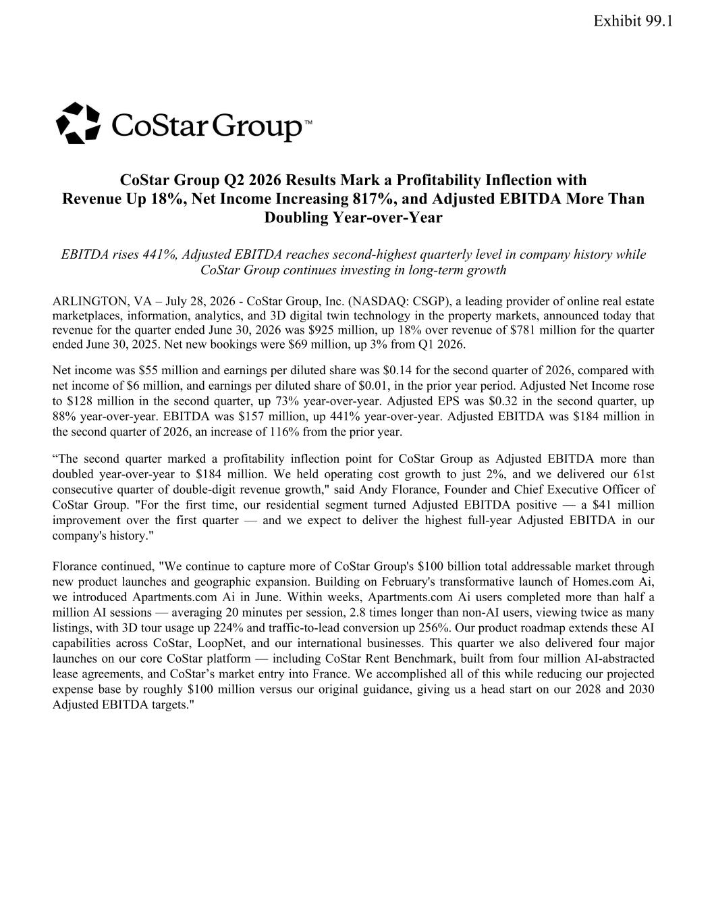

CoStar Group Q2 2026 Results Mark a Profitability Inflection with Revenue Up 18%, Net Income Increasing 817%, and Adjusted EBITDA More Than Doubling Year-over-Year EBITDA rises 441%, Adjusted EBITDA reaches second-highest quarterly level in company history while CoStar Group continues investing in long-term growth ARLINGTON, VA – July 28, 2026 - CoStar Group, Inc. (NASDAQ: CSGP), a leading provider of online real estate marketplaces, information, analytics, and 3D digital twin technology in the property markets, announced today that revenue for the quarter ended June 30, 2026 was $925 million, up 18% over revenue of $781 million for the quarter ended June 30, 2025. Net new bookings were $69 million, up 3% from Q1 2026. Net income was $55 million and earnings per diluted share was $0.14 for the second quarter of 2026, compared with net income of $6 million, and earnings per diluted share of $0.01, in the prior year period. Adjusted Net Income rose to $128 million in the second quarter, up 73% year-over-year. Adjusted EPS was $0.32 in the second quarter, up 88% year-over-year. EBITDA was $157 million, up 441% year-over-year. Adjusted EBITDA was $184 million in the second quarter of 2026, an increase of 116% from the prior year. “The second quarter marked a profitability inflection point for CoStar Group as Adjusted EBITDA more than doubled year-over-year to $184 million. We held operating cost growth to just 2%, and we delivered our 61st consecutive quarter of double-digit revenue growth," said Andy Florance, Founder and Chief Executive Officer of CoStar Group. "For the first time, our residential segment turned Adjusted EBITDA positive — a $41 million improvement over the first quarter — and we expect to deliver the highest full-year Adjusted EBITDA in our company's history." Florance continued, "We continue to capture more of CoStar Group's $100 billion total addressable market through new product launches and geographic expansion. Building on February's transformative launch of Homes.com Ai, we introduced Apartments.com Ai in June. Within weeks, Apartments.com Ai users completed more than half a million AI sessions — averaging 20 minutes per session, 2.8 times longer than non-AI users, viewing twice as many listings, with 3D tour usage up 224% and traffic-to-lead conversion up 256%. Our product roadmap extends these AI capabilities across CoStar, LoopNet, and our international businesses. This quarter we also delivered four major launches on our core CoStar platform — including CoStar Rent Benchmark, built from four million AI-abstracted lease agreements, and CoStar’s market entry into France. We accomplished all of this while reducing our projected expense base by roughly $100 million versus our original guidance, giving us a head start on our 2028 and 2030 Adjusted EBITDA targets." Exhibit 99.1

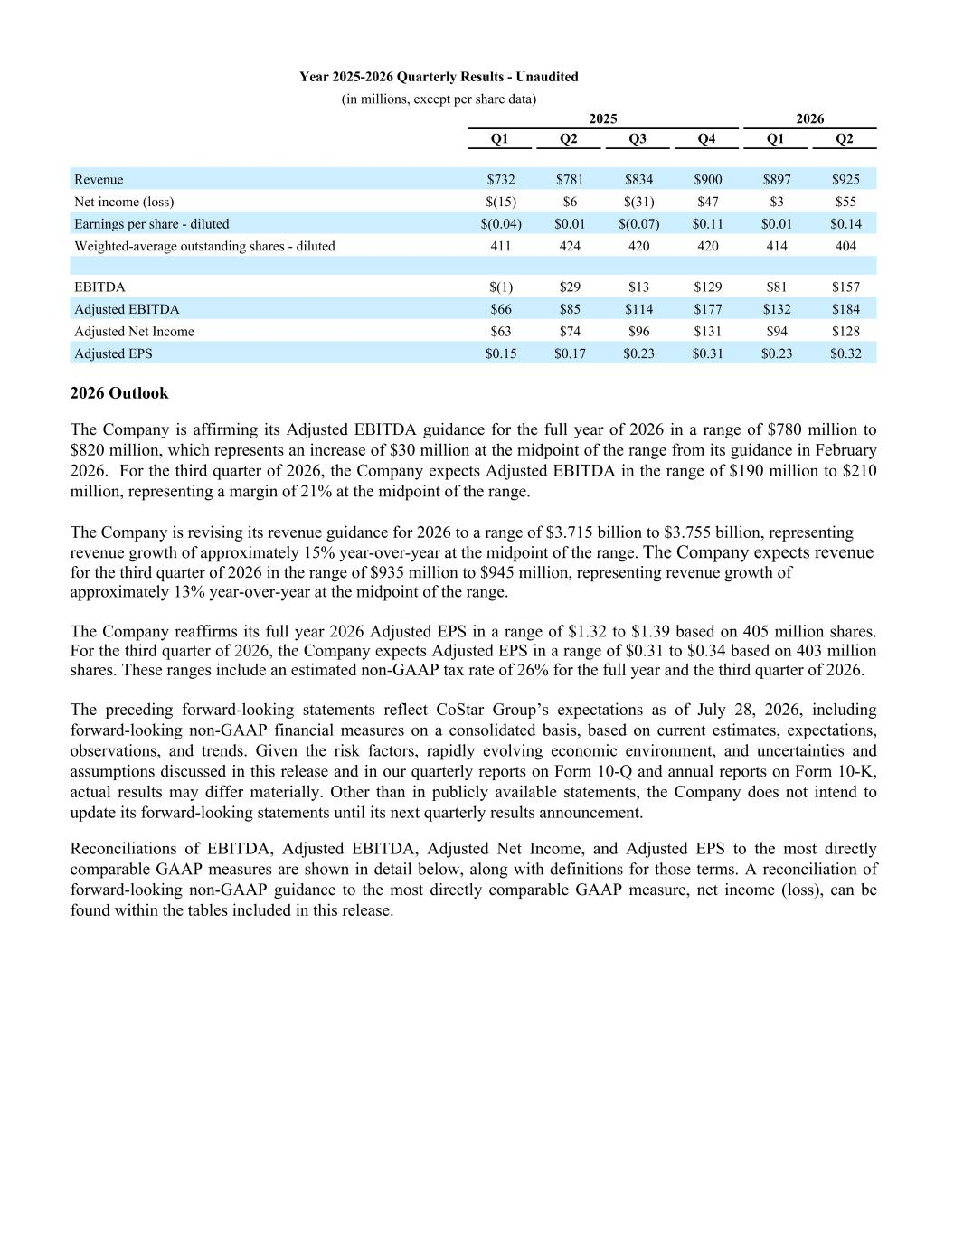
Year 2025-2026 Quarterly Results - Unaudited (in millions, except per share data) 2025 2026 Q1 Q2 Q3 Q4 Q1 Q2 Revenue $732 $781 $834 $900 $897 $925 Net income (loss) $(15) $6 $(31) $47 $3 $55 Earnings per share - diluted $(0.04) $0.01 $(0.07) $0.11 $0.01 $0.14 Weighted-average outstanding shares - diluted 411 424 420 420 414 404 EBITDA $(1) $29 $13 $129 $81 $157 Adjusted EBITDA $66 $85 $114 $177 $132 $184 Adjusted Net Income $63 $74 $96 $131 $94 $128 Adjusted EPS $0.15 $0.17 $0.23 $0.31 $0.23 $0.32 2026 Outlook The Company is affirming its Adjusted EBITDA guidance for the full year of 2026 in a range of $780 million to $820 million, which represents an increase of $30 million at the midpoint of the range from its guidance in February 2026. For the third quarter of 2026, the Company expects Adjusted EBITDA in the range of $190 million to $210 million, representing a margin of 21% at the midpoint of the range. The Company is revising its revenue guidance for 2026 to a range of $3.715 billion to $3.755 billion, representing revenue growth of approximately 15% year-over-year at the midpoint of the range. The Company expects revenue for the third quarter of 2026 in the range of $935 million to $945 million, representing revenue growth of approximately 13% year-over-year at the midpoint of the range. The Company reaffirms its full year 2026 Adjusted EPS in a range of $1.32 to $1.39 based on 405 million shares. For the third quarter of 2026, the Company expects Adjusted EPS in a range of $0.31 to $0.34 based on 403 million shares. These ranges include an estimated non-GAAP tax rate of 26% for the full year and the third quarter of 2026. The preceding forward-looking statements reflect CoStar Group’s expectations as of July 28, 2026, including forward-looking non-GAAP financial measures on a consolidated basis, based on current estimates, expectations, observations, and trends. Given the risk factors, rapidly evolving economic environment, and uncertainties and assumptions discussed in this release and in our quarterly reports on Form 10-Q and annual reports on Form 10-K, actual results may differ materially. Other than in publicly available statements, the Company does not intend to update its forward-looking statements until its next quarterly results announcement. Reconciliations of EBITDA, Adjusted EBITDA, Adjusted Net Income, and Adjusted EPS to the most directly comparable GAAP measures are shown in detail below, along with definitions for those terms. A reconciliation of forward-looking non-GAAP guidance to the most directly comparable GAAP measure, net income (loss), can be found within the tables included in this release.

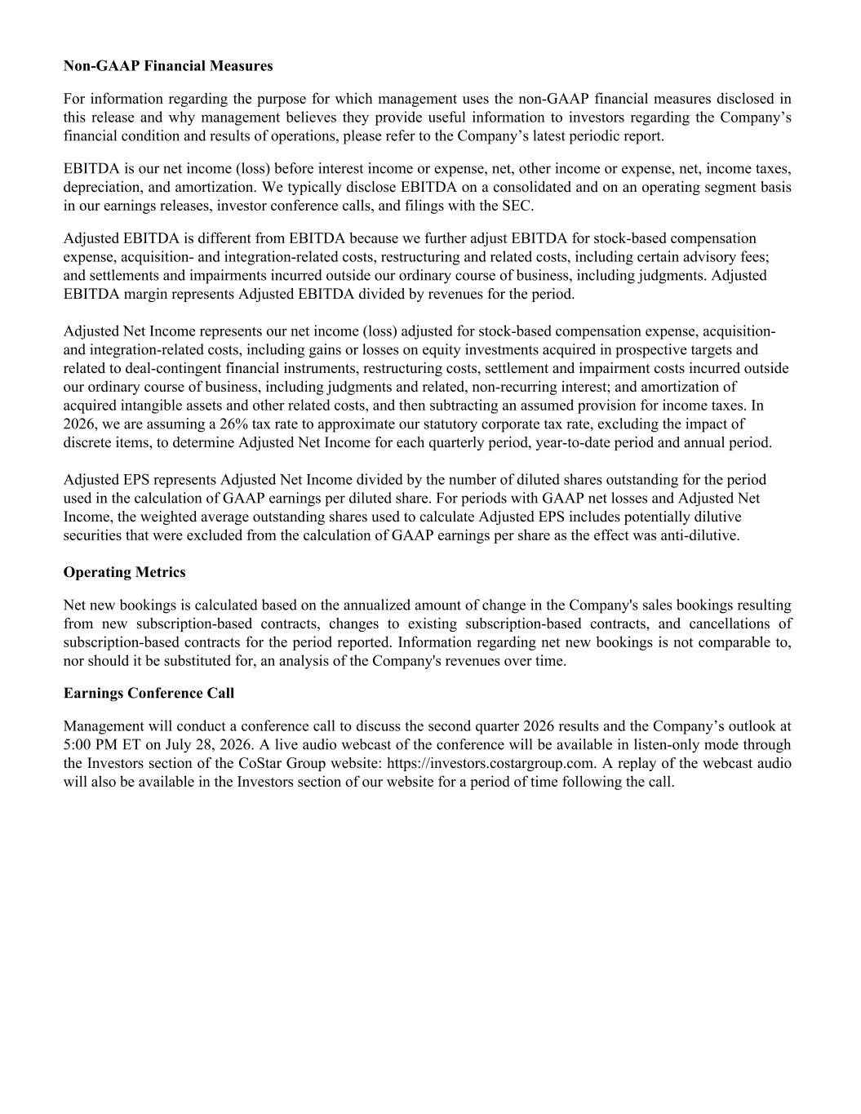
Non-GAAP Financial Measures For information regarding the purpose for which management uses the non-GAAP financial measures disclosed in this release and why management believes they provide useful information to investors regarding the Company’s financial condition and results of operations, please refer to the Company’s latest periodic report. EBITDA is our net income (loss) before interest income or expense, net, other income or expense, net, income taxes, depreciation, and amortization. We typically disclose EBITDA on a consolidated and on an operating segment basis in our earnings releases, investor conference calls, and filings with the SEC. Adjusted EBITDA is different from EBITDA because we further adjust EBITDA for stock-based compensation expense, acquisition- and integration-related costs, restructuring and related costs, including certain advisory fees; and settlements and impairments incurred outside our ordinary course of business, including judgments. Adjusted EBITDA margin represents Adjusted EBITDA divided by revenues for the period. Adjusted Net Income represents our net income (loss) adjusted for stock-based compensation expense, acquisition- and integration-related costs, including gains or losses on equity investments acquired in prospective targets and related to deal-contingent financial instruments, restructuring costs, settlement and impairment costs incurred outside our ordinary course of business, including judgments and related, non-recurring interest; and amortization of acquired intangible assets and other related costs, and then subtracting an assumed provision for income taxes. In 2026, we are assuming a 26% tax rate to approximate our statutory corporate tax rate, excluding the impact of discrete items, to determine Adjusted Net Income for each quarterly period, year-to-date period and annual period. Adjusted EPS represents Adjusted Net Income divided by the number of diluted shares outstanding for the period used in the calculation of GAAP earnings per diluted share. For periods with GAAP net losses and Adjusted Net Income, the weighted average outstanding shares used to calculate Adjusted EPS includes potentially dilutive securities that were excluded from the calculation of GAAP earnings per share as the effect was anti-dilutive. Operating Metrics Net new bookings is calculated based on the annualized amount of change in the Company's sales bookings resulting from new subscription-based contracts, changes to existing subscription-based contracts, and cancellations of subscription-based contracts for the period reported. Information regarding net new bookings is not comparable to, nor should it be substituted for, an analysis of the Company's revenues over time. Earnings Conference Call Management will conduct a conference call to discuss the second quarter 2026 results and the Company’s outlook at 5:00 PM ET on July 28, 2026. A live audio webcast of the conference will be available in listen-only mode through the Investors section of the CoStar Group website: https://investors.costargroup.com. A replay of the webcast audio will also be available in the Investors section of our website for a period of time following the call.

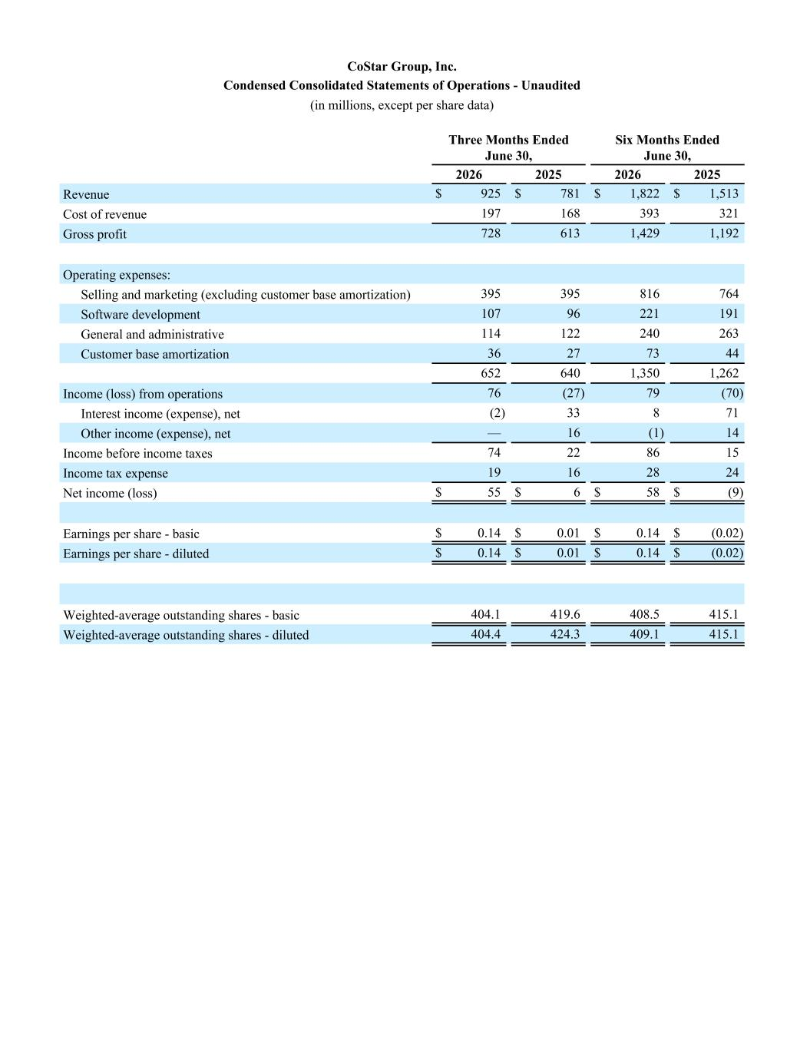
CoStar Group, Inc. Condensed Consolidated Statements of Operations - Unaudited (in millions, except per share data) Three Months Ended June 30, Six Months Ended June 30, 2026 2025 2026 2025 Revenue $ 925 $ 781 $ 1,822 $ 1,513 Cost of revenue 197 168 393 321 Gross profit 728 613 1,429 1,192 Operating expenses: Selling and marketing (excluding customer base amortization) 395 395 816 764 Software development 107 96 221 191 General and administrative 114 122 240 263 Customer base amortization 36 27 73 44 652 640 1,350 1,262 Income (loss) from operations 76 (27) 79 (70) Interest income (expense), net (2) 33 8 71 Other income (expense), net — 16 (1) 14 Income before income taxes 74 22 86 15 Income tax expense 19 16 28 24 Net income (loss) $ 55 $ 6 $ 58 $ (9) Earnings per share - basic $ 0.14 $ 0.01 $ 0.14 $ (0.02) Earnings per share - diluted $ 0.14 $ 0.01 $ 0.14 $ (0.02) Weighted-average outstanding shares - basic 404.1 419.6 408.5 415.1 Weighted-average outstanding shares - diluted 404.4 424.3 409.1 415.1

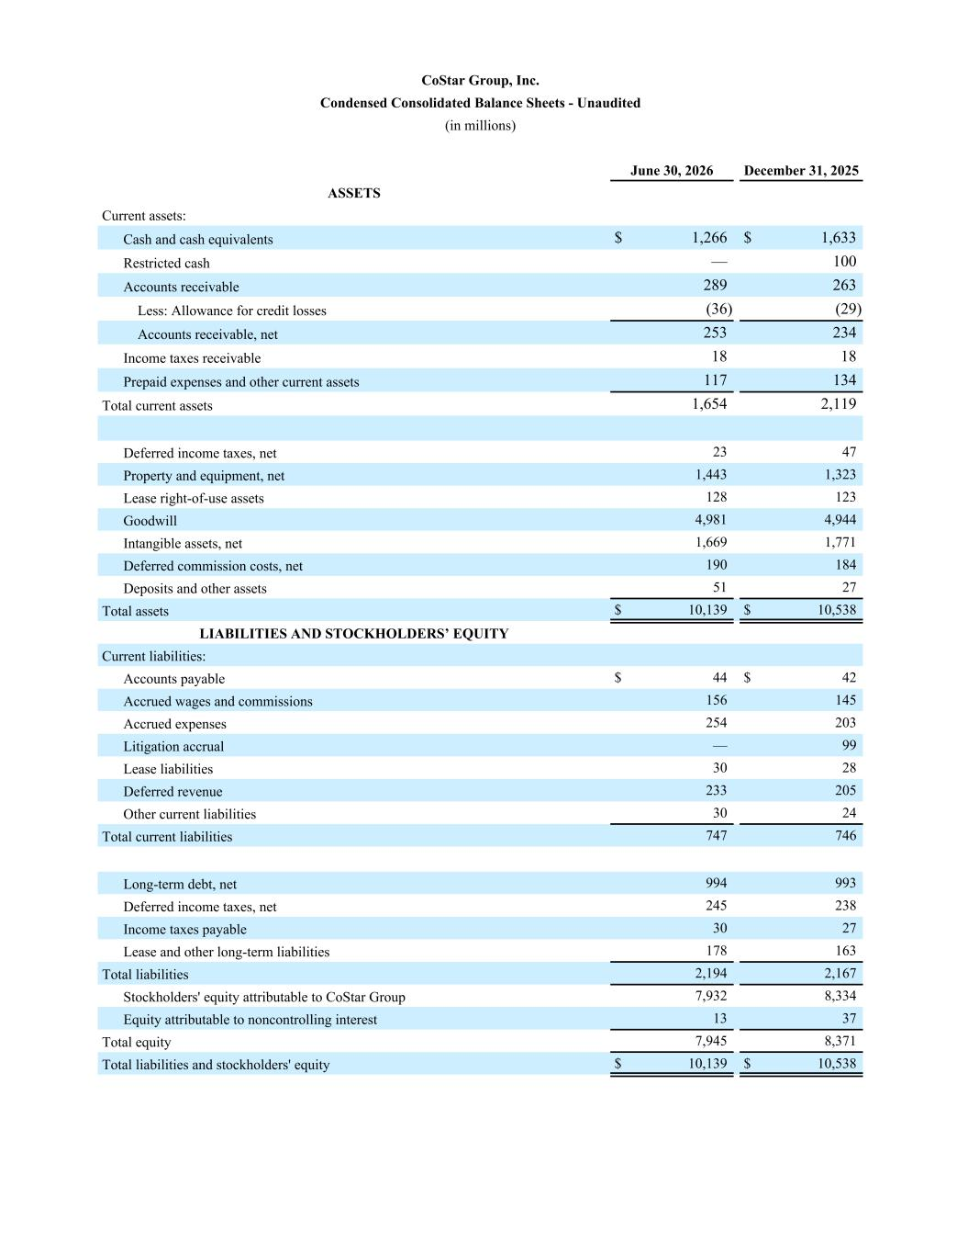
CoStar Group, Inc. Condensed Consolidated Balance Sheets - Unaudited (in millions) June 30, 2026 December 31, 2025 ASSETS Current assets: Cash and cash equivalents $ 1,266 $ 1,633 Restricted cash — 100 Accounts receivable 289 263 Less: Allowance for credit losses (36) (29) Accounts receivable, net 253 234 Income taxes receivable 18 18 Prepaid expenses and other current assets 117 134 Total current assets 1,654 2,119 Deferred income taxes, net 23 47 Property and equipment, net 1,443 1,323 Lease right-of-use assets 128 123 Goodwill 4,981 4,944 Intangible assets, net 1,669 1,771 Deferred commission costs, net 190 184 Deposits and other assets 51 27 Total assets $ 10,139 $ 10,538 LIABILITIES AND STOCKHOLDERS’ EQUITY Current liabilities: Accounts payable $ 44 $ 42 Accrued wages and commissions 156 145 Accrued expenses 254 203 Litigation accrual — 99 Lease liabilities 30 28 Deferred revenue 233 205 Other current liabilities 30 24 Total current liabilities 747 746 Long-term debt, net 994 993 Deferred income taxes, net 245 238 Income taxes payable 30 27 Lease and other long-term liabilities 178 163 Total liabilities 2,194 2,167 Stockholders' equity attributable to CoStar Group 7,932 8,334 Equity attributable to noncontrolling interest 13 37 Total equity 7,945 8,371 Total liabilities and stockholders' equity $ 10,139 $ 10,538

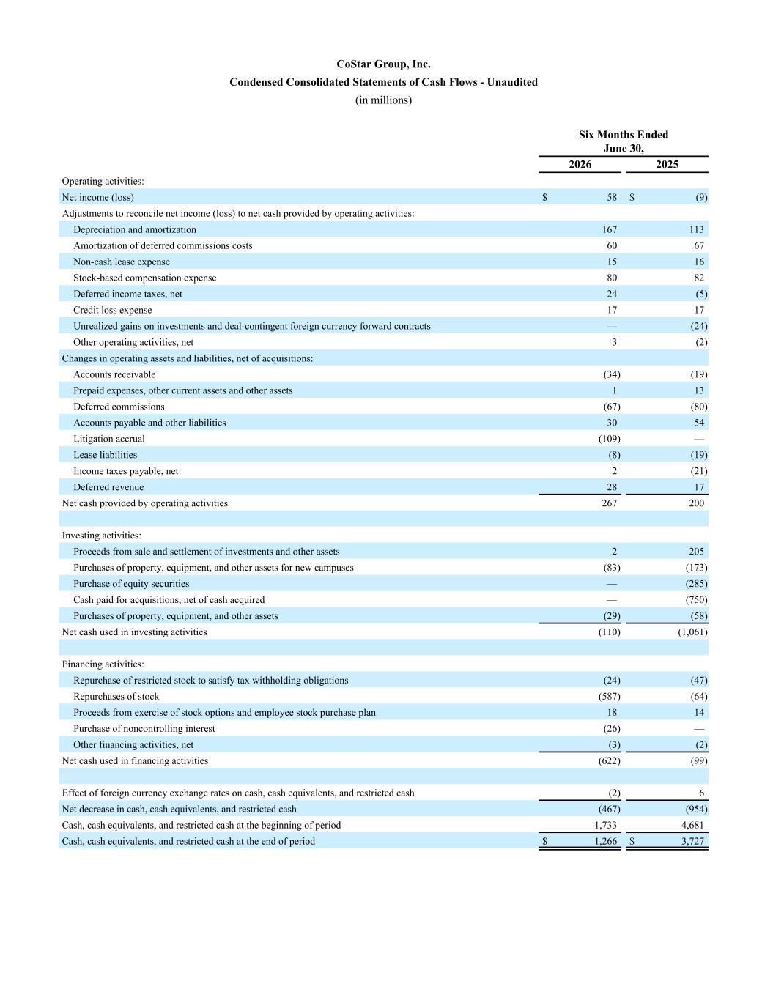
CoStar Group, Inc. Condensed Consolidated Statements of Cash Flows - Unaudited (in millions) Six Months Ended June 30, 2026 2025 Operating activities: Net income (loss) $ 58 $ (9) Adjustments to reconcile net income (loss) to net cash provided by operating activities: Depreciation and amortization 167 113 Amortization of deferred commissions costs 60 67 Non-cash lease expense 15 16 Stock-based compensation expense 80 82 Deferred income taxes, net 24 (5) Credit loss expense 17 17 Unrealized gains on investments and deal-contingent foreign currency forward contracts — (24) Other operating activities, net 3 (2) Changes in operating assets and liabilities, net of acquisitions: Accounts receivable (34) (19) Prepaid expenses, other current assets and other assets 1 13 Deferred commissions (67) (80) Accounts payable and other liabilities 30 54 Litigation accrual (109) — Lease liabilities (8) (19) Income taxes payable, net 2 (21) Deferred revenue 28 17 Net cash provided by operating activities 267 200 Investing activities: Proceeds from sale and settlement of investments and other assets 2 205 Purchases of property, equipment, and other assets for new campuses (83) (173) Purchase of equity securities — (285) Cash paid for acquisitions, net of cash acquired — (750) Purchases of property, equipment, and other assets (29) (58) Net cash used in investing activities (110) (1,061) Financing activities: Repurchase of restricted stock to satisfy tax withholding obligations (24) (47) Repurchases of stock (587) (64) Proceeds from exercise of stock options and employee stock purchase plan 18 14 Purchase of noncontrolling interest (26) — Other financing activities, net (3) (2) Net cash used in financing activities (622) (99) Effect of foreign currency exchange rates on cash, cash equivalents, and restricted cash (2) 6 Net decrease in cash, cash equivalents, and restricted cash (467) (954) Cash, cash equivalents, and restricted cash at the beginning of period 1,733 4,681 Cash, cash equivalents, and restricted cash at the end of period $ 1,266 $ 3,727

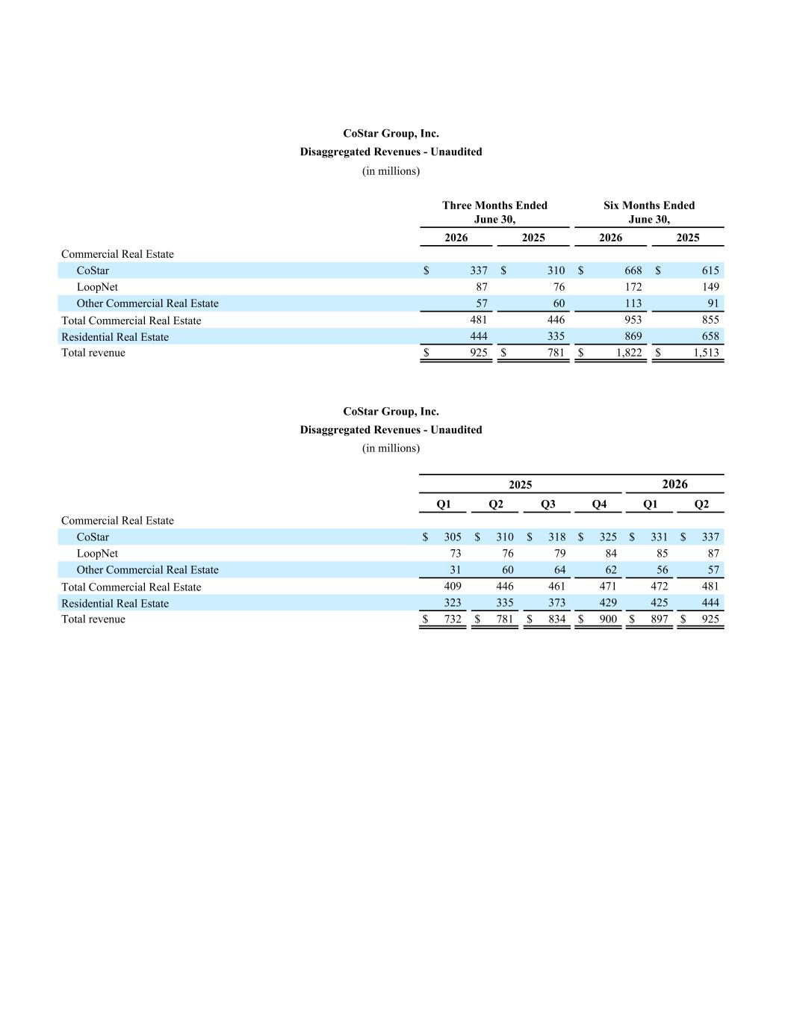
CoStar Group, Inc. Disaggregated Revenues - Unaudited (in millions) Three Months Ended June 30, Six Months Ended June 30, 2026 2025 2026 2025 Commercial Real Estate CoStar $ 337 $ 310 $ 668 $ 615 LoopNet 87 76 172 149 Other Commercial Real Estate 57 60 113 91 Total Commercial Real Estate 481 446 953 855 Residential Real Estate 444 335 869 658 Total revenue $ 925 $ 781 $ 1,822 $ 1,513 CoStar Group, Inc. Disaggregated Revenues - Unaudited (in millions) 2025 2026 Q1 Q2 Q3 Q4 Q1 Q2 Commercial Real Estate CoStar $ 305 $ 310 $ 318 $ 325 $ 331 $ 337 LoopNet 73 76 79 84 85 87 Other Commercial Real Estate 31 60 64 62 56 57 Total Commercial Real Estate 409 446 461 471 472 481 Residential Real Estate 323 335 373 429 425 444 Total revenue $ 732 $ 781 $ 834 $ 900 $ 897 $ 925

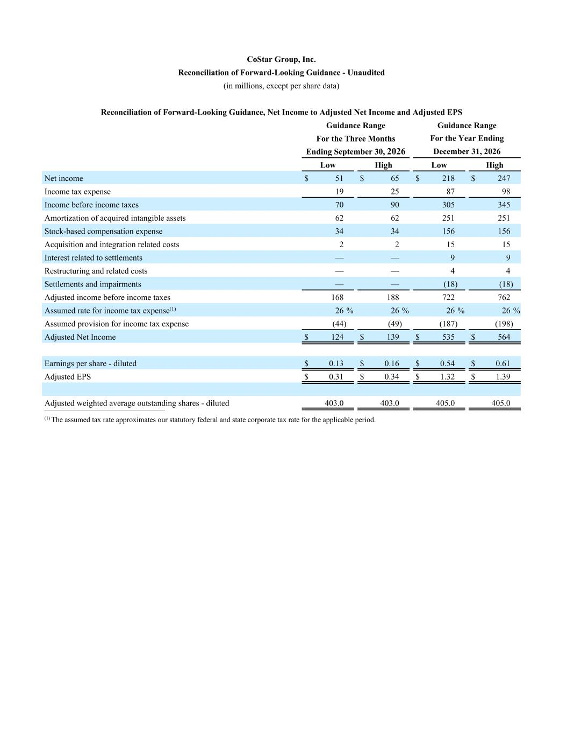
CoStar Group, Inc. Reconciliation of Forward-Looking Guidance - Unaudited (in millions, except per share data) Reconciliation of Forward-Looking Guidance, Net Income to Adjusted Net Income and Adjusted EPS Guidance Range Guidance Range For the Three Months For the Year Ending Ending September 30, 2026 December 31, 2026 Low High Low High Net income $ 51 $ 65 $ 218 $ 247 Income tax expense 19 25 87 98 Income before income taxes 70 90 305 345 Amortization of acquired intangible assets 62 62 251 251 Stock-based compensation expense 34 34 156 156 Acquisition and integration related costs 2 2 15 15 Interest related to settlements — — 9 9 Restructuring and related costs — — 4 4 Settlements and impairments — — (18) (18) Adjusted income before income taxes 168 188 722 762 Assumed rate for income tax expense(1) 26 % 26 % 26 % 26 % Assumed provision for income tax expense (44) (49) (187) (198) Adjusted Net Income $ 124 $ 139 $ 535 $ 564 Earnings per share - diluted $ 0.13 $ 0.16 $ 0.54 $ 0.61 Adjusted EPS $ 0.31 $ 0.34 $ 1.32 $ 1.39 Adjusted weighted average outstanding shares - diluted 403.0 403.0 405.0 405.0 __________________________ (1) The assumed tax rate approximates our statutory federal and state corporate tax rate for the applicable period.

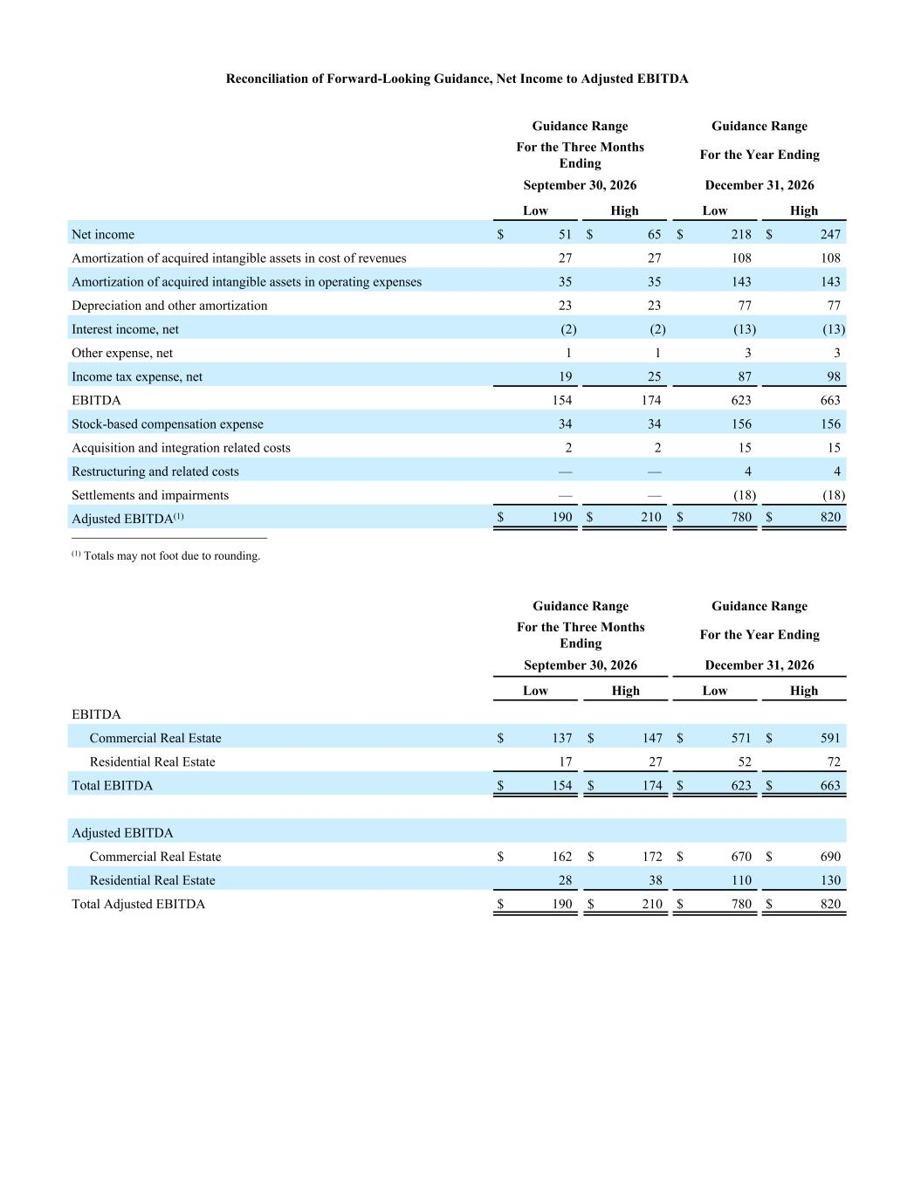
Reconciliation of Forward-Looking Guidance, Net Income to Adjusted EBITDA Guidance Range Guidance Range For the Three Months Ending For the Year Ending September 30, 2026 December 31, 2026 Low High Low High Net income $ 51 $ 65 $ 218 $ 247 Amortization of acquired intangible assets in cost of revenues 27 27 108 108 Amortization of acquired intangible assets in operating expenses 35 35 143 143 Depreciation and other amortization 23 23 77 77 Interest income, net (2) (2) (13) (13) Other expense, net 1 1 3 3 Income tax expense, net 19 25 87 98 EBITDA 154 174 623 663 Stock-based compensation expense 34 34 156 156 Acquisition and integration related costs 2 2 15 15 Restructuring and related costs — — 4 4 Settlements and impairments — — (18) (18) Adjusted EBITDA(1) $ 190 $ 210 $ 780 $ 820 __________________________ (1) Totals may not foot due to rounding. Guidance Range Guidance Range For the Three Months Ending For the Year Ending September 30, 2026 December 31, 2026 Low High Low High EBITDA Commercial Real Estate $ 137 $ 147 $ 571 $ 591 Residential Real Estate 17 27 52 72 Total EBITDA $ 154 $ 174 $ 623 $ 663 Adjusted EBITDA Commercial Real Estate $ 162 $ 172 $ 670 $ 690 Residential Real Estate 28 38 110 130 Total Adjusted EBITDA $ 190 $ 210 $ 780 $ 820

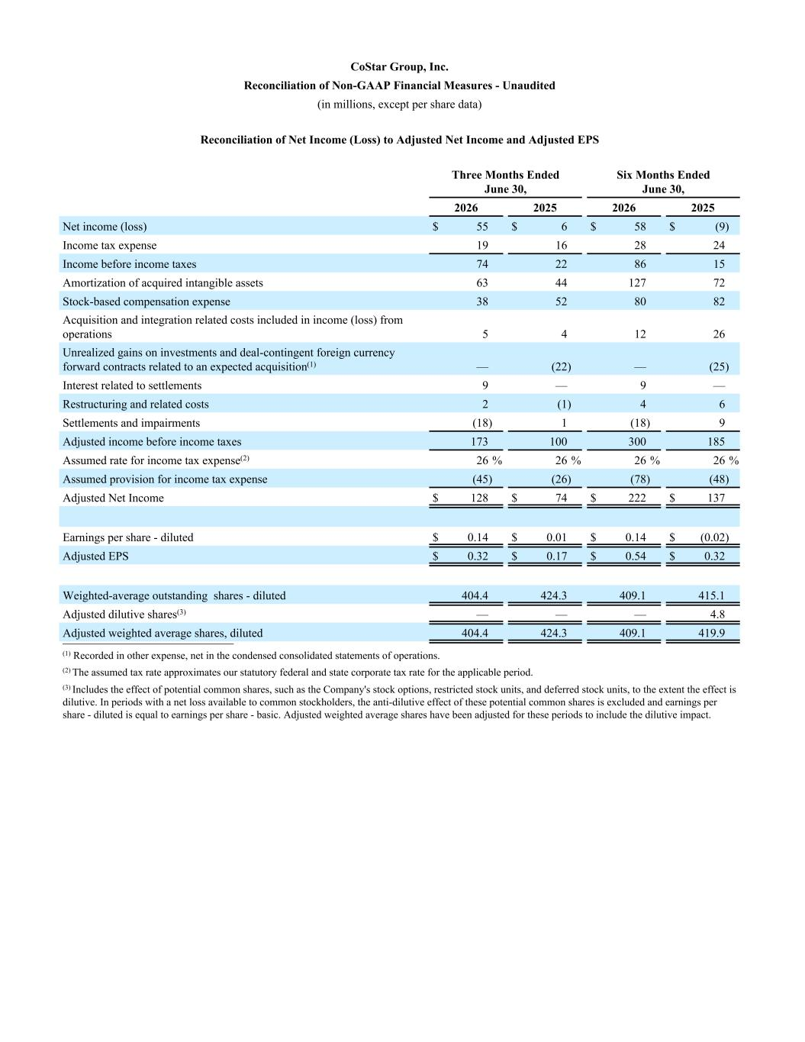
CoStar Group, Inc. Reconciliation of Non-GAAP Financial Measures - Unaudited (in millions, except per share data) Reconciliation of Net Income (Loss) to Adjusted Net Income and Adjusted EPS Three Months Ended June 30, Six Months Ended June 30, 2026 2025 2026 2025 Net income (loss) $ 55 $ 6 $ 58 $ (9) Income tax expense 19 16 28 24 Income before income taxes 74 22 86 15 Amortization of acquired intangible assets 63 44 127 72 Stock-based compensation expense 38 52 80 82 Acquisition and integration related costs included in income (loss) from operations 5 4 12 26 Unrealized gains on investments and deal-contingent foreign currency forward contracts related to an expected acquisition(1) — (22) — (25) Interest related to settlements 9 — 9 — Restructuring and related costs 2 (1) 4 6 Settlements and impairments (18) 1 (18) 9 Adjusted income before income taxes 173 100 300 185 Assumed rate for income tax expense(2) 26 % 26 % 26 % 26 % Assumed provision for income tax expense (45) (26) (78) (48) Adjusted Net Income $ 128 $ 74 $ 222 $ 137 Earnings per share - diluted $ 0.14 $ 0.01 $ 0.14 $ (0.02) Adjusted EPS $ 0.32 $ 0.17 $ 0.54 $ 0.32 Weighted-average outstanding shares - diluted 404.4 424.3 409.1 415.1 Adjusted dilutive shares(3) — — — 4.8 Adjusted weighted average shares, diluted 404.4 424.3 409.1 419.9 __________________________ (1) Recorded in other expense, net in the condensed consolidated statements of operations. (2) The assumed tax rate approximates our statutory federal and state corporate tax rate for the applicable period. (3) Includes the effect of potential common shares, such as the Company's stock options, restricted stock units, and deferred stock units, to the extent the effect is dilutive. In periods with a net loss available to common stockholders, the anti-dilutive effect of these potential common shares is excluded and earnings per share - diluted is equal to earnings per share - basic. Adjusted weighted average shares have been adjusted for these periods to include the dilutive impact.

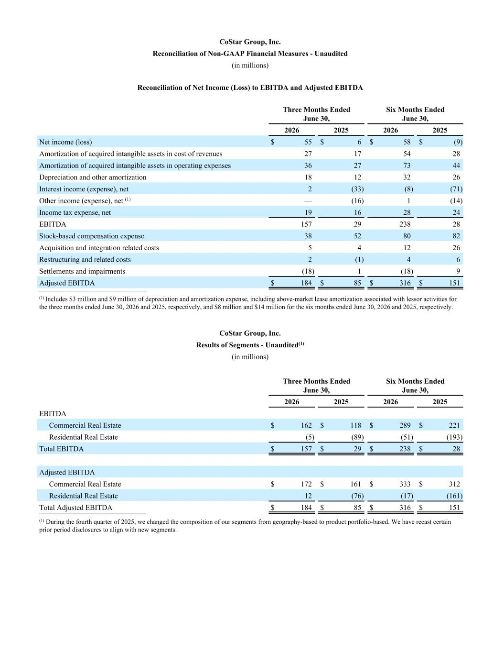
CoStar Group, Inc. Reconciliation of Non-GAAP Financial Measures - Unaudited (in millions) Reconciliation of Net Income (Loss) to EBITDA and Adjusted EBITDA Three Months Ended June 30, Six Months Ended June 30, 2026 2025 2026 2025 Net income (loss) $ 55 $ 6 $ 58 $ (9) Amortization of acquired intangible assets in cost of revenues 27 17 54 28 Amortization of acquired intangible assets in operating expenses 36 27 73 44 Depreciation and other amortization 18 12 32 26 Interest income (expense), net 2 (33) (8) (71) Other income (expense), net (1) — (16) 1 (14) Income tax expense, net 19 16 28 24 EBITDA 157 29 238 28 Stock-based compensation expense 38 52 80 82 Acquisition and integration related costs 5 4 12 26 Restructuring and related costs 2 (1) 4 6 Settlements and impairments (18) 1 (18) 9 Adjusted EBITDA $ 184 $ 85 $ 316 $ 151 __________________________ (1) Includes $3 million and $9 million of depreciation and amortization expense, including above-market lease amortization associated with lessor activities for the three months ended June 30, 2026 and 2025, respectively, and $8 million and $14 million for the six months ended June 30, 2026 and 2025, respectively. CoStar Group, Inc. Results of Segments - Unaudited(1) (in millions) Three Months Ended June 30, Six Months Ended June 30, 2026 2025 2026 2025 EBITDA Commercial Real Estate $ 162 $ 118 $ 289 $ 221 Residential Real Estate (5) (89) (51) (193) Total EBITDA $ 157 $ 29 $ 238 $ 28 Adjusted EBITDA Commercial Real Estate $ 172 $ 161 $ 333 $ 312 Residential Real Estate 12 (76) (17) (161) Total Adjusted EBITDA $ 184 $ 85 $ 316 $ 151 __________________________ (1) During the fourth quarter of 2025, we changed the composition of our segments from geography-based to product portfolio-based. We have recast certain prior period disclosures to align with new segments.

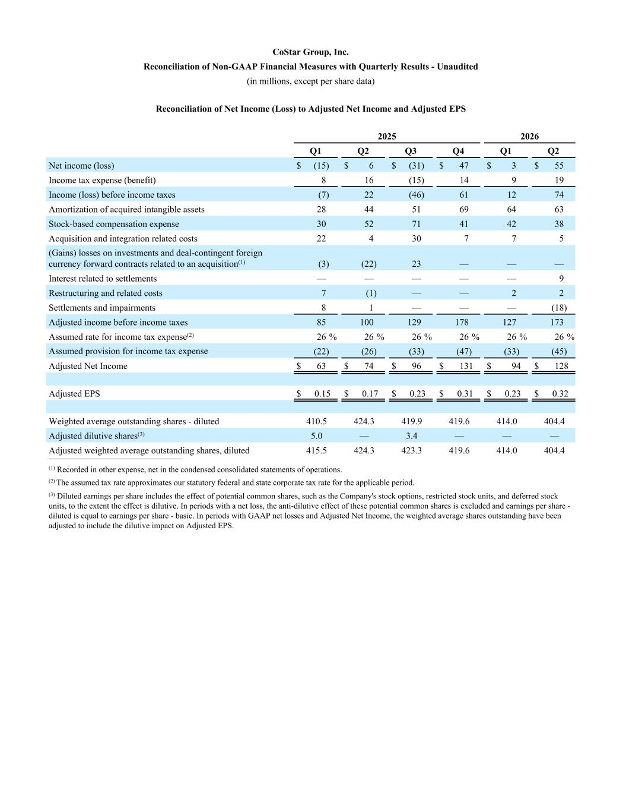
Reconciliation of Net Income (Loss) to Adjusted Net Income and Adjusted EPS 2025 2026 Q1 Q2 Q3 Q4 Q1 Q2 Net income (loss) $ (15) $ 6 $ (31) $ 47 $ 3 $ 55 Income tax expense (benefit) 8 16 (15) 14 9 19 Income (loss) before income taxes (7) 22 (46) 61 12 74 Amortization of acquired intangible assets 28 44 51 69 64 63 Stock-based compensation expense 30 52 71 41 42 38 Acquisition and integration related costs 22 4 30 7 7 5 (Gains) losses on investments and deal-contingent foreign currency forward contracts related to an acquisition(1) (3) (22) 23 — — — Interest related to settlements — — — — — 9 Restructuring and related costs 7 (1) — — 2 2 Settlements and impairments 8 1 — — — (18) Adjusted income before income taxes 85 100 129 178 127 173 Assumed rate for income tax expense(2) 26 % 26 % 26 % 26 % 26 % 26 % Assumed provision for income tax expense (22) (26) (33) (47) (33) (45) Adjusted Net Income $ 63 $ 74 $ 96 $ 131 $ 94 $ 128 Adjusted EPS $ 0.15 $ 0.17 $ 0.23 $ 0.31 $ 0.23 $ 0.32 Weighted average outstanding shares - diluted 410.5 424.3 419.9 419.6 414.0 404.4 Adjusted dilutive shares(3) 5.0 — 3.4 — — — Adjusted weighted average outstanding shares, diluted 415.5 424.3 423.3 419.6 414.0 404.4__________________________ (1) Recorded in other expense, net in the condensed consolidated statements of operations. (2) The assumed tax rate approximates our statutory federal and state corporate tax rate for the applicable period. (3) Diluted earnings per share includes the effect of potential common shares, such as the Company's stock options, restricted stock units, and deferred stock units, to the extent the effect is dilutive. In periods with a net loss, the anti-dilutive effect of these potential common shares is excluded and earnings per share - diluted is equal to earnings per share - basic. In periods with GAAP net losses and Adjusted Net Income, the weighted average shares outstanding have been adjusted to include the dilutive impact on Adjusted EPS. CoStar Group, Inc. Reconciliation of Non-GAAP Financial Measures with Quarterly Results - Unaudited (in millions, except per share data)

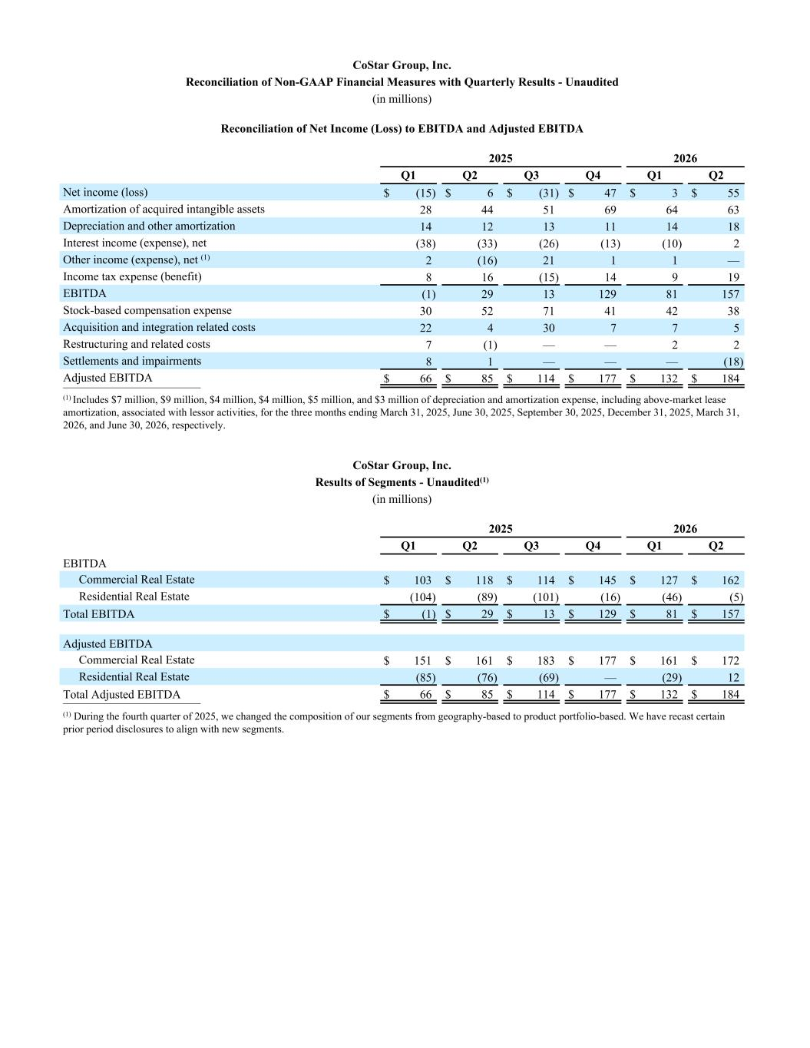
CoStar Group, Inc. Reconciliation of Non-GAAP Financial Measures with Quarterly Results - Unaudited (in millions) Reconciliation of Net Income (Loss) to EBITDA and Adjusted EBITDA 2025 2026 Q1 Q2 Q3 Q4 Q1 Q2 Net income (loss) $ (15) $ 6 $ (31) $ 47 $ 3 $ 55 Amortization of acquired intangible assets 28 44 51 69 64 63 Depreciation and other amortization 14 12 13 11 14 18 Interest income (expense), net (38) (33) (26) (13) (10) 2 Other income (expense), net (1) 2 (16) 21 1 1 — Income tax expense (benefit) 8 16 (15) 14 9 19 EBITDA (1) 29 13 129 81 157 Stock-based compensation expense 30 52 71 41 42 38 Acquisition and integration related costs 22 4 30 7 7 5 Restructuring and related costs 7 (1) — — 2 2 Settlements and impairments 8 1 — — — (18) Adjusted EBITDA $ 66 $ 85 $ 114 $ 177 $ 132 $ 184 __________________________ (1) Includes $7 million, $9 million, $4 million, $4 million, $5 million, and $3 million of depreciation and amortization expense, including above-market lease amortization, associated with lessor activities, for the three months ending March 31, 2025, June 30, 2025, September 30, 2025, December 31, 2025, March 31, 2026, and June 30, 2026, respectively. CoStar Group, Inc. Results of Segments - Unaudited(1) (in millions) 2025 2026 Q1 Q2 Q3 Q4 Q1 Q2 EBITDA Commercial Real Estate $ 103 $ 118 $ 114 $ 145 $ 127 $ 162 Residential Real Estate (104) (89) (101) (16) (46) (5) Total EBITDA $ (1) $ 29 $ 13 $ 129 $ 81 $ 157 Adjusted EBITDA Commercial Real Estate $ 151 $ 161 $ 183 $ 177 $ 161 $ 172 Residential Real Estate (85) (76) (69) — (29) 12 Total Adjusted EBITDA $ 66 $ 85 $ 114 $ 177 $ 132 $ 184 __________________________ (1) During the fourth quarter of 2025, we changed the composition of our segments from geography-based to product portfolio-based. We have recast certain prior period disclosures to align with new segments.

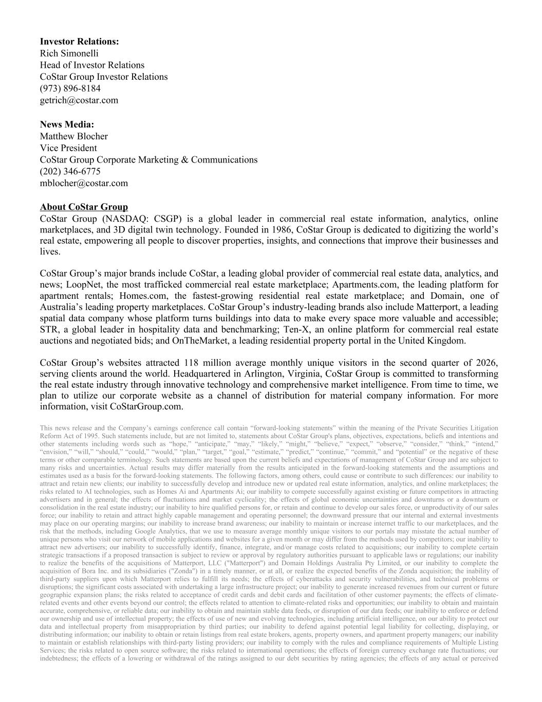
Investor Relations: Rich Simonelli Head of Investor Relations CoStar Group Investor Relations (973) 896-8184 getrich@costar.com News Media: Matthew Blocher Vice President CoStar Group Corporate Marketing & Communications (202) 346-6775 mblocher@costar.com About CoStar Group CoStar Group (NASDAQ: CSGP) is a global leader in commercial real estate information, analytics, online marketplaces, and 3D digital twin technology. Founded in 1986, CoStar Group is dedicated to digitizing the world’s real estate, empowering all people to discover properties, insights, and connections that improve their businesses and lives. CoStar Group’s major brands include CoStar, a leading global provider of commercial real estate data, analytics, and news; LoopNet, the most trafficked commercial real estate marketplace; Apartments.com, the leading platform for apartment rentals; Homes.com, the fastest-growing residential real estate marketplace; and Domain, one of Australia’s leading property marketplaces. CoStar Group’s industry-leading brands also include Matterport, a leading spatial data company whose platform turns buildings into data to make every space more valuable and accessible; STR, a global leader in hospitality data and benchmarking; Ten-X, an online platform for commercial real estate auctions and negotiated bids; and OnTheMarket, a leading residential property portal in the United Kingdom. CoStar Group’s websites attracted 118 million average monthly unique visitors in the second quarter of 2026, serving clients around the world. Headquartered in Arlington, Virginia, CoStar Group is committed to transforming the real estate industry through innovative technology and comprehensive market intelligence. From time to time, we plan to utilize our corporate website as a channel of distribution for material company information. For more information, visit CoStarGroup.com. This news release and the Company’s earnings conference call contain “forward-looking statements” within the meaning of the Private Securities Litigation Reform Act of 1995. Such statements include, but are not limited to, statements about CoStar Group's plans, objectives, expectations, beliefs and intentions and other statements including words such as “hope,” “anticipate,” “may,” “likely,” “might,” “believe,” “expect,” “observe,” “consider,” “think,” “intend,” “envision,” “will,” “should,” “could,” “would,” “plan,” “target,” “goal,” “estimate,” “predict,” “continue,” “commit,” and “potential” or the negative of these terms or other comparable terminology. Such statements are based upon the current beliefs and expectations of management of CoStar Group and are subject to many risks and uncertainties. Actual results may differ materially from the results anticipated in the forward-looking statements and the assumptions and estimates used as a basis for the forward-looking statements. The following factors, among others, could cause or contribute to such differences: our inability to attract and retain new clients; our inability to successfully develop and introduce new or updated real estate information, analytics, and online marketplaces; the risks related to AI technologies, such as Homes Ai and Apartments Ai; our inability to compete successfully against existing or future competitors in attracting advertisers and in general; the effects of fluctuations and market cyclicality; the effects of global economic uncertainties and downturns or a downturn or consolidation in the real estate industry; our inability to hire qualified persons for, or retain and continue to develop our sales force, or unproductivity of our sales force; our inability to retain and attract highly capable management and operating personnel; the downward pressure that our internal and external investments may place on our operating margins; our inability to increase brand awareness; our inability to maintain or increase internet traffic to our marketplaces, and the risk that the methods, including Google Analytics, that we use to measure average monthly unique visitors to our portals may misstate the actual number of unique persons who visit our network of mobile applications and websites for a given month or may differ from the methods used by competitors; our inability to attract new advertisers; our inability to successfully identify, finance, integrate, and/or manage costs related to acquisitions; our inability to complete certain strategic transactions if a proposed transaction is subject to review or approval by regulatory authorities pursuant to applicable laws or regulations; our inability to realize the benefits of the acquisitions of Matterport, LLC ("Matterport") and Domain Holdings Australia Pty Limited, or our inability to complete the acquisition of Bora Inc. and its subsidiaries ("Zonda") in a timely manner, or at all, or realize the expected benefits of the Zonda acquisition; the inability of third-party suppliers upon which Matterport relies to fulfill its needs; the effects of cyberattacks and security vulnerabilities, and technical problems or disruptions; the significant costs associated with undertaking a large infrastructure project; our inability to generate increased revenues from our current or future geographic expansion plans; the risks related to acceptance of credit cards and debit cards and facilitation of other customer payments; the effects of climate- related events and other events beyond our control; the effects related to attention to climate-related risks and opportunities; our inability to obtain and maintain accurate, comprehensive, or reliable data; our inability to obtain and maintain stable data feeds, or disruption of our data feeds; our inability to enforce or defend our ownership and use of intellectual property; the effects of use of new and evolving technologies, including artificial intelligence, on our ability to protect our data and intellectual property from misappropriation by third parties; our inability to defend against potential legal liability for collecting, displaying, or distributing information; our inability to obtain or retain listings from real estate brokers, agents, property owners, and apartment property managers; our inability to maintain or establish relationships with third-party listing providers; our inability to comply with the rules and compliance requirements of Multiple Listing Services; the risks related to open source software; the risks related to international operations; the effects of foreign currency exchange rate fluctuations; our indebtedness; the effects of a lowering or withdrawal of the ratings assigned to our debt securities by rating agencies; the effects of any actual or perceived


failure to comply with privacy or data protection laws, regulations, or standards; the effects of changes in tax laws, regulations, or fiscal and tax policies; the effects of third-party claims, litigation, regulatory proceedings, or government investigations; the risks related to return on investment; and the risks related to the specific timing, price, and size of repurchases under the Stock Repurchase Program, including that the Stock Repurchase Program may be suspended or discontinued at any time at the Company’s discretion. More information about potential factors that could cause results to differ materially from those anticipated in the forward-looking statements include, but are not limited to, those stated in CoStar Group’s filings from time to time with the Securities and Exchange Commission (the "SEC"), including in CoStar Group’s Annual Reports on Form 10-K and Quarterly Reports on Form 10-Q, each of which is filed with the SEC, including in the “Risk Factors” section of those filings, as well as CoStar Group’s other filings with the SEC (including Current Reports on Form 8-K) available at the SEC’s website (www.sec.gov). All forward-looking statements are based on information available to CoStar Group on the date hereof, and CoStar Group assumes no obligation to update or revise any forward-looking statements, whether as a result of new information, future events or otherwise, except as required by applicable law.

